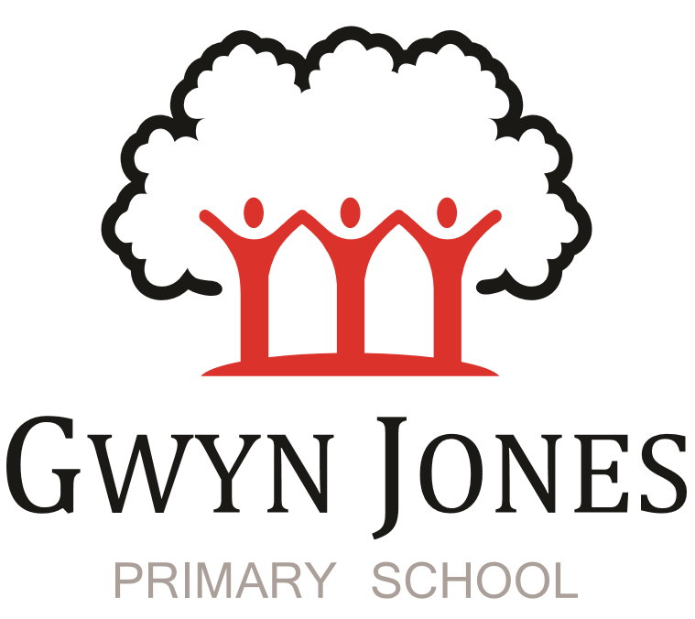



**Recruitment Pack**

|  |
| --- |
| **Cleaner**  Permanent  Rate of Pay: £11.00 per hour  Hours of work: 6am-8am  Start date: September 2025 |

 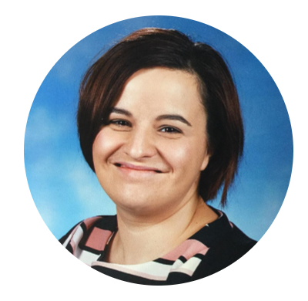

Dear Applicant,

Thank you for your interest in this exciting opportunity to join Gwyn Jones Primary School as a member of team in the role of Cleaner to join our friendly and hardworking team. We are seeking energetic and motivated individuals to join our cleaning team. We are looking for people who take pride in their work and can help make our school a clean and safe environment. Previous experience and knowledge of school cleaning is desirable but not essential, as training will be provided.

We are a two-form entry, culturally diverse school based in East London and we are very proud of our school. Visitors comment on the warmth of the school and the friendliness of both staff and pupils alike. Our dedicated staff team are incredibly hard working and are committed to creating a happy, secure and stimulating environment in which every child can achieve their potential and develop a life-long love of learning.

At Gwyn Jones Primary School we are a Rights Respecting School and we actively teach our children about the rights of the child. The Rights Respecting ethos permeates all parts of school life and into our school motto “Inspired and Empowered”. This motto epitomises the staff’s genuine commitment to provide a rich, creative and challenging curriculum which inspires children’s curiosity and empowers our pupils to have a voice and be knowledgeable, active global citizens. We strive to ensure that every child thrives academically whilst benefiting from excellent pastoral care that nurtures and develops emotional wellbeing.

We are looking for someone who has good communication skills and is flexible in their approach when supporting children and working alongside other colleagues. We know it is important to be positive, inspirational and a real team player.

The successful applicant will be :

* Someone who can work well in a team
* Someone who would like to work in a happy and friendly school
* Someone who has a good understanding of health and safety matters
* Someone who takes pride in their work and can clean to a high standard

I hope this application pack and the information available generally on our website and on social media will give you a flavour of our School. I would be delighted to show you around our friendly and caring school. To arrange a visit please contact the school office on 02085567904 or email: [HR@gwynjones.waltham.sch.uk](mailto:HR@gwynjones.waltham.sch.uk)

I look forward to meeting with you

**Sian Boutalbi**

**Headteacher**

 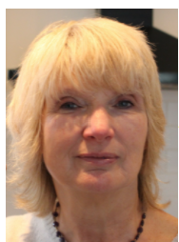

Dear Applicant,

Thank you for your interest in the position of Cleaner.

Gwyn Jones is a successful and very popular school within the local area. We are fortunate in having an engaged and culturally diverse community, a hardworking and talented staff team and amazing pupils.

As Governors, we work alongside the Head and her dedicated team in our common belief in the fundamental importance of Primary Education as the foundation for developing a lifelong love of learning in our children. Our Governing Board is keen to develop its skills and knowledge of the school and its community and supports the drive within school for continuous improvement within a nurturing and supportive environment.

Our curriculum is rich, diverse and challenging and aims to provide a range of exciting and meaningful experiences which foster confidence and provide aspirations. Staff plan for children to be academically challenged, creatively inspired and supported in their personal development.

Gwyn Jones maintains strong links with other local schools within Waltham Forest. As a member of our staff team you would receive ongoing support and development in your role.

If the thought of this role in our school excites you, we look forward to receiving your application.

**Liz Jackson**

**Chair of Governors**

**Vision and Values**



At Gwyn Jones, we are committed to ensuring that every member of our school community is **inspired and empowered** each day.

We aim to inspire and empower our children by:

* Providing excellent teaching which nurtures our children’s innate curiosity, allowing them opportunities to take risks and to think for themselves.
* Supporting our children to have responsibility for their own learning; to have their own opinions and the skills to articulate them.
* Allowing all children access to a rich and broad curriculum which fully prepares them to be active, global citizens.
* Ensuring all children participate in a variety of trips and visitors in their local and wider community.
* Acting as role models who respect others and enjoy the rich diversity of our school family.
* Insisting that every child is known well, safe and nurtured to achieve their personal best.

We aim to inspire and empower our staff by:

* Providing a wide range of relevant and innovative professional learning in school which focuses on collaboration and sharing good practice, including lesson study, planning support, team teacher and action research.
* Forging strong links with external agencies to deliver professional development - teaching schools, higher education institutes etc.
* Giving developmental feedback with clear and specific actions for staff and leaders.
* Establishing coaching and mentoring relationships which encourage reflection.
* Identifying and nurturing leadership talent.

**Rights Respecting School**  

### **What is UNICEF's Rights Respecting Schools?**

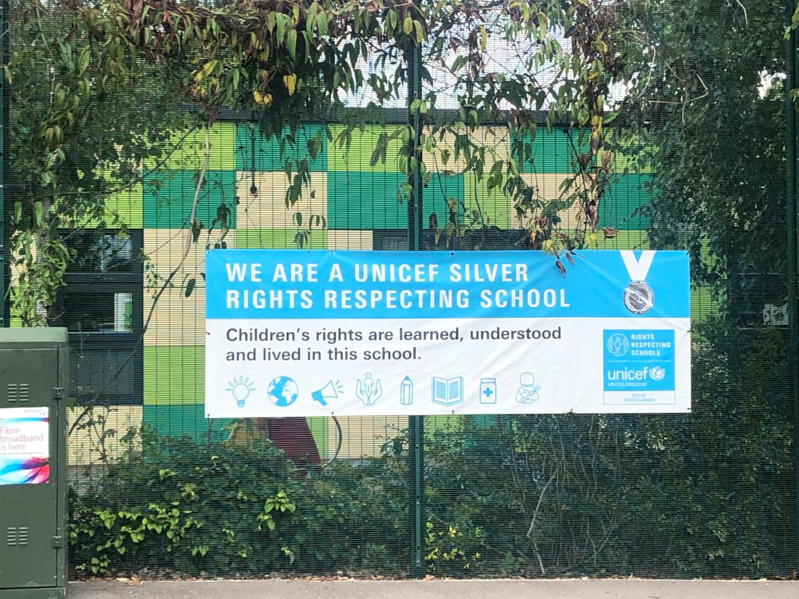

We are committed to placing the UN Convention on the Rights of the Child at the heart of our core values and ethos; believing children’s participation is integral to all aspects of school life. This results in empowered and self-confident children who can advocate for the rights of children everywhere.

This ethos further fosters a sense of community, respect and responsibility. It encourages the children to be active and informed citizens, who look to develop a positive future for all; campaigning and raising awareness.

The children’s experiences at Gwyn Jones Primary ensure the children know that they have the Rights of the Child and that these rights are inalienable. They also understand responsibilities they have as members of our local and global society.

**How to Apply**

Should you wish to apply for the post, please complete an application form and include a personal statement, which clearly demonstrates your suitability for this role. Please send your completed applications to [HR@gwynjones.waltham.sch.uk](mailto:HR@gwynjones.waltham.sch.uk)

**Closing Date**

Please ensure your application arrives by noon on the closing date of Friday 5th September 2025 at 9am.

**Shortlisting**

If you have not heard from us by Tuesday 9th September 2025 please assume that unfortunately, on this occasion, your application has not been successful.

**Interview**

Interviews will take place on Friday 12th September 2025.

**Safeguarding**

Applicants called for interview are kindly requested to contact their referees so that references are received ahead of the interview dates.

Gwyn Jones Primary School is committed to safeguarding and promoting the welfare of children and young people and expects all staff and volunteers to share this commitment. The school follows safer recruitment practices and the successful applicants will be required to apply for an Enhanced Disclosure and Barring Service check. A copy of our Safeguarding Policy is available to view on our website. Following KCSIE guidance 2024 an online search may be conducted on publicly available social media for shortlisted candidates only prior to interview.

**Location**

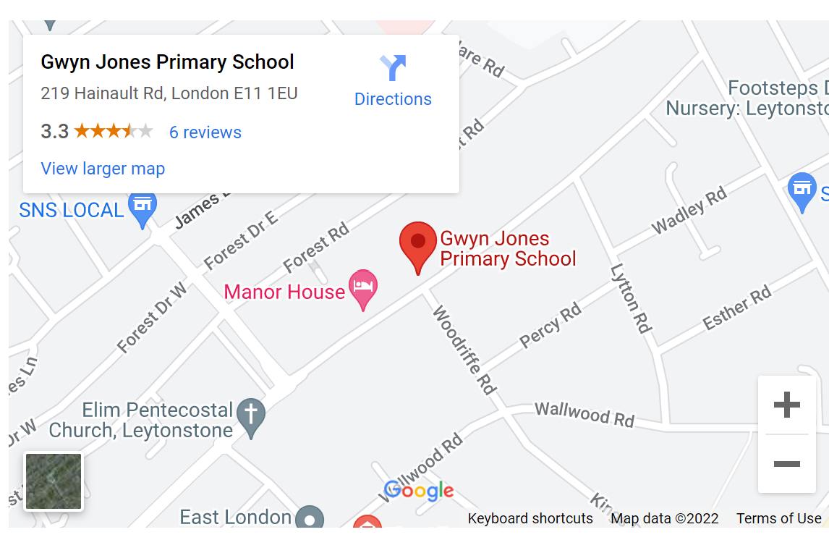

Job description and person specification

GWYN JONES PRIMARY SCHOOL

JOB DESCRIPTION

**Job Title: Cleaner**

**Responsible to: Site Manager**

**Responsible for: no one**

# Job Purpose

To clean the interior of Gwyn Jones Primary School to the required standards.

# Major Tasks

1. To understand and comply with the School’s Equal Opportunities Policy.
2. To uphold and comply within the statutory provisions of the Health & Safety at Work Act 1974 and any other relevant legislation or Council Policies and Procedures relating to Health & Safety at work.
3. To carry out cleaning duties as directed.
4. To attend relevant training

# Duties and Responsibilities

You will be required to carry out all or some of these tasks for the area(s) in which you have been directed to work.

1. To sweep/dust control sweep/spot mop/thorough mop all hard floor surfaces as directed.
2. To spot vacuum/thorough vacuum all carpeted floors, upholstered furniture and other areas as designated.
3. To dust/dust control dust/damp dust/wash all furniture, fixtures, fittings, surfaces pipes and skirting boards up to hand height as directed. High level dusting to be carried out as required using high dust control extending frame.
4. To clean telephones, including the mouthpiece as directed.
5. To empty, replace and clean wastepaper bins as required.
6. To remove rubbish to designated collection points, to include all paper waste to be collected in rubbish bags and craft waste to be removed in receptacle provided.
7. To clean sanitary areas as designated to include all toilets, urinals, sinks, basins, showers, baths and associated fixtures and fittings.
8. Replace hand towels, toilet rolls and hand soap as required.
9. Empty and remove ashes from sanitary towel disposal units where required.
10. To carry out all floor maintenance duties as directed, using the procedure as laid down, machinery equipment and materials provided for this purpose. These duties will include the following:

spray cleaning, machine buffing, stripping floors of water based polishes, repolishing floor using water based polishes, machine scrubbing, hand stripping/scrubbing, maintaining unsealed wooden floors with wax polishes where required, the application of oleo resinous seals to wood floors as required, and carpet cleaning.

1. To regularly remove all finger and scuff marks, splashes etc, from internal glass doors, kickplates, walls and paintwork, and to thoroughly clean these items as required.
2. To wash walls, tiles and ceilings above hand height as required using equipment supplied. This work to be done by operative from floor level.
3. To remove graffiti, chewing gum etc, using laid down procedures.
4. To thoroughly clean venetian blinds and vertical blinds as required using methods and equipment as directed. This work to; be done by operative from floor level.
5. To understand and comply with the School’s Health & Safety Policy.
6. To maintain the high standard of cleanliness and good condition of all machinery and equipment used by you, and to report any faults to the SSO.
7. To be aware of fire prevention and drill procedures.
8. To lock doors and return keys to designated place as required.
9. To maintain client confidentiality and security of buildings, closing and locking windows as required.

