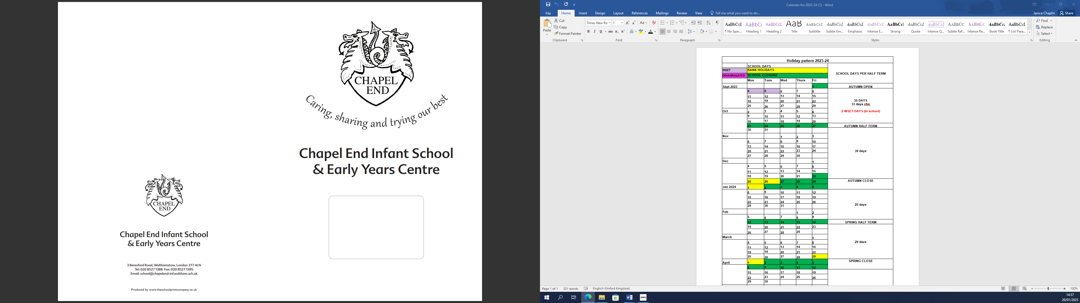

**Recruitment Pack**

|  |
| --- |
| **SEN Learning Support Assistant**  **Permanent, Full Time Contract**  Scale 3, points 5-6 |

**Waltham Forest Council is committed to safeguarding children,**

**young people, and vulnerable adults.**

Dear Applicant,

Thank you for your interest in this exciting opportunity to join Chapel End Infant School and Early Years Centre as an SEN Learning Support Assistant.

Our vision: *‘To provide the children of Chapel End with a high quality educational experience within a nurturing environment, giving them the best possible start to their lifelong journey’* is what guides us on a daily basis.

We are a welcoming and diverse school set in lovely grounds across two sites. During our recent Ofsted inspection (September 2022), it was noted that ‘warm relationships between staff and pupils are rooted in the school’s values. All are treated with kindness and respect.’

To add to our professional, skilled and friendly team, we wish to appoint an SEN Learning Support Assistant, who will be an excellent role model for our children. The ideal candidate will be a highly committed, caring individual, who is passionate about providing the best education for every child in our inclusive school.

It is essential that you are dedicated, passionate and conscientious. We are looking for applicants with a high degree of motivation and professionalism. Your ability to build positive relationships and work as part of a team will be essential to our selection process.

I hope this application pack and the information available generally on our [website](https://www.chapelendinfants.com/walthamforest/primary/chapelend-inf/site/pages/parents/startingschool) will tell you everything you need to know about our school. We would encourage you to arrange a visit to the school, please contact our school office on: 020 8527 1388 or [school@chapelend-inf.waltham.sch.uk](mailto:school@chapelend-inf.waltham.sch.uk).

I look forward to receiving your application pack.

Janice Chaplin

Headteacher

**How to Apply**

To apply for the post, please complete an application form and include a personal statement, which clearly demonstrates your suitability for this role. Please send your completed application pack via email to [school@chapelend-inf.waltham.sch.uk](mailto:school@chapelend-inf.waltham.sch.uk), or drop it off at the Infant school office on Beresford Road (address below).

**Closing Date**

Please ensure your application arrives by 12.00pm on the closing date of **Friday 14th March 2025**.

**Shortlisting**

Shortlisting will take place on **Friday 14th March**, if you have not heard from us by the end of the shortlisting day, please assume that unfortunately on this occasion, your application has not been successful.

**Interviews**

Interviews will take place on **Tuesday 18th March 2025.**

**Safeguarding**

Applicants called for interview are kindly requested to contact their referees so that references are received ahead of the interview dates.

Chapel End Infant School & Early Years Centre is committed to safeguarding and promoting the welfare of children and young people and expects all staff and volunteers to share this commitment. The school follows safer recruitment practices and the successful applicant will be required to apply for an Enhanced Disclosure and Barring Service check. A copy of our Safeguarding Policy is available to view on our website.

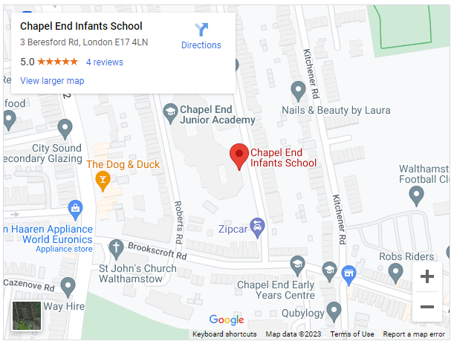**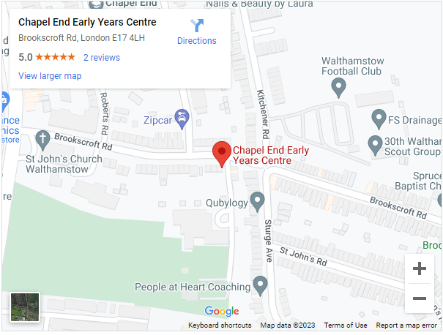Location**



**JOB DESCRIPTION**

**SEND Learning Support Assistant Level 2**

**Responsible to: Headteacher**

**Grade:** Scale 3

**Job Purpose:** To work under the instruction/guidance of teaching/senior staff to undertake work/care/support programmes, to enable access to learning for pupils and to assist the teacher in the management of pupils and the classroom. Work may be carried out in the classroom or outside the main teaching area

**Support for Pupils**

* Supervise and provide particular support for pupils, including those with special educational needs and/or disabilities, ensuring their safety and access to learning activities
* Assist with the development and implementation of Behaviour Support Plans.
* Establish constructive relationships with pupils and interact with them according to individual needs
* Promote the inclusion and acceptance of all pupils
* Encourage pupils to interact with others and engage in activities led by the teacher
* Set challenging and demanding expectations and promote self-esteem and independence
* Provide feedback to pupils in relation to progress and achievement under guidance of the teacher

**Support for teachers**

* Create and maintain a purposeful, orderly and supportive environment, in accordance with lesson plans and assist with the display of pupils’ work
* Use strategies, in liaison with the teacher, to support pupils to achieve learning goals
* Assist with the planning of learning activities
* Monitor pupils’ responses to learning activities and accurately record achievement/progress as directed
* Provide detailed and regular feedback to teachers on pupils achievement, progress, problems etc
* Promote good pupil behaviour, dealing promptly with conflict and incidents in line with the schools Positive Behaviour Management policy and encourage pupils to take responsibility for their own behaviour
* Establish constructive relationships with parents/carers
* Administer routine statutory assessments and undertake routine marking of pupils’ work
* Provide clerical/admin support as required.

**Support for curriculum**

* Undertake structured and agreed learning activities/teaching programmes, adjusting activities according to pupil responses
* Undertake programmes linked to local and national learning strategies eg literacy, numeracy, KS1, early years recording achievement and progress and feeding back to the teacher
* Support the use of ICT in learning activities and develop pupils’ competence and independence in its use
* Prepare, maintain and use equipment/resources required to meet the lesson plans/relevant learning activity and assist pupils in their use

**Support for school**

* Be aware of and comply with policies and procedures relating to child protection, health, safety and security, confidentiality and data protection, reporting all concerns to an appropriate person
* Be aware of and support difference and ensure all pupils have equal access to opportunities to learn and develop
* Contribute to the overall ethos/work aims of the school
* Appreciate and support the role of other professionals
* Attend and participate in relevant meetings as required
* Participate in training and other learning activities and performance development as required
* Assist with the supervision of pupils out of lesson times, including before and after school and at lunchtime
* Accompany teaching staff and pupils on visits, trips and out of school activities as required and take responsibility for a group under the supervision of the teacher

**Learning Support Assistant - Level 2**

**Person Specification**

|  |  |  |
| --- | --- | --- |
| **Experience** | **Essential/Desirable** | **Met/Not met** |
| Working with or caring for children of relevant age | **E** |  |
| **Qualifications** |  |  |
| Good numeracy/literacy skills | **E** |  |
| NVQ 2 for teaching assistants or equivalent qualification | **E** |  |
| Training in relevant learning strategies e.g. RWI | **E** |  |
| First-aid training | **D** |  |
| **Knowledge, Skills, Abilities** |  |  |
| Knowledge and ability to use ICT effectively to support learning | **D** |  |
| Reasonable word processing skills | **D** |  |
| Use of other equipment technology – camera, photocopier | **E** |  |
| Understanding of relevant polices/codes of practice and awareness of relevant legislation | **E** |  |
| General understanding of Key Stage 1 and Foundation Stage Curriculum and other basic learning programmes/strategies | **E** |  |
| Basic understanding of child development and learning | **E** |  |
| Ability to self-evaluate learning needs and actively seek learning opportunities | **E** |  |
| Ability to relate well to children and adults | **E** |  |
| Work constructively as part of a team, understanding classroom roles and responsibilities and your own position within these | **E** |  |
| **DISQUALIFYING FACTORS** Indication of sexist, racist or anti-disability attitudes or any other attitudes inconsistent with the Council’s Equal Opportunities Policy. | | |



**Equality Statement**

Waltham Forest is a diverse borough where diversity is valued and is integral to both service delivery and employment of its staff.

The Council is proud of its rich mix of communities and as the largest employer in the area, it works hard to respond to the changing needs of its population. We use our statutory duties on race, gender and disability equality and best practice in respect of age, faith and sexual orientation to ensure equality of opportunity in the workplace.

The Council is committed to meeting its 4 equality objectives:

* Promoting equality of opportunity
* Opposing all forms of discrimination, intolerance and disadvantage
* Ensuring our workforce reflects the diverse communities of Waltham Forest at all levels.
* Providing fair, appropriate, accessible and excellent Services to all.

Respecting Diversity is a core Council value.



**Safer Recruitment Statement**

**1. Introduction**

This statement sets out the minimum requirements of the recruitment process that aims to:  
  
• Attract the best possible applicants to vacancies   
• Deter prospective applicants who are unsuitable for work with children, young people, and vulnerable adults   
• Identify and reject applicants who are unsuitable for work with children, young people and vulnerable adults.

At least one interview panel member must have completed the Council’s safer recruitment training.

All managers are advised that the wider recruitment policy and procedure must be looked at prior to commencing a recruitment campaign. This statement looks solely at safer recruitment.

**2. Inviting Applications**

2.1 All recruitment advertisements will include the statement

"Waltham Forest Council is committed to safeguarding children, young people, and vulnerable adults.”

2.2 Prospective applicants will be supplied, as a minimum, with the following:

* Job description and person specification
* Waltham Forest Council Safer Recruitment Statement
* Online Application Form
* Equal Opportunities Statement

2.3 All prospective applicants must complete, in full, an application form accounting for any gaps in their education or employment history.  
  
**3. Short Listing and References**

3.1 Short-listing of candidates will be against the person specification for the post.

3.2 Where requested and where possible, references will be taken up before the selection stage, so that any discrepancies can be probed during the selection stage.

3.3 References will be sought directly from the referee. References or testimonials provided by the candidate will never be accepted.

3.4 All referees will be contacted by telephone in order to clarify any anomalies or discrepancies and to verify the identity of the referee. A detailed written note will be kept of such exchanges.

3.5 Referees will always be asked specific questions regarding:   
  
• The candidate’s suitability for working with children, young people, and vulnerable adults;   
• Any disciplinary warnings, including time-expired warnings, that relate to the safeguarding of children, young people, and vulnerable adults;   
• The candidate’s suitability for this post.

3.6 Waltham Forest Council employees are entitled to see and receive, if requested, copies of their employment references.

**4. The Selection Process**

4.1 Selection techniques will be determined by the nature and duties of the vacant post, but all vacancies will require an interview of short-listed candidates.

4.2 Interviews will always be face-to-face.

4.3 Candidates will always be required to:

• Explain satisfactorily any gaps in employment;   
• Explain satisfactorily any anomalies or discrepancies in the information available to the panel;   
• Declare any information that is likely to appear on a DBS;   
• Demonstrate their capacity to safeguard and protect the welfare of children, young people, and vulnerable adults.   
  
4.4 Waltham Forest Council will always:  
  
• Confirm the outcome of the interview to the applicant within one week   
• Give detailed feedback on the interview if requested by the applicant

**5. Employment Checks**

* 1. All successful applicants are required to:

• Provide proof of identity   
• Complete a vetting form  
• Complete a DBS application and receive satisfactory clearance   
• Provide actual certificates of qualifications   
• Complete a confidential health questionnaire  
• Provide proof of eligibility to live and work in the UK

**6. Induction and Probation**

6.1 All staff who are new to Waltham Forest Council will receive an Induction that includes the Council’s Safeguarding policies and guidance on safe working practices.

6.2 All new staff will be subject to a 6 month probation period as detailed in the probation policy, which will provide a formal framework for ensuring that the standards of performance set by the Council are fully communicated. Checks will also be put in place during the probationary period to ensure safeguarding has been covered.