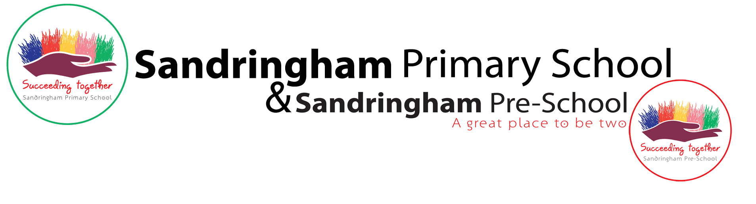

# Job Description: Nursery Nurse

### Job Title: Nursery Nurse Scale: Level 3

### Job Purpose:

A Level 3 Nursery Nurse will encourage pupils to participate in the social and academic life of Sandringham EYFS, help enable all children to become more independent learners, and help to raise their standards of achievement. The Key worker/ Nursery Nurse will act as a key worker for our Sandringham Central provision of children ensuring they have equal opportunities to learn and develop.

### Duties:

#### Support for the Pupil

* To meet the personal needs of children whilst encouraging their independence;
* To support children with social and emotional educational needs through the delivery of specific learning programmes and contributing to setting and reviewing targets;
* Organise liaison on behalf of pupils with outside agencies, e.g. Speech Therapists and Educational Psychologists;
* To encourage children to interact and work cooperatively ensuring all children are engaged in learning;
* To update children’s data;
* Establish & develop close, effective working partnerships with parents/carers to ensure the wellbeing of all children.

#### Support for Nursery Manager/Reception Leader

* To work closely with EYFS leaders to assist in the delivery of all areas of the curriculum;
* Raise the awareness of EYFS leaders to the strengths and difficulties of individual pupils;
* Take responsibility for collating information on each individual child within the Key worker group through observations, monitoring, assessing and recording;
* Work with colleagues to plan, prepare and set out an attractive, stimulating range of equipment, activities & displays, indoors and out;
* Work within the team to accurately plan, implement and evaluate all activities/resources to provide an appropriate curriculum.
* Assist in the monitoring of Individual Education Plans (IEPs) for children who need learning support;
* Raise the awareness of EYFS leaders to any pressures on pupils which may result in behaviour problems;
* Provide support for colleagues in developing effective approaches to managing behaviour;
* Assist in setting behaviour targets;
* Assist in reviewing Education Health and Care Plans.

#### Support for the School

* To assist with the general pastoral care of children, including helping children who are unwell, distressed or unsettled.
* Review and develop their own professional practice;
* To comply with policies and procedures relating to child protection, health, safety and security, inclusion and data protection, reporting all concerns to the appropriate named person.

**Support for the Curriculum**

* To assist in the development of the three prime areas; personal, social and emotional development, communication and language and physical development;
* To help, adapt and plan the development of resources necessary to lead learning activities, taking into account children’s interests, language and cultural backgrounds.

| IMPORTANT INFORMATION FOR APPLICANTS |
| --- |
| The criteria listed in this Person Specification are all essential to the job. Where the Method of Assessment is stated to be the Application Form, your application needs to demonstrate clearly and concisely how you meet each of the criteria, even if other methods of assessment are also shown. If you do not address these criteria fully, or if we do not consider that you meet them, you will not be shortlisted. Please give specific examples wherever possible. |

| CRITERIA | METHOD OF ASSESSMENT |
| --- | --- |
| EQUALITY AND DIVERSITY | |
| The London Borough of Newham has a strong commitment to achieving equality of opportunity in both services to the community and the employment of people and expects all employees to understand and promote its policies in their work. Sandringham Primary School is committed to promoting a diverse and inclusive community and strongly encourages people of all different backgrounds to apply to our inclusive and dynamic school. We aim to be a place where we can all be ourselves and succeed on merit.  **Safeguarding Statement**  Our organisation is committed to safeguarding and promoting the welfare of children, young people and vulnerable adults and expects all staff and post holders to share this commitment. We follow the safer recruitment processes and the most up to date Keeping Children Safe in Education DFE guidance which involves us carrying online candidate searches, requesting references, DBS and barring checks. | |
| KNOWLEDGE:  Knowledge of child learning processes and development stages.    Awareness of the Equal Opportunities Policy and its implications for Educational practice. | Application Form/ Interview /Test    Application Form/ Interview /Test |

| QUALIFICATIONS:    Qualifications NNEB – Diploma in Nursery Nursing    OR    National Vocational Qualification in Child Care and Education Level III    OR    BTEC – Diploma in Nursery Nursing (2yr FT)    OR    BTEC – Certificate in Nursery Nursing (2yr PT) | Certificate |
| --- | --- |
| EXPERIENCE:  Experience of working with children, in either a voluntary or paid capacity, in an educational or similar setting. | Application Form/ Interview |
| SKILLS AND ABILITIES:  Ability to recognise children’s needs and problems, to be able to help in the development of literacy skills for under 5’s.    Ability to communicate with, and relate well to children, particularly under 5’s.    Ability to organise classroom activities/to work as part of a team | Interview      Interview      Interview |
| PERSONAL STYLE AND BEHAVIOUR: | Application Form/ Interview/ Certificate/Test (delete as applicable) |
| OTHER SPECIAL REQUIREMENTS:  Please state on your application form qualification held with details of relevant work placements. The successful candidate will also be expected to provide a copy of their certificate before confirmation of appointment. | Application Form |