Job Title:  Early Years Practitioner | 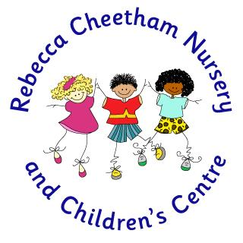
Grading: Scale 3 | Required for September 2024

EQUALITY AND DIVERSITY

We are committed to and champion equality and diversity in all aspects of employment with the London Borough of Newham. All employees are expected to understand and promote equality and diversity in the course of their work.

POSTHOLDER REPORTS TO: THE LEADERSHIP TEAM

- PURPOSE OF THE JOB

- To promote learning and teaching in the EYFS.
- To effectively implement the EYFS curriculum, using an inclusive play based approach within which children lead their own learning.
- To monitor, maintain and develop the resources, creating a positive learning environment.
- To share responsibility for the well-being and success of all children and community members by maintaining high expectations and effectively promoting professional duties.
- To deliver the school’s strong commitment to equality of opportunity.
- To carry out such other associated duties as are reasonably assigned by the Head Teacher

- RESPONSIBILITIES

- class and classroom management enabling all children to reach their full potential
- maintaining high standards of learning and behaviour
- reviewing pupil progress and setting appropriate targets as a key person
- delivery of the Early Years Foundation Stage Curriculum and school policies, through planning and teaching, assessment of pupil progress through monitoring and on-going record keeping
- establishing positive professional relationships with children, parents, and families, keeping them informed of childrens’ progress. Promoting a shared school / home approach
- leading and creating a positive team ethos with staff. Collaborate and work with colleagues and other relevant professionals within and beyond the school
- continuing to pursue professional development and participating in the school’s monitoring cycle and performance management review process
- promoting the health, safety and well-being of children in line with safeguarding procedures
- upholding the ethos and aims of the school and children’s centre

Person Specification – Early Years Practitioner

Qualifications | - Full and relevant Early Years Qualification (including NNEB, B/TEC CC, CSS (Childcare and NVQ Childcare and Education Level 3)
Experience | - Successful experience within the Early Years including Nursery provision  - Pro active team member
Knowledge and Understanding | - Clear understanding of the Early Years Foundation Stage curriculum
Curriculum, Teaching and Learning | - Ability to teach creatively and effectively to meet the needs of all learners  - Ability to use assessment effectively to inform future learning and set appropriate targets  - Ability to critically self evaluate and review
Leadership and Management | - An understanding of monitoring and evaluation strategies  - Ability to:  - be an excellent role model  - set high standards  - model good professional relationships
Resources | - Ability to use resources effectively to create a positive learning environment  - To monitor the use of resources
Parents and Community | - Commitment to parent and community partnerships
Equal Opportunities | - Commitment and knowledge of inclusive education
Interpersonal skills | - Enthusiasm, commitment and personality  - A good sense of humour  - Good communication and interpersonal skills  - An excellent record of attendance and punctuality

