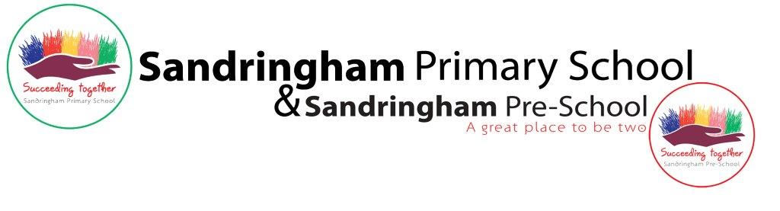**Job Description:Apprentice Nursery Nurse/ Teaching Assistant**

**Rolling recruitment process**

Short listing and interviews will take place through an ongoing process with the first round of interviews likely to be mid June. We recommend early applications.

Successful applications will be contacted and called for an interview.

### **Job Title: Apprentice Nursery Nurse/ Teaching Assistant**

Sandringham Primary School is looking for an enthusiastic, caring individual to join their team of professionals in caring for their provision of children within our dynamic learning environment. The position will give the opportunity to work and learn from experienced and skilled nursery nurses/ teaching assistants and early years teachers in an exciting, forward thinking setting and provide the opportunity to complete qualifications as part of the National Apprentice Scheme. As a school we have had several successful apprentices who have gone on to quality and become excellent practitioners.

Being part of the main school calendar, initially the hours will be 8:00am - 4:00pm term time only working a 40 hour week. A pre-agreed amount of study time will be allocated within this time.

### **Job Purpose:**

An Apprentice will encourage pupils to participate in the social and academic life of the school, help enable them all to become more independent learners, and help to raise their standards of achievement. The Apprentice will be assigned a mentor to support them to help them develop the skills needed to be a successful practitioner and follow our approach as a school. Apprentices might work with children with special needs, early years or the main primary school. The focus of the apprenticeship could be on completing a Teaching Assistant or Nursery Nurse qualification.

**Safeguarding Statement**

Our organisation is committed to safeguarding and promoting the welfare of children, young people and vulnerable adults and expects all staff and post holders to share this commitment. We follow the safer recruitment processes and the most up to date Keeping Children Safe in Education DFE guidance which involves us carrying online candidate searches, requesting references, DBS and barring checks.

**Equality Statement**

The London Borough of Newham has a strong commitment to achieving equality of opportunity in both services to the community and the employment of people and expects all employees to understand and promote its policies in their work. Sandringham Primary School is committed to promoting a diverse and inclusive community and strongly encourages people of all different backgrounds to apply to our inclusive and dynamic school. We aim to be a place where we can all be ourselves and succeed on merit.

### **Qualifications/ Additional Requirements**

* GCSE in English Language and Maths grade C or above
* DBS and barring by association checks completed (these can be sort following interview)
* Meet the National Requirements of the Newham College Apprentice Scheme
* Hold at least an NVQ2 or be working towards an appropriate qualification in child care Need to check I have phrased this correctly and the right qualification
* Hold at least an NVQ2 or be working towards an appropriate qualification in child care
* Work well as part of a team
* Have patience and a good sense of humour
* Genuinely enjoy children's company
* Basic ICT skills
* Be professionally presented, articulate and committed to upholding the school's values and reputation
* A commitment to and an understanding of equal opportunities and the ability to assist in the implementation of Sandringham School policies
* A commitment to safeguarding children and the health and safety of everyone involved in the day to day activities

### **Duties**

#### **Support for the Pupil**

* To meet the personal needs of children whilst encouraging their independence;
* To be a quality play partner/ learning coach;
* To work within and adhere to the school safeguarding policy at all times;
* To support children with social and emotional educational needs through the delivery of Specific learning programmes and contributing to setting and reviewing targets;
* Organise liaison on behalf of pupils with outside agencies, e.g. Speech Therapists and Educational Psychologists;
* To encourage children to interact and work cooperatively ensuring all children are engaged in learning;
* To update children’s data;
* Establish & develop close, effective, working partnerships with parents/carers to ensure the wellbeing of all children.

#### **Support for Nursery Nurses/ Teacher Assistants**

* To work closely with Nursery Nurses/ Teacher Assistants/ Class teachers/ SEND team to assist in the delivery of all areas of the curriculum;
* Raise the awareness of the Nursery Nurses/ Teacher Assistants/ Class teachers/ SEND team to the strengths and difficulties of individual pupils;
* Collating information on each individual child through observations, monitoring, assessing and recording;
* Assist their team to plan, prepare and set out an attractive, stimulating range of equipment, activities & displays, indoors and out;
* Work within the team to accurately plan, implement and evaluate all activities/resources to provide an appropriate curriculum.
* Assist in the monitoring of Individual Education Plans (IEPs) for children who need learning support;
* Assist in setting behaviour targets;
* Assist in reviewing Education Health and Care Plans.

#### **Support for the School**

* To assist with the general pastoral care of children, including helping children who are unwell, distressed or unsettled.
* Review and develop their own professional practice;
* To comply with policies and procedures relating to child protection, health, safety and security, inclusion and data protection, reporting all concerns to the appropriate named person.

**Support for the Curriculum**

* To assist in the development of the three prime areas; personal, social and emotional development, communication and language and physical development;
* To help, adapt and plan the development of resources necessary to lead learning activities, taking into account children’s interests, language and cultural backgrounds.

May 2024