ST. MICHAEL’S R.C PRIMARY SCHOOL

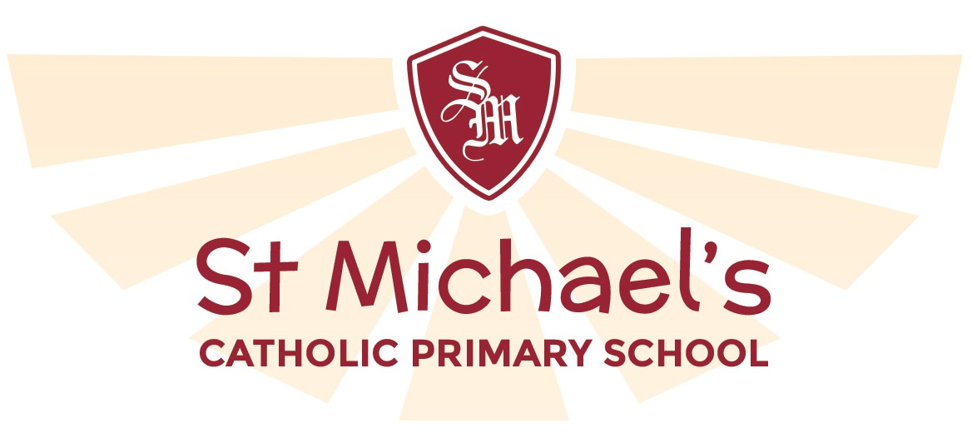 PERSON SPECIFICATION

School Group: Two
Post Title: Teacher
Grade: MPS

You should demonstrate on your application form that you meet the following criteria.

Specific Requirement: Candidates must actively support the Catholic ethos and our Mission Statement of St. Michael’s

AREA | Requirement | Criteria Grade
QUALIFICATIONS  AND EXPERIENCE | Qualifications
QUALIFICATIONS  AND EXPERIENCE | a) DfES Qualified teacher status. | Essential
QUALIFICATIONS  AND EXPERIENCE | b). Catholic Certificate of Religious Studies or to be gained within 2 years | Desirable
QUALIFICATIONS  AND EXPERIENCE | c). Evidence of undertaking relevant in-service training in recent years. | If applicable
QUALIFICATIONS  AND EXPERIENCE | Experience
QUALIFICATIONS  AND EXPERIENCE | - Evidence of successful primary classroom practice. | Essential
QUALIFICATIONS  AND EXPERIENCE | - Experience of working in a multicultural school in partnership with parents. | If applicable
QUALIFICATIONS  AND EXPERIENCE | - Evidence of subject specialism development | If applicable
DISPOSITION | - Personal Qualities
DISPOSITION | a) Good motivational Skills | Essential
DISPOSITION | b) Ability to work as part of a Team | Essential
DISPOSITION | c) Willingness to share experience | Essential
DISPOSITION | d) Respect for the views of parents and a commitment to the importance of parents in the learning process. | Essential
DISPOSITION | e) Commitment to the Catholic ethos of the school. | Essential
 | - Commitment to Excellence  Evidence of a commitment to excellence and the maximising of academic and personal achievement for all pupils. | Essential
SKILLS
KNOWLEDGE AND ABILITIES

SKILLS  KNOWLEDGE AND ABILITIES | 5. Educational and curriculum Matters  a) Understanding of Curriculum. Development in Religion Education | Desirable
SKILLS  KNOWLEDGE AND ABILITIES | - Evidence of a good general knowledge and understanding of the National Curriculum. | Essential
SKILLS  KNOWLEDGE AND ABILITIES | - An understanding of the different ways in which children learn and the appropriateness of a variety of teaching styles to meet the individual needs of each child. | Essential
SKILLS  KNOWLEDGE AND ABILITIES | - Evidence of the ability to organise successfully the curriculum for a class of pupils of mixed abilities, aptitudes and educational needs through planning, preparation, monitoring and assessment. | Essential
SKILLS  KNOWLEDGE AND ABILITIES | - Evidence of a clear understanding of the new SEN Code of Practice. | Desirable
SKILLS  KNOWLEDGE AND ABILITIES | - Evidence of good organisational skills to create and maintain a stimulating and attractive learning environment. | Essential
SKILLS  KNOWLEDGE AND ABILITIES | - Evidence of good ICT skills showing ability to use a range of packages to teach, communicate information to various audiences. | Essential
SKILLS  KNOWLEDGE AND ABILITIES | - Evidence of Performance Management experience, effective quality management and the promotion of professional development required. | Depending on experience
SKILLS  KNOWLEDGE AND ABILITIES | - Record Keeping  Evidence of knowledge and understanding of effective record, keeping, and its use to promote the educational and personal development of all children within the school. | Essential
SKILLS  KNOWLEDGE AND ABILITIES | - Behaviour and Ethos  Evidence of the ability to maintain effective classroom discipline in a positive context and to promote well ordered and self disciplined behaviour throughout the school. | Essential
SKILLS  KNOWLEDGE AND ABILITIES | - Interpersonal Skills.  Evidence of good interpersonal skills and the ability to work as a member of a team and develop and maintain good relationships with all members of the school community. To work co-operatively with the staff of the Local Education Authority and relevant agencies as required. | Essential
SKILLS  KNOWLEDGE AND ABILITIES | Communications  Evidence of the ability to communicate effectively using a range of methods, as appropriate, to a range of audiences | Essential
SKILLS  KNOWLEDGE AND ABILITIES | - Health and Safety  An understanding of the responsibility of the classteacher with regard to the health and safety of pupils in their care.  Ability to undertake risk assessment to ensure safety of pupils and staff | Essential
SKILLS  KNOWLEDGE AND ABILITIES | - Equal Opportunities  Evidence of a commitment to an equal opportunities policy both in service delivery and employment, and an understanding of its effective operation within a school. An ability to ensure that each child's identity is respected, maintained and enhanced and that stereotypes are challenged in a sensitive way | Essential

