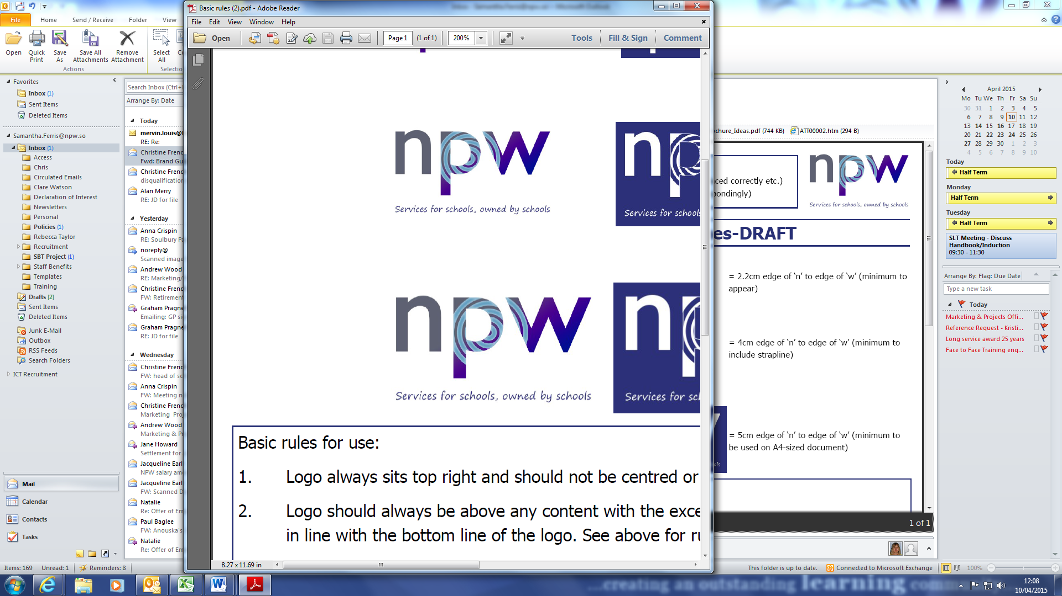

Job Description

Job Title: Data Protection Officer | Service Area: Cross Functional
Grade: PO5 | Job Number:
Date last updated: July 2023 | Date of last evaluation: July 2023

Our purpose is to advance children and young people’s education and improve the lives of all members of the community. We provide solutions that free up leadership time allowing schools to concentrate on teaching and learning through a one-stop shop for school services. Providing flexible and bespoke support for schools' Education ICT, HR, Governor Services and School Management.

All NPW employees are expected to deliver high performance, be focussed on continuous improvement and development, work flexibly, and be customer focussed.

Job Context

- The postholder reports to the Director of Strategy for internal compliance duties and duties related to commercial services offered externally
- The postholder has no budget responsibility
- The postholder may be required to work evenings, weekends and occasional school holidays, to meet the requirements of the service.

Key Measures

To drive compliance with the EU General Data Protection Regulation (GDPR)/National Data Protection Laws and other related legislation ensuring ongoing compliance of all core activities for NPW.

To develop and deliver commercial services offering for Data and Compliance Services maximising customer satisfaction, income and enhancing the reputation of NPW.

Key Accountabilities

Key tasks and accountabilities are intended to be a guide to the range and level of work expected of the post holder. This is not an exhaustive list of all tasks that may fall to the post holder and employees will be expected to carry out such other reasonable duties which may be required from time to time.

Commercial Focus

- To evaluate data compliance and assurance service offerings in line with customer needs, market trends and identify service development areas
- To generate leads and service take up by promoting current and future offerings
- To obtain customer feedback and continuously improve service through self-development and quality of delivery
- To look for future trends and analyse potential opportunities to enhance service offer
- To deliver services to clients related to data compliance and assurance
- To assist in product development where applicable

Leadership and Management

- To lead data compliance activities and assurance within NPW ensuring risks are managed and controlled in relation to data security
- To ensure that documentation to demonstrate compliance with data security such as policies and procedures are kept up to date including but not limited to Subject Access Requests (SARs) and Breach Reporting
- To plan and schedule data processing audits regularly, monitoring core activities to ensure they comply with the relevant data protection regulations

- To ensure guidance and awareness is in place for staff on their obligation to adhere to relevant data protection regulations when dealing with personal data

- To Advise and inform on data protection impact assessments (DPIA), including monitoring performance of DPIAs against the requirements of relevant data protection regulations

- To be the point of contact for the Information Commissioners Office (ICO) on issues relating to processing of personal data, and to consult with the ICO, where necessary, on any other personal data matters

- Regularly monitor compliance with relevant data protection regulation by conducting audits of processes relating to personal data, and report to the Executive Leadership Team and where applicable to the Board of Directors

- To monitor compliance with the Data Protection Policy throughout NPW and to develop/advise on procedures for effective security
- To advise senior management on the allocation of information security responsibilities
- To contribute to the business continuity and disaster recovery planning process
- Work with information asset owners to ascertain the extent to which personal data is collected, held and/or used in NPW, and that it is properly controlled and safeguarded from loss of confidentiality, integrity or availability from any cause
- To ensure privacy notices are compliant and transparent from a controller and a processor perspective for third party suppliers
- To promote a ‘culture of compliance’ within NPW and to external clients

General

- To maintain an up-to-date knowledge of relevant data protection laws and any dependencies
- To promote a collaborative and creative environment
- To support the development and implementation of service offerings
- To work as part of the wider team providing services to clients
- To undertake other duties as may reasonably be required from time to time

Person Specification

SAFEGUARDING
We are committed to safeguarding and promoting the welfare of children and young people. All employees are expected to share this commitment by ensuring that safeguarding procedures are followed in the course of their work.

EQUALITY AND DIVERSITY
We are committed to and champion equality and diversity in all aspects of employment with NPW. All employees are expected to understand and promote our Equality and Diversity Policy in the course of their work.

Key criteria

Skills and Abilities

- Ability to synthesise legislation and frame for practical implementation
- Ability to apply creativity to a subject matter to enable client engagement
- Ability to plan and deliver effective training programmes to a wide variety of clients
- Strong Communication/interpersonal skills. Ability to communicate effectively with a range of professional staff and outside agencies, at a senior level. Able to liaise and negotiate proficiently
- Strong organisational skills and a professional and pro-active approach to work. An ability to document work, manage time effectively and prioritise workloads appropriately, including when working under pressure
- An ability to work collaboratively as part of a wider team and communicate effectively with colleagues and senior managers
- High level of numeracy and literacy skills, including the ability to read and assimilate a wide range of information and produce and present detailed guidance/reports clearly and concisely

Experience
- Experience in risk and compliance
- Experience in delivering training to a varied audience
- Experience in Data Protection within a lead role
- Experience in Project Management and Delivery

Qualifications
- Formal Data Protection Qualification and/or Risk and Compliance Qualification

Knowledge
- Extensive knowledge of Data Protection Regulations and other areas such as the Freedom of Information Act
- Knowledge of schools’ operations, decision-making processes and recent developments in Education.
- Extensive Knowledge of risk and compliance practices
- Knowledge of International Standards and Frameworks
- Extensive knowledge of training delivery
Personal Attributes and Other Requirements
Commitment to and understanding of:
- The implementation of Equal Opportunities in all aspects of service.

Core Competencies

The framework has various levels within each competency to make it relevant for all grade of employee. The table below details the competencies and levels that are required for this post. Please refer to the NPW Competency Framework, for the full criteria for each competency and level.

Competency | Level | Description
Customer Care and Service Delivery  Understanding the needs of the customer and prioritising to ensure customer satisfaction. | 3 | - Uses internal and external measures to identify shortfalls in customer service and quality and then acts on the information  - Develops innovative practices and services that ensure a customer driven service  - Tries to match business strategies to current and emerging customer needs  - Anticipates potential problems and takes pre-emptive action
Collaborative Working  Working with and understanding the roles of internal staff / service and external agencies. | 3 | - Tackles conflict within the team, trying to balance team and individual needs  - Proactively develops relationships with customers, colleagues and external organisations, ensuring frameworks are in place to achieve outcomes  - Shares resources for the benefit of the wider organisation  - Encourages teams during difficult or challenging times  - Uses ideas from team members to improve ways of working
Seeking Excellence  Identifying potential for improvement in our own service area and NPW as an organisation. | 3 | - Seeks ideas and inspiration from sources inside and outside of the organisation  - Evaluates own and other performance, giving and implementing feedback to improve  - Encourages others to look at issues from varying perspectives  - Identifies, implements and measures efficiency
Communication and Relationships  Ability to work effectively with other people via difference methods, both inside and outside of NPW, building and promoting effective working relationships. | 2 | - Shows understanding of others viewpoints and ideas  - Enhances communication through the use of visual aids and technology when appropriate  - Shares information and communicates effectively with others  - Provides active support to enable individuals to communicate and participate in communication  - Successfully persuades people of the benefits of a particular approach / idea
Achieving Results  How well we reach our individual objectives and deadlines, dealing with obstacles to ensure completion. | 3 | - Takes personal responsibility for the performance of their team  - Makes a significant contribution to the wider objectives of the business  - Achieves results through effective management of self and others  - Identifies and manages risk  - Deals with poor performance of others before it becomes critical  - Sets demanding but achievable objectives

Specific Competencies

Competency | Level | Description
Forward Planning  Having a clear plan for achieving objectives and monitoring progress | 2 | - Has contingency plans and fall-back options in place  - Regularly checks on progress against objectives and acts on findings  - Communicates plans to appropriate staff / stakeholders  - Develops/monitors and adjusts plan as necessary  - Plans and prioritises workload to ensure deadlines are met during busy periods
Financial and Resource Management  Managing the resources or budget available, ensuring that we keep within agreed limits and use this to the best effect. | 1 | - Aware of decisions that they make that have a financial impact, for example, placing an order  - Accurately codes expenditure and income  - Follows procedures that are designed to meet financial management requirements
Business Awareness  Understanding the direction and strategic plan for our service area and NPW as an organisation. | 2 | - Understands the main services provided by all departments within the organisation  - Understands all roles within their service area and can explain these clearly  - Involves other business areas when taking actions or decisions that need their support or may affect them  - Keeps up to date with key services provided by own team and the wider organisation
Leadership and Development  The ability to lead and inspire others, helping them to develop and hone their skills. | 3 | - Encourages sharing of skills within and across teams  - Inspires, encourages and supports others  - Assess and plans to meet organisational skill and capability gaps  - Inspires commitment and a shared sense of purpose across the team / service  - Promotes continuous improvement and value for money in all activities

