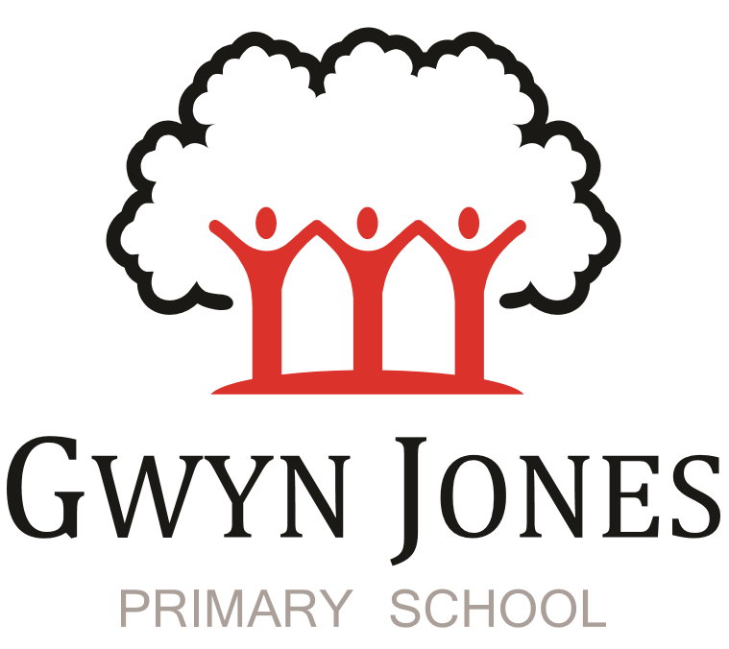



**Recruitment Pack**

|  |
| --- |
| **Early Years After School Club Play Worker**  Permanent Contract- Term Time Only (45.05 weeks)  Grade: Scale 2  Range: 3-4 (£8644.51 – £8787.08 pro rata)  15 Hours per week - 3pm-6pm Monday to Friday |

 

Dear Applicant,

Thank you for your interest in this exciting opportunity to join Gwyn Jones Primary School as a member of team in the role of Early Years After School Club Play Worker. The successful candidate will organise activities, ensure snacks and refreshments are provided to children and children are supervised at all times.

We are a two-form entry, culturally diverse school based in East London and we are very proud of our school. Visitors comment on the warmth of the school and the friendliness of both staff and pupils alike. Our dedicated staff team are incredibly hard working and are committed to creating a happy, secure and stimulating environment in which every child can achieve their potential and develop a life-long love of learning.

At Gwyn Jones Primary School we are a Rights Respecting School and we actively teach our children about the rights of the child. The Rights Respecting ethos permeates all parts of school life and into our school motto “Inspired and Empowered”. This motto epitomises the staff’s genuine commitment to provide a rich, creative and challenging curriculum which inspires children’s curiosity and empowers our pupils to have a voice and be knowledgeable, active global citizens. We strive to ensure that every child thrives academically whilst benefiting from excellent pastoral care that nurtures and develops emotional wellbeing.

I hope this application pack and the information available generally on our website and on social media will give you a flavour of our School. I would be delighted to show you around our friendly and caring school. To arrange a visit please contact the school office on 02085567904 or email: [HR@gwynjones.waltham.sch.uk](mailto:HR@gwynjones.waltham.sch.uk)

I look forward to meeting with you

**Sian Boutalbi**

**Headteacher**

 

Dear Applicant,

Thank you for your interest in the position of Early Years After School Club Play Worker at Gwyn Jones Primary School.

Gwyn Jones is a successful and very popular school within the local area. We are fortunate in having an engaged and culturally diverse community, a hardworking and talented staff team and amazing pupils.

As Governors, we work alongside the Head and her dedicated team in our common belief in the fundamental importance of Primary Education as the foundation for developing a lifelong love of learning in our children. Our Governing Board is keen to develop its skills and knowledge of the school and its community and supports the drive within school for continuous improvement within a nurturing and supportive environment.

Our curriculum is rich, diverse and challenging and aims to provide a range of exciting and meaningful experiences which foster confidence and provide aspirations. Staff plan for children to be academically challenged, creatively inspired and supported in their personal development.

Gwyn Jones maintains strong links with other local schools within Waltham Forest. As a member of our staff team you would receive ongoing support and development in your role.

If the thought of this role in our school excites you, we look forward to receiving your application.

**Liz Jackson**

**Chair of Governors**

**Vision and Values**



At Gwyn Jones, we are committed to ensuring that every member of our school community is **inspired and empowered** each day.

We aim to inspire and empower our children by:

* Providing excellent teaching which nurtures our children’s innate curiosity, allowing them opportunities to take risks and to think for themselves.
* Supporting our children to have responsibility for their own learning; to have their own opinions and the skills to articulate them.
* Allowing all children access to a rich and broad curriculum which fully prepares them to be active, global citizens.
* Ensuring all children participate in a variety of trips and visitors in their local and wider community.
* Acting as role models who respect others and enjoy the rich diversity of our school family.
* Insisting that every child is known well, safe and nurtured to achieve their personal best.

We aim to inspire and empower our staff by:

* Providing a wide range of relevant and innovative professional learning in school which focuses on collaboration and sharing good practice, including lesson study, planning support, team teacher and action research.
* Forging strong links with external agencies to deliver professional development - teaching schools, higher education institutes etc.
* Giving developmental feedback with clear and specific actions for staff and leaders.
* Establishing coaching and mentoring relationships which encourage reflection.
* Identifying and nurturing leadership talent.

**Rights Respecting School**  

### **What is UNICEF's Rights Respecting Schools?**

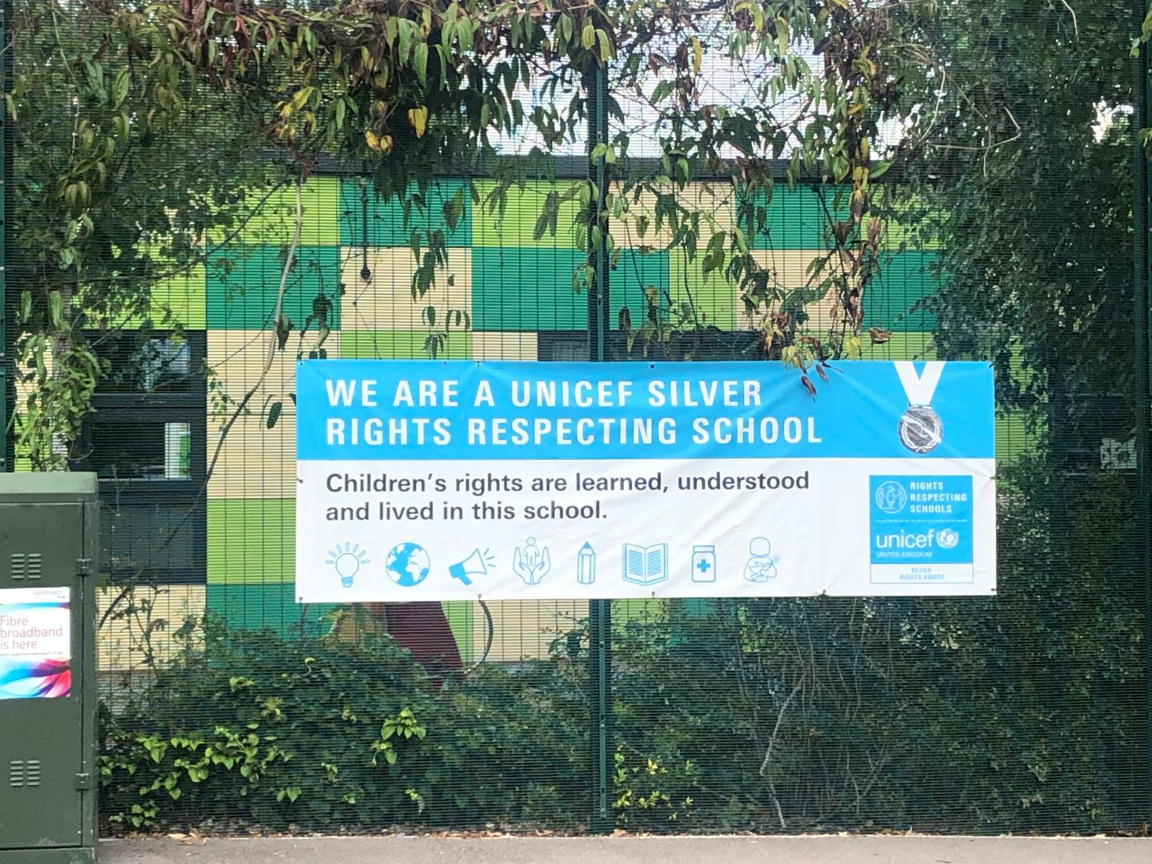

We are committed to placing the UN Convention on the Rights of the Child at the heart of our core values and ethos; believing children’s participation is integral to all aspects of school life. This results in empowered and self-confident children who can advocate for the rights of children everywhere.

This ethos further fosters a sense of community, respect and responsibility. It encourages the children to be active and informed citizens, who look to develop a positive future for all; campaigning and raising awareness.

The children’s experiences at Gwyn Jones Primary ensure the children know that they have the Rights of the Child and that these rights are inalienable. They also understand responsibilities they have as members of our local and global society.

**How to Apply**

Should you wish to apply for the post, please complete an application form and include a personal statement, which clearly demonstrates your suitability for this role. Please send your completed applications to [HR@gwynjones.waltham.sch.uk](mailto:HR@gwynjones.waltham.sch.uk)

**Closing Date**

Please ensure your application arrives by noon on the closing date of Monday 25th September 2023.

**Shortlisting**

Shortlisting will take place on Monday 25th September 2023 if you have not heard from us by Wednesday 27th September 2023 please assume that unfortunately, on this occasion, your application has not been successful.

**Interview**

Interviews will take place on Friday 29th September 2023.

**Safeguarding**

Applicants called for interview are kindly requested to contact their referees so that references are received ahead of the interview dates.

Gwyn Jones Primary School is committed to safeguarding and promoting the welfare of children and young people and expects all staff and volunteers to share this commitment. The school follows safer recruitment practices and the successful applicants will be required to apply for an Enhanced Disclosure and Barring Service check. Candidates should be aware that the school will conduct an online search prior to appointment. A copy of our Safeguarding Policy is available to view on our website

**Location**

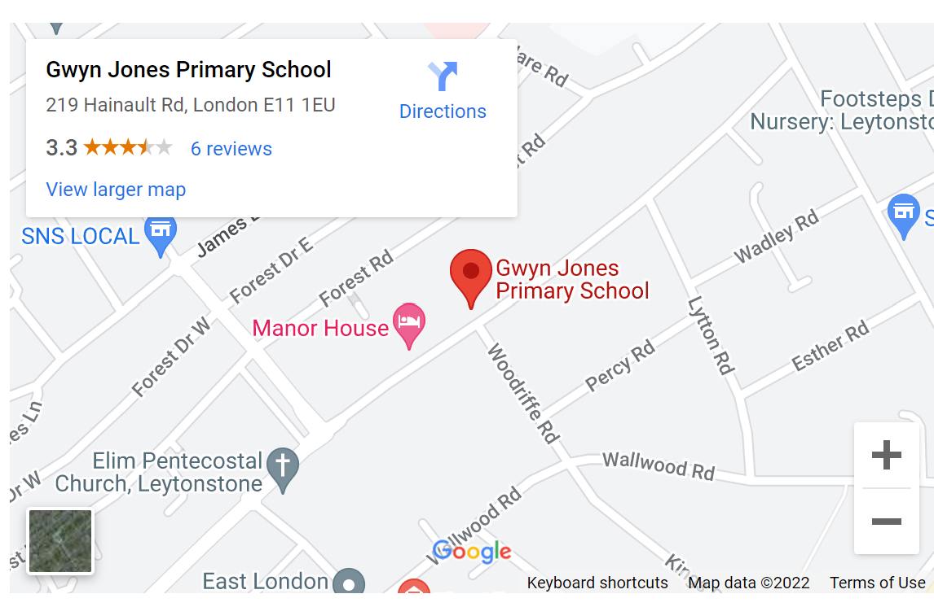

**Class Teacher – Job description**

GWYN JONES PRIMARY SCHOOL

JOB DESCRIPTION

**Job Title: Early Years After School club Play Worker**

**Grade: Scale 2**

**Range: 3-4**

**Responsible to: After School Club/Breakfast Club Leader / Headteacher**

**Responsible for: none**

# Job Purpose

# To assist the Play Leader and work as part of a team in the day to day running of the After School Club providing care and play activities for the children.

# Major Tasks

# **T**o understand and comply with the Council’s Equal Opportunities Policy and acceptance of personal responsibility for its practical application. All employers are required to comply with and promote the policy and to ensure that discrimination is eliminated in the service of the authority.

# To uphold and comply with the statutory provisions of the Health and Safety at Work Act 1974 and any other relevant legislation or Council Policies and Procedures relating to Health and Safety at work.

# To be responsible for the safety and well being of the children at all times and act in accordance with the Health and Safety at Work Act.

# To supervise the children under the direction of the Play Leader and provide suitable sports activities as planned by the Play Leader for the children.

# To ensure that the children attending the club do not leave the school premises unless accompanied by an adult (during the agreed session times).

# Duties and Responsibilities

# Quality childcare:

# To attain, and continuously deliver, Gwyn Jones Primary School’s standards of childcare within the framework laid down by the school’s handbook and by After School Club Leader

# Promptly reporting anything of an unusual or serious nature to the After School Club Leader or DSL.

# Applying professional standards of care at all times with due regard for the safety, physical and emotional needs of the children, including an awareness of child protection.

# Creating a welcoming and happy environment for all by helping to ensure that club rules are implemented and adequate behaviour maintained.

# Helping to ensure that children are provided with a variety of nutritious snacks with due regard for food safety and hygiene and in line with the DfES Food Standards.

# Premises and equipment care:

# By ensuring that:

# The premises of the club and the club’s equipment are adequately cared for.

# The facilities used are left in a clean and tidy condition.

# Any damage is reported promptly to the After school Club Leader.

# Club equipment is adequately maintained and cared for and to take part in a regular programme of cleaning and tidying equipment and storage areas.

Programme:   
To ensure that the play activities in the club are of an educational and enjoyable nature.

# By working as a team to provide a variety of creative and appropriate play activities, by planning together with other staff varied weekly and term activity programmes that are in line with EYFS curriculum

# By working directly with the children during each session and ensure that planned activities are implemented and adequately supervised.

Health and Safety:

# To ensure that Health and Safety regulations are adhered to.

# Working in such a way that high standards of health and safety are maintained and to take part in half-term fire drills.

# Dealing with accidents appropriately by ensuring that first aid is administered and accident details recorded and reported in full to the parent/carer.

# Relationships

# The Playworker will be expected to relate to:

# Parents by encouraging parental involvement in the club and promoting positive staff/parent relations through regular communication.

# The school through liaison on a daily basis with school staff, meetings with the head teacher/manager as required and attendance at school events when necessary.

Other requirements:

1. To participate in training and performance management as required.
2. To have an up-to-date Enhanced DBS Disclosure
3. Duties and responsibilities of the post may change over time as requirements and circumstances change. The person in the post may also be required to carry out such other duties consistent with the grade from time to time.

**Play Worker**

**Person Specification**

1. **Experience**
   1. Previous experience of providing care for groups of children of primary school age
   2. Previous experience of providing play activities for groups of children of primary school age
2. **Qualifications**
   1. **NVQ level 3 in Play work (or equivalent eg NCFE CACHE Level 3 Diploma for the Early Years Workforce) (please do not apply if you do not hold a relevant qualification)**
   2. Good numeracy/literacy skills
   3. Current Pediatric First Aid certificate or willingness to train within 6 months of starting in post
   4. Current Food and Hygiene certificate or willingness to train within 6 months of starting in post
   5. Participate in development and training opportunities
3. **Knowledge, Skills and Abilities**
   1. Ability to work as part of a team
   2. Good interpersonal & communication skills
   3. Ability to relate well to children and adults
   4. Ability to work under own initiative
   5. Knowledge of childcare regulations
   6. Reliability