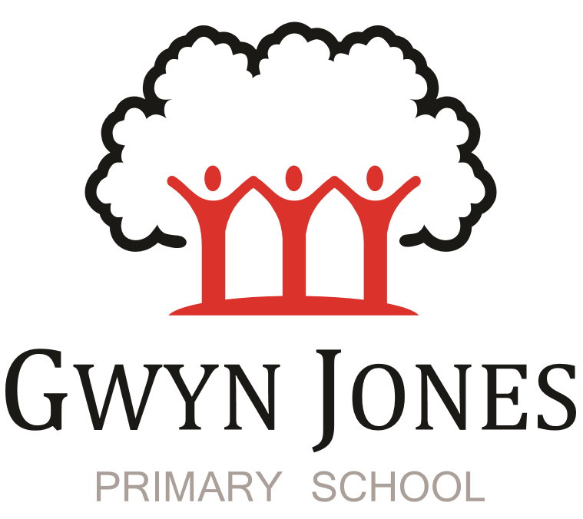



**Recruitment Pack**

|  |
| --- |
| **Early Years Practitioner with EYFS Breakfast club**  **Permanent**  **Scale 4**  **Point: 7-10 (£23,071-£24,322 pro rata salary)**  **(45.05 week term time only including 5 INSET DAYS contract**  **36 hours and 40 mins per week)**  **Hours of work: 7:40am-3:30pm Monday to Friday with 30 mins for lunch**  **October 2023 start** |

 

Dear Applicant,

Thank you for your interest in this exciting opportunity to join Gwyn Jones Primary School as a member of team in the role of Early Years Practitioner and EYFS breakfast club.

We are a two-form entry, culturally diverse school based in East London and we are very proud of our school. Visitors comment on the warmth of the school and the friendliness of both staff and pupils alike. Our dedicated staff team are incredibly hard working and are committed to creating a happy, secure and stimulating environment in which every child can achieve their potential and develop a life-long love of learning.

At Gwyn Jones Primary School we are a Rights Respecting School and we actively teach our children about the rights of the child. The Rights Respecting ethos permeates all parts of school life and into our school motto “Inspired and Empowered”. This motto epitomises the staff’s genuine commitment to provide a rich, creative and challenging curriculum which inspires children’s curiosity and empowers our pupils to have a voice and be knowledgeable, active global citizens. We strive to ensure that every child thrives academically whilst benefiting from excellent pastoral care that nurtures and develops emotional wellbeing.

We are looking for someone who has good communication skills and is flexible in their approach when supporting children and working alongside other colleagues. We know it is important to be positive, inspirational and a real team player. To add to our team, we wish to appoint an excellent Teaching Assistant who will draw upon their experience and expertise in teaching to raise standards for all children including those with SEND. Together, we will drive outstanding learning and teaching that is challenging, interesting and motivational to all pupils building inquiring lifelong learners who care for their world and all that live in it.

I hope this application pack and the information available generally on our website and on social media will give you a flavour of our School. I would be delighted to show you around our friendly and caring school. To arrange a visit please contact the school office on 02085567904 or email: [HR@gwynjones.waltham.sch.uk](mailto:HR@gwynjones.waltham.sch.uk)

I look forward to meeting with you

**Sian Boutalbi**

**Headteacher**

 

Dear Applicant,

Thank you for your interest in the position of Early Years Practitioner and EYFS breakfast club at Gwyn Jones Primary School.

Gwyn Jones is a successful and very popular school within the local area. We are fortunate in having an engaged and culturally diverse community, a hardworking and talented staff team and amazing pupils.

As Governors, we work alongside the Head and her dedicated team in our common belief in the fundamental importance of Primary Education as the foundation for developing a lifelong love of learning in our children. Our Governing Board is keen to develop its skills and knowledge of the school and its community and supports the drive within school for continuous improvement within a nurturing and supportive environment.

Our curriculum is rich, diverse and challenging and aims to provide a range of exciting and meaningful experiences which foster confidence and provide aspirations. Staff plan for children to be academically challenged, creatively inspired and supported in their personal development.

Gwyn Jones maintains strong links with other local schools within Waltham Forest. As a member of our staff team you would receive ongoing support and development in your role.

If the thought of this role in our school excites you, we look forward to receiving your application.

**Liz Jackson**

**Chair of Governors**

**Vision and Values**



At Gwyn Jones, we are committed to ensuring that every member of our school community is **inspired and empowered** each day.

We aim to inspire and empower our children by:

* Providing excellent teaching which nurtures our children’s innate curiosity, allowing them opportunities to take risks and to think for themselves.
* Supporting our children to have responsibility for their own learning; to have their own opinions and the skills to articulate them.
* Allowing all children access to a rich and broad curriculum which fully prepares them to be active, global citizens.
* Ensuring all children participate in a variety of trips and visitors in their local and wider community.
* Acting as role models who respect others and enjoy the rich diversity of our school family.
* Insisting that every child is known well, safe and nurtured to achieve their personal best.

We aim to inspire and empower our staff by:

* Providing a wide range of relevant and innovative professional learning in school which focuses on collaboration and sharing good practice, including lesson study, planning support, team teacher and action research.
* Forging strong links with external agencies to deliver professional development - teaching schools, higher education institutes etc.
* Giving developmental feedback with clear and specific actions for staff and leaders.
* Establishing coaching and mentoring relationships which encourage reflection.
* Identifying and nurturing leadership talent.

**Rights Respecting School**  

### **What is UNICEF's Rights Respecting Schools?**

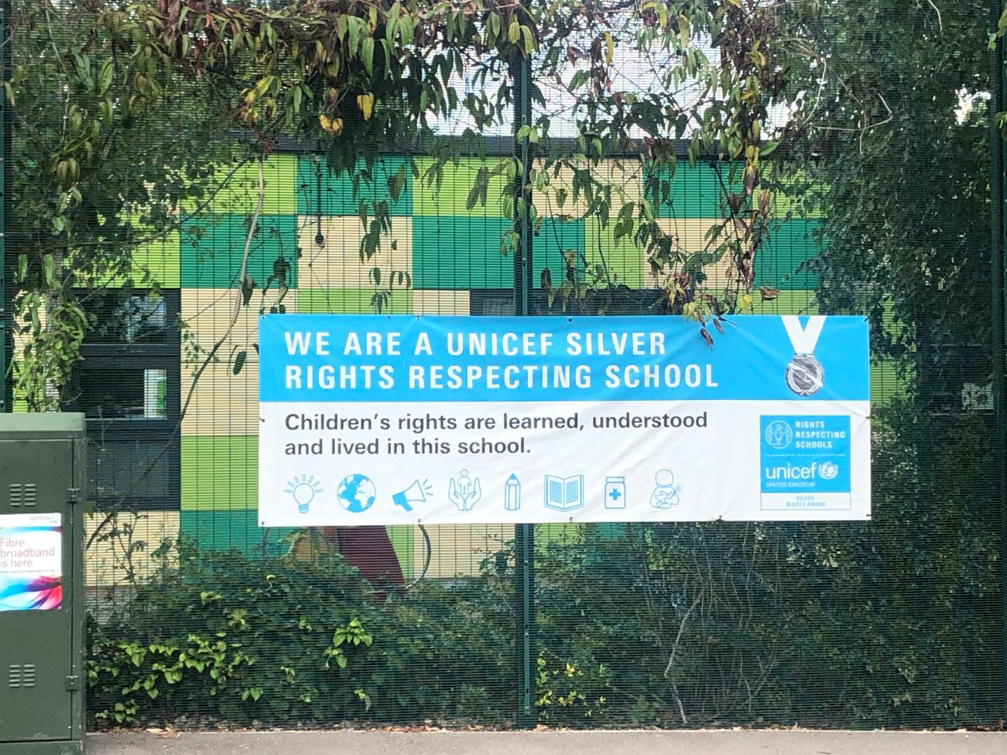

We are committed to placing the UN Convention on the Rights of the Child at the heart of our core values and ethos; believing children’s participation is integral to all aspects of school life. This results in empowered and self-confident children who can advocate for the rights of children everywhere.

This ethos further fosters a sense of community, respect and responsibility. It encourages the children to be active and informed citizens, who look to develop a positive future for all; campaigning and raising awareness.

The children’s experiences at Gwyn Jones Primary ensure the children know that they have the Rights of the Child and that these rights are inalienable. They also understand responsibilities they have as members of our local and global society.

**How to Apply**

Should you wish to apply for the post, please complete an application form and include a personal statement, which clearly demonstrates your suitability for this role. Please send your completed applications to [HR@gwynjones.waltham.sch.uk](mailto:HR@gwynjones.waltham.sch.uk)

**Closing Date**

Please ensure your application arrives by 12 noon on Monday 25th September 2023.

**Shortlisting**

Shortlisting will take place on Monday 25th September 2023 if you have not heard from us by Wednesday 27th September 2023 please assume that unfortunately, on this occasion, your application has not been successful.

**Interview**

Interviews will take place on Monday 2nd October 2023.

Applicants called for interview are kindly requested to contact their referees so that references are received ahead of the interview dates.

Gwyn Jones Primary School is committed to safeguarding and promoting the welfare of children and young people and expects all staff and volunteers to share this commitment. The school follows safer recruitment practices and the successful applicants will be required to apply for an Enhanced Disclosure and Barring Service check. Candidates should be aware that the school will carry out an online search prior to appointment. A copy of our Safeguarding Policy is available to view on our website.

**Location**

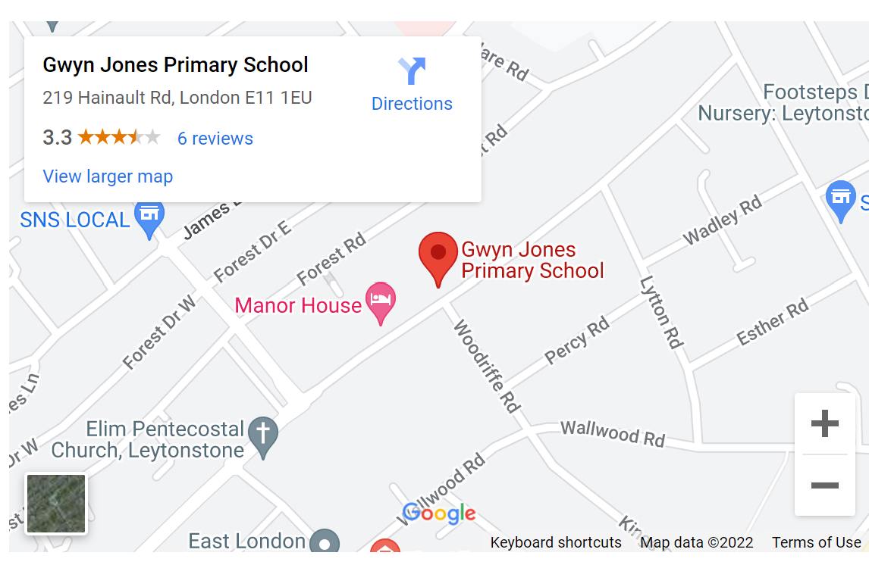

**JOB DESCRIPTION**

**POST: EARLY YEARS PRACTITIONER LEVEL 2 with breakfast club**

**Scale:** 4 (Point 7 – 10)

**Responsible to:** Senior Management / Headteacher

**Experience and Qualifications:**

Nursery Nurses **with EYFS experience and at least one of the following:**

CACHE Level 3 Diploma in Child Care and Education

BTEC National Diploma in Early Years

NVQ Level 3 in Children’s Care, Learning and Development

NNEB certificate

**Job Purpose**

1 To provide service delivery within the requirements of the Early Years Foundation Stage Framework, Every Child Matters and Ofsted Care Standards (Under 3s).

2 To work in partnership and complementary to the Nursery, Reception teacher or lead professional, in order to help meet the aims of the EYFS. The Nursery, Reception Teacher or Lead Professionals are responsible for planning the overall policy and curriculum, and the Early Years Practitioners are given some responsibility for planning part of the programme and are to play a full part in its implementation.

3 To organise and run the EYFS breakfast club provision.

**Major Tasks**, **Duties and Responsibilities**

***1 Support for Children***

1.1 Share responsibility for safety, health and welfare of children at all times

1.2 Ensure all children have access to the full curriculum

1.3 Build positive, nurturing relationships with children

1.4 Guide the development of children’s social behaviour and attitudes

1.5 Frequently supervise children on activities without a teacher present including outdoor activities

1.6 Observing and assessing children’s development and progress

1.7 Keeping accurate records of observation, assessment and development of children

1.8 Acting as a key worker for a group of children

***2 Support for the Teacher***

2.1 Organising materials and equipment for use within the EYFS

2.2 Sharing responsibility for care and maintenance of resources and equipment

2.3 Assisting in preparation and clearing up of activities and encouraging children to help

2.4 Sharing responsibility for display

2.5 Contributing to curriculum development ensuring a stimulating environment

2.6 Taking responsibility for specific activities already planned for

2.7 Taking on other tasks such as Lunch Time supervision when required

2.8 Attend weekly staff and planning meetings

***3 Support for the Parents***

3.1 Encourage parents and carers to be involved in the setting and their children’s learning

3.2 Establish good relationships with parents and carers

3.3 Build up a trusting relationship with parents/carers of key worker group

3.4 Take part in home visits when appropriate and required

***Supporting the Early Years Setting – School or Children’s Centre***

4.1 Support the aims and policies of the setting

4.2 Promote the ethos of the setting at all times

**Other requirements:**

1 To participate in training and performance management as required.

2 To have an up-to-date Enhanced DBS Disclosure.

**This Job Description indicates only the main duties and responsibilities of the post. During the course of duties, you may be asked to carry out other tasks that may be reasonably assigned to you.**

**Safeguarding:**

As a school we are committed to the safeguarding of children and adults. All jobs offers will be subject to an enhanced DBS check and two satisfactory written references.

Please sign, print your name, and date below to indicate your acceptance of this Job Description.

**Signature: …………………………………………………………………………………………………………………..**

**Name: …………………………………………………………………………………………………………………..**

**Date: …………………………………………………………………………………………………………………..**

**Person Specification**

**Level 2 Early Years Practitioner**

|  |  |
| --- | --- |
| **Qualifications** | **Essential or Desirable** |
| NNEB/CACHE Level 3/NVQ Level 3 in Childcare and Education or equivalent | **E** |
| **Experience** | |
| previous experience of working as an Early Years Practitioner | **E** |
| Evidence of anti – discriminatory practice | **E** |
| Some evidence of working with children with special needs | **E** |
| Evidence of working with children from 0-4 | **E** |
| **Knowledge and Understanding** | |
| Early Years Foundation Stage | **E** |
| Child Development | **E** |
| Learning through play | **E** |
| Safeguarding | E |
| Maintaining a safe environment | **E** |
| **Skills and Aptitudes** | |
| Good standard of written work | **E** |
| Good interpersonal and communication skills | **E** |
| Ability to use computers | **D** |
| Ability to work part of a team | **E** |
| Flexibility and enthusiasm for the job | **E** |
| **Other job requirements** |  |
| Willingness to undertake relevant professional development | **E** |