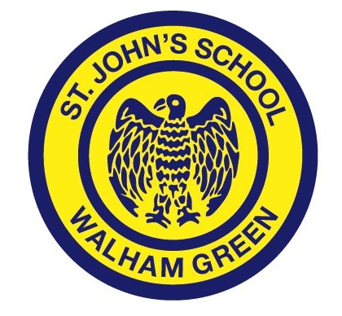
St John’s Walham Green CE Primary School
JOB DESCRIPTION

Job Title: Class Teacher
Responsible to: Phase Leader, Assistant Headteacher, Deputy Headteacher and Headteacher
Aims of the Post:
To provide the highest quality of education, care and preparation for life for all pupils in accordance with the Teacher Standards.
Duties & Responsibilities:
This job description describes in general terms the normal duties which the post-holder will be expected to undertake. However, the duties listed below are in no order of priority and are not exhaustive.

Main Responsibilities as a Class Teacher
- To participate with colleagues in planning materials; schemes of work and lesson plans, which should engage, stimulate and challenge students of all abilities, and should cater for all learning styles.
- To ensure that all lessons are planned, prepared and delivered with clear differentiation to cater for students of all abilities and backgrounds whilst ensuring individual student progress.
- To share in the preparation and delivery of SMSC elements in all lessons across the curriculum.
- To promote a love of learning and children’s intellectual curiosity.
- To maintain an up to date knowledge of all curriculum subjects and utilise a range of teaching methods in line with currently acknowledged best practice.
- Demonstrate an understanding of and take responsibility for promoting high standards of literacy, articulacy and the correct use of Standard English, whatever the teacher’s specialist subject.
- Reflect systematically on the effectiveness of lessons and approaches to teaching.
- To take responsibility for improving teaching through appropriate professional development, responding to advice and feedback from colleagues.
- Set homework and plan other out-of-class activities to consolidate and extend the knowledge and understanding pupils have acquired on a regular basis according to the homework policy.
- To use directed time to actively contribute to the wider life of the school.
- To demonstrate a firm commitment to uphold the aims and ethos of a Church of England School

Management and assessment
- Know and understand how to assess the relevant subject and curriculum areas.
- Use relevant data to monitor progress, set targets and plan subsequent lessons.
- Be accountable for pupils’ attainment, progress and outcomes.
- To keep appropriate records and to complete assessments and profiles of pupils as required.
- To maintain the allocated teaching areas to ensure that they are conducive to a stimulating and exciting learning experience.
- To monitor and control the use and storage of teaching materials, books and equipment.

Communications and Meetings
- Communicate effectively with parents with regard to pupils’ achievements and well-being.
- Develop effective professional relationships with colleagues, knowing how and when to draw on advice and specialist support.
- To participate actively in meetings with colleagues and parents.

4 GENERAL DUTIES
- To adhere to the policies and procedures of St John’s Walham Green CE Primary School
- To carry out ‘the duties of a schoolteacher’ as set out in the Schoolteachers’ Pay and Conditions Document & Teacher Standards.
- To share in the corporate responsibility for the development and well-being of all students.
- To share in the corporate responsibility for innovative use of IT
- Make a positive contribution to the wider life and ethos of the school;
- Demonstrate consistently the positive attitudes, values and behaviour which are based on mutual respect between pupils and staff

5 ETHOS
Promoting the ethos of St John’s, as expressed in the mission and vision statements, is a shared responsibility to which teaching staff make a significant contribution.

