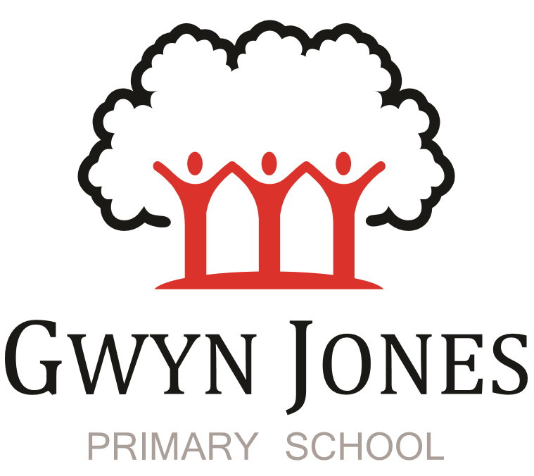



**Recruitment Pack**

|  |
| --- |
| **Level 2 Teaching Assistant and EYFS Tea Time club worker**  **Fixed Term 1year Contract**  **Scale 3 Point: 5-6 (£21340-£21691) Pro Rata salary (£24804-£25212 FTE salary)**  **(44.86 week term time only including 5 INSET DAYS contract**  **40 hours per week)** |

 

Dear Applicant,

Thank you for your interest in this exciting opportunity to join Gwyn Jones Primary School as a member of team in the role of Teaching Assistant and EYFS teatime club worker.

We are a two-form entry, culturally diverse school based in East London and we are very proud of our school. Visitors comment on the warmth of the school and the friendliness of both staff and pupils alike. Our dedicated staff team are incredibly hard working and are committed to creating a happy, secure and stimulating environment in which every child can achieve their potential and develop a life-long love of learning.

At Gwyn Jones Primary School we are a Rights Respecting School and we actively teach our children about the rights of the child. The Rights Respecting ethos permeates all parts of school life and into our school motto “Inspired and Empowered”. This motto epitomises the staff’s genuine commitment to provide a rich, creative and challenging curriculum which inspires children’s curiosity and empowers our pupils to have a voice and be knowledgeable, active global citizens. We strive to ensure that every child thrives academically whilst benefiting from excellent pastoral care that nurtures and develops emotional wellbeing.

We are looking for someone who has good communication skills and is flexible in their approach when supporting children and working alongside other colleagues. We know it is important to be positive, inspirational and a real team player. To add to our team, we wish to appoint an excellent Teaching Assistant who will draw upon their experience and expertise in teaching to raise standards for all children including those with SEND. Together, we will drive outstanding learning and teaching that is challenging, interesting and motivational to all pupils building inquiring lifelong learners who care for their world and all that live in it.

I hope this application pack and the information available generally on our website and on social media will give you a flavour of our School. I would be delighted to show you around our friendly and caring school. To arrange a visit please contact the school office on 02085567904 or email: [HR@gwynjones.waltham.sch.uk](mailto:HR@gwynjones.waltham.sch.uk)

I look forward to meeting with you

**Sian Boutalbi**

**Headteacher**

 

Dear Applicant,

Thank you for your interest in the position of Teaching Assistant and EYFS Teatime club worker at Gwyn Jones Primary School.

Gwyn Jones is a successful and very popular school within the local area. We are fortunate in having an engaged and culturally diverse community, a hardworking and talented staff team and amazing pupils.

As Governors, we work alongside the Head and her dedicated team in our common belief in the fundamental importance of Primary Education as the foundation for developing a lifelong love of learning in our children. Our Governing Board is keen to develop its skills and knowledge of the school and its community and supports the drive within school for continuous improvement within a nurturing and supportive environment.

Our curriculum is rich, diverse and challenging and aims to provide a range of exciting and meaningful experiences which foster confidence and provide aspirations. Staff plan for children to be academically challenged, creatively inspired and supported in their personal development.

Gwyn Jones maintains strong links with other local schools within Waltham Forest. As a member of our staff team you would receive ongoing support and development in your role.

If the thought of this role in our school excites you, we look forward to receiving your application.

**Liz Jackson**

**Chair of Governors**

**Vision and Values**



At Gwyn Jones, we are committed to ensuring that every member of our school community is **inspired and empowered** each day.

We aim to inspire and empower our children by:

* Providing excellent teaching which nurtures our children’s innate curiosity, allowing them opportunities to take risks and to think for themselves.
* Supporting our children to have responsibility for their own learning; to have their own opinions and the skills to articulate them.
* Allowing all children access to a rich and broad curriculum which fully prepares them to be active, global citizens.
* Ensuring all children participate in a variety of trips and visitors in their local and wider community.
* Acting as role models who respect others and enjoy the rich diversity of our school family.
* Insisting that every child is known well, safe and nurtured to achieve their personal best.

We aim to inspire and empower our staff by:

* Providing a wide range of relevant and innovative professional learning in school which focuses on collaboration and sharing good practice, including lesson study, planning support, team teacher and action research.
* Forging strong links with external agencies to deliver professional development - teaching schools, higher education institutes etc.
* Giving developmental feedback with clear and specific actions for staff and leaders.
* Establishing coaching and mentoring relationships which encourage reflection.
* Identifying and nurturing leadership talent.

**Rights Respecting School**  

### **What is UNICEF's Rights Respecting Schools?**

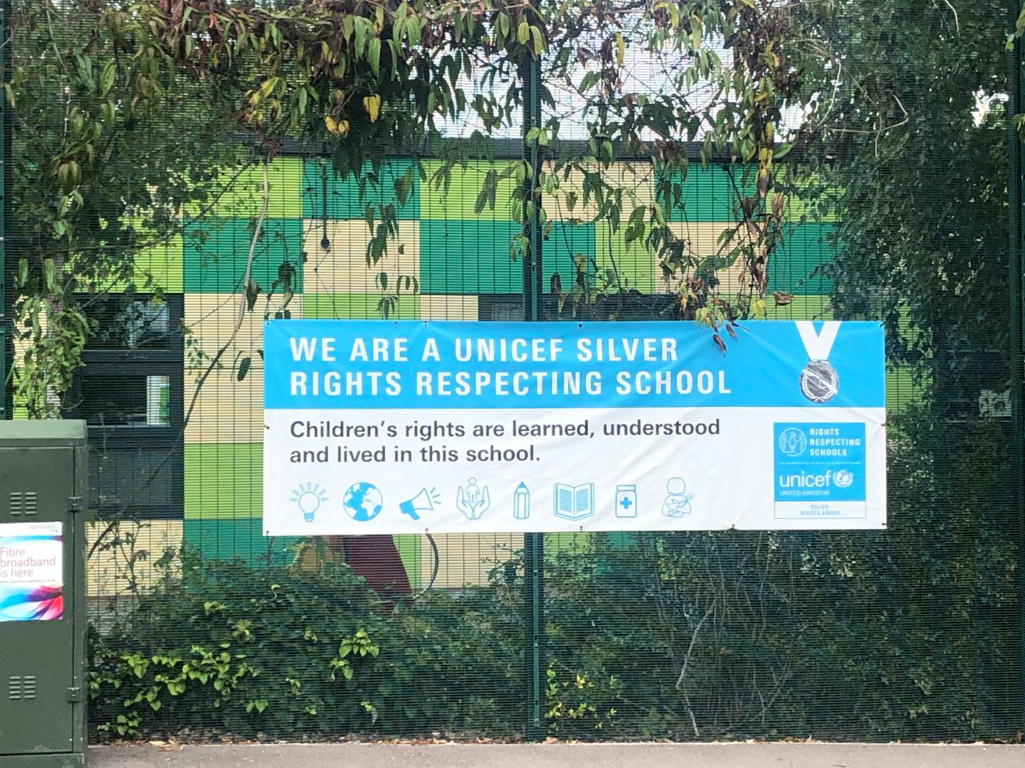

We are committed to placing the UN Convention on the Rights of the Child at the heart of our core values and ethos; believing children’s participation is integral to all aspects of school life. This results in empowered and self-confident children who can advocate for the rights of children everywhere.

This ethos further fosters a sense of community, respect and responsibility. It encourages the children to be active and informed citizens, who look to develop a positive future for all; campaigning and raising awareness.

The children’s experiences at Gwyn Jones Primary ensure the children know that they have the Rights of the Child and that these rights are inalienable. They also understand responsibilities they have as members of our local and global society.

**How to Apply**

Should you wish to apply for the post, please complete an application form and include a personal statement, which clearly demonstrates your suitability for this role. Please send your completed applications to [HR@gwynjones.waltham.sch.uk](mailto:HR@gwynjones.waltham.sch.uk)

**Closing Date**

Please ensure your application arrives by 12 noon Friday 24th March 2023.

**Shortlisting**

Shortlisting will take place on Friday 24th March 2023 if you have not heard from us by Monday 27th March 23 please assume that unfortunately, on this occasion, your application has not been successful.

**Interview**

Interviews will take place on Wednesday 29th March 2023.

**Safeguarding**

Applicants called for interview are kindly requested to contact their referees so that references are received ahead of the interview dates.

Gwyn Jones Primary School is committed to safeguarding and promoting the welfare of children and young people and expects all staff and volunteers to share this commitment. The school follows safer recruitment practices and the successful applicants will be required to apply for an Enhanced Disclosure and Barring Service check. A copy of our Safeguarding Policy is available to view on our website

**Location**

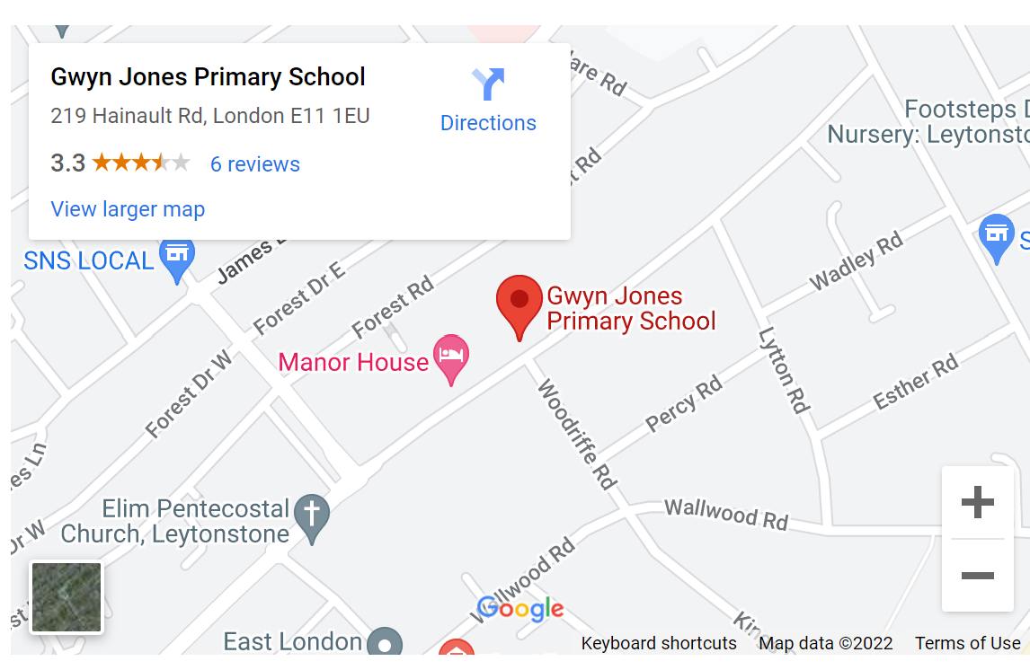

**Teaching Assistant and EYFS Teatime club worker – Level 2**

**JOB DESCRIPTION**

# Job Purpose

##### To work under the instruction/guidance of teaching/senior staff to undertake work/care/support programmes, to enable access to learning for pupils and to assist the teacher in the management of pupils and the classroom.  Work may be carried out in the classroom or outside the main teaching area.

**Key External Contacts**

Parents, carers

**Key Internal Contacts**

* Head Teacher, Teaching staff, pupils, support staff

**Major Tasks**, **Duties and Responsibilities**

***1 Support for Pupils***

* Supervise and provide particular support for pupils, including those with special needs, ensuring their safety and access to learning activities and teatime club activities
* Assist with the development and implementation of Individual Education/Behaviour Plans and Personal Care programmes *(for example implementing intimate care plans- nappy changing, attending to specific toileting needs)*
* Establish constructive relationships with pupils and interact with them according to individual needs
* Promote the inclusion and acceptance of all pupils
* Encourage pupils to interact with others and engage in activities led by the teacher
* Set challenging and demanding expectations and promote self-esteem and independence
* Provide feedback to pupils in relation to progress and achievement under guidance of the teacher
* Assist with the planning and delivery of play activities in teatime club
* Prepare, serve and sore food safely at teatime club

***2 Support for Teachers***

* Create and maintain a purposeful, orderly and supportive environment, in accordance with lesson plans and assist with the display of pupils’ work
* Use strategies, in liaison with the teacher, to support pupils to achieve learning goals
* Assist with the planning of learning activities
* Monitor pupils’ responses to learning activities and accurately record achievement/progress as directed
* Provide detailed and regular feedback to teachers on pupils’ achievement, progress, problems etc.
* Promote good pupil behaviour, dealing promptly with conflict and incidents in line with established policy and encourage pupils to take responsibility for their own behaviour
* Establish constructive relationships with parents/carers
* Administer routine tests and invigilate exams and undertake routine marking of pupils’ work in line with the school feedback policy
* Provide clerical/admin. support e.g. photocopying, typing, filing etc.

***3 Support for the Curriculum***

* Undertake structured and agreed learning activities/teaching programmes, adjusting activities according to pupil responses
* Undertake programmes linked to local and national strategies e.g. literacy, numeracy,, early years recording achievement and progress and feeding back to the teacher
* Support the use of ICT in learning activities and develop pupils’ competence and independence in its use
* Prepare, maintain and use equipment/resources required to meet the lesson plans/relevant learning activity and assist pupils in their use

***4    Support for the School***

* Be aware of and comply with policies and procedures relating to child protection, health, safety and security, confidentiality and data protection, reporting all concerns to an appropriate person
* Be aware of and support difference and ensure all pupils have equal access to opportunities to learn and develop
* Actively support and contribute to the overall ethos/work/aims of the school
* Appreciate and support the role of other professionals
* Attend and participate in relevant meetings as required
* Participate in training and other learning activities and performance development as required
* Assist with the supervision of pupils out of lesson times, including before and after school and at lunchtime
* Accompany teaching staff and pupils on visits, trips and out of school activities as required and take responsibility for a group under the supervision of the teacher

**Other requirements:**

* To attend and participate in staff meetings.
* To participate in training and performance management as required.
* To have an up-to-date Enhanced DBS Disclosure.
* To undertakeany other tasks as directed by the Head teacher commensurate with the grading of the post.

**Teaching Assistant**

**Level 2**

Person Specification.

**1. Experience**

1.1 Working with or caring for children of relevant age

**2. Qualifications**

* 1. Good numeracy/literacy skills
  2. NVQ 2 for Teaching Assistants or equivalent qualifications (see list of qualifications at end of document)
  3. Training in the relevant curriculum areas e.g. RWI
  4. First aid training/training as appropriate
  5. Food Hygiene certificate

**3. Knowledge, Skills and abilities**

3.1 Knowledge and ability to use ICT effectively to support learning

3.2 Reasonable word processing skills

3.3 Use of other equipment technology – video, photocopier

3.4 Understanding of relevant polices/codes of practice and awareness of relevant legislation

3.5 General understanding of national/foundation stage curriculum and other basic learning programmes/strategies

3.6 Basic understanding of child development and learning

3.7 Ability to self-evaluate learning needs and actively seek learning opportunities

3.8 Ability to relate well to children and adults

3.9 Work constructively as part of a team, understanding classroom roles and responsibilities and your own position within these

Relevant Qualifications

|  |  |  |  |  |  |
| --- | --- | --- | --- | --- | --- |
| **Qualification Level** | **From which year** | **Qualification Name** | **Awarding Organisation Title** | **Qualification Number** | **Notes/Additional Requirements** |
| 2 | 2019 | BIIAB Level 2 Diploma for the Early Years Practitioner | BIIAB | 603/5227/9 |  |
| 2 | 2019 | City & Guilds Level 2 Diploma for the Early Years Practitioner (England) | City and Guilds | 603/4935/9 |  |
| 2 | 2019 | Level 2 Diploma for the Early Years Practitioner | iCan Qualifications Limited (iCQ) | 603/5193/7 |  |
| 2 | 2019 | Level 2 Diploma for the Early Years Practitioner | Innovate Awarding | 603/4814/8 |  |
| 2 | 2019 | NCFE CACHE Level 2 Diploma for the Early Years Practitioner | NCFE | 603/3723/0 | Where the qualification certificate shows: NCFE CACHE Level 2 Diploma for the Early Years Practitioner (Knowledge only pathway)- the holder cannot count in the level 2 ratios. |
| 2 | 2019 | BTEC Level 2 Diploma in Children's Play, Learning and Development (Early Years Practitioner) | Pearson | 603/0509/5 |  |
| 2 | 2019 | Pearson BTEC Level 2 Diploma for Early Years Practitioners | Pearson | 603/4999/2 |  |
| 2 | 2019 | Skillsfirst Level 2 Diploma for the Early Years Practitioner (RQF) | Skillsfirst | 603/5179/2 |  |
| 2 | 2019 | TQUK Level 2 Diploma for the Early Years Practitioner (RQF) | TQUK | 603/5096/9 |  |
| 2 | 2019 | Level 2 Children and Young People's Workforce (CYPW) Intermediate Apprenticeship Framework (early years pathway) | Various | N/A | From 1 September 2019 the level 2 CYPW Intermediate Apprenticeship Framework (early years pathway) will include the new DfE approved EYP qualifications listed on this spreadsheet. The framework will continue to be full and relevant for the level 2 ratios. |

|  |  |  |  |
| --- | --- | --- | --- |
| 2 | BTEC First Diploma in Childrens Care Learning and Development | Various Awarding Organisations |  |
| 2 | BTEC First Diploma in Early Years | Edexcel (now Pearson) |  |
| 2 | Certificate In Child Care and Education | Various Awarding Organisations |  |
| 2 | Certificate in Playgroup Practice | NCFE |  |
| 2 | Certificate in Playwork | Various Awarding Organisations |  |
| 2 | Certificate in PreSchool Practice CPP | CACHE Council for Awards in Care Health and Education |  |
| 2 | Certificate in Sessional Creche Work | NCFE |  |
| 2 | Diploma in Child Care and Education | CACHE Council for Awards in Care Health and Education |  |
| 2 | Diploma in Playwork | Various Awarding Organisations |  |
| 2 | Diploma in Playwork Mandatory Units | CITYGUILDS |  |
| 2 | Foundation Certificate in Montessori Pedagogy | Montessori Centre International |  |
| 2 | Intermediate Certificate Playwork | NCFE |  |
| 2 | Montessori Early Years Classroom Assistants Certificate | Montessori Partnership |  |
| 2 | NVQ or SVQ in Childcare and Education | Various Awarding Organisations |  |
| 2 | NVQ or SVQ in Early Years Care and Education | Various Awarding Organisations |  |
| 2 | Preliminary Diploma in Nursery Nursing | NNEB National Nursery Examination Board |  |
| 2 | Certificate for the Children and Young People's Workforce | Various Awarding Organisations |  |
| 2 | NVQ or SVQ in Children’s Care, Learning and Development | Various Awarding Organisations |  |
| 2 | NVQor SVQ in Playwork | Various Awarding Organisations |  |
| 2 | NVQ or SVQ for Teaching Assistants | Various Awarding Organisations | Considered full and relevant at level 2 where the practitioner achieved it and had their **practice assessed** in the Early Years Foundation Stage in the maintained sector. |
| 2 | NVQ or SVQ Supporting Teaching and Learning in Schools | Various Awarding Organisations | Considered full and relevant at level 2 where the practitioner achieved it and had their **practice assessed** in the Early Years Foundation Stage in the maintained sector. |