



**Recruitment Pack**

|  |
| --- |
| **Site Manager**  **Level 3**  **Permanent Full Time Contract**  Salary: Scale points 18-20 (£30,699- £31,731)  Hours: 36.0 hours per week.  Weeks per year: 52 |

 

Dear Applicant,

Thank you for your interest in this exciting opportunity to join Gwyn Jones Primary School as the Site Manager (Level 3).

We are a two-form entry, culturally diverse school based in East London and we are very proud of our school. Visitors comment on the warmth of the school and the friendliness of both staff and pupils alike. Our dedicated staff team are incredibly hard working and are committed to creating a happy, secure and stimulating environment in which every child can achieve their potential and develop a life-long love of learning.

At Gwyn Jones Primary School we are a Rights Respecting School and we actively teach our children about the rights of the child. The Rights Respecting ethos permeates all parts of school life and into our school motto “Inspired and Empowered”. This motto epitomises the staff’s genuine commitment to provide a rich, creative and challenging curriculum which inspires children’s curiosity and empowers our pupils to have a voice and be knowledgeable, active global citizens. We strive to ensure that every child thrives academically whilst benefiting from excellent pastoral care that nurtures and develops emotional wellbeing.

To add to our team, we wish to appoint an enthusiastic and committed Site Manager to lead on the premises throughout the school. The successful candidate will be willing to contribute towards the effective provision of cleanliness and health and safety of the school and will be used to working in a busy environment. We will need you to be committed to work in the early hours of the morning and late evenings to cover locking the building and committed to working weekends when needed.

It is essential that you have a flexible approach, a high degree of motivation and be fully committed to working in a busy school environment. You will be required to show initiative and promote a positive image of the school through your presence on the school gate and keeping our school clean and tidy.

I hope this application pack and the information available generally on our website and on social media will give you a flavour of our School. I would be delighted to show you around our friendly and caring school. To arrange a visit please contact the school office on 02085567904 or email: [HR@gwynjones.waltham.sch.uk](mailto:HR@gwynjones.waltham.sch.uk)

I look forward to meeting with you

**Sian Boutalbi**

**Headteacher**

 

Dear Applicant,

Thank you for your interest in the position of Site Manager at Gwyn Jones Primary School.

Gwyn Jones is a successful and very popular school within the local area. We are fortunate in having an engaged and culturally diverse community, a hardworking and talented staff team and amazing pupils.

As Governors, we work alongside the Head and her dedicated team in our common belief in the fundamental importance of Primary Education as the foundation for developing a lifelong love of learning in our children. Our Governing Board is keen to develop its skills and knowledge of the school and its community and supports the drive within school for continuous improvement within a nurturing and supportive environment.

Our curriculum is rich, diverse and challenging and aims to provide a range of exciting and meaningful experiences which foster confidence and provide aspirations. Staff plan for children to be academically challenged, creatively inspired and supported in their personal development.

Gwyn Jones maintains strong links with other local schools within Waltham Forest. As a member of our staff team you would receive ongoing support and development in your role.

If the thought of this role in our school excites you, we look forward to receiving your application.

**Liz Jackson**

**Chair of Governors**

**Vision and Values**



At Gwyn Jones, we are committed to ensuring that every member of our school community is **inspired and empowered** each day.

We aim to inspire and empower our children by:

* Providing excellent teaching which nurtures our children’s innate curiosity, allowing them opportunities to take risks and to think for themselves.
* Supporting our children to have responsibility for their own learning; to have their own opinions and the skills to articulate them.
* Allowing all children access to a rich and broad curriculum which fully prepares them to be active, global citizens.
* Ensuring all children participate in a variety of trips and visitors in their local and wider community.
* Acting as role models who respect others and enjoy the rich diversity of our school family.
* Insisting that every child is known well, safe and nurtured to achieve their personal best.

We aim to inspire and empower our staff by:

* Providing a wide range of relevant and innovative professional learning in school which focuses on collaboration and sharing good practice, including lesson study, planning support, team teacher and action research.
* Forging strong links with external agencies to deliver professional development - teaching schools, higher education institutes etc.
* Giving developmental feedback with clear and specific actions for staff and leaders.
* Establishing coaching and mentoring relationships which encourage reflection.
* Identifying and nurturing leadership talent.

**Rights Respecting School**  

### **What is UNICEF's Rights Respecting Schools?**

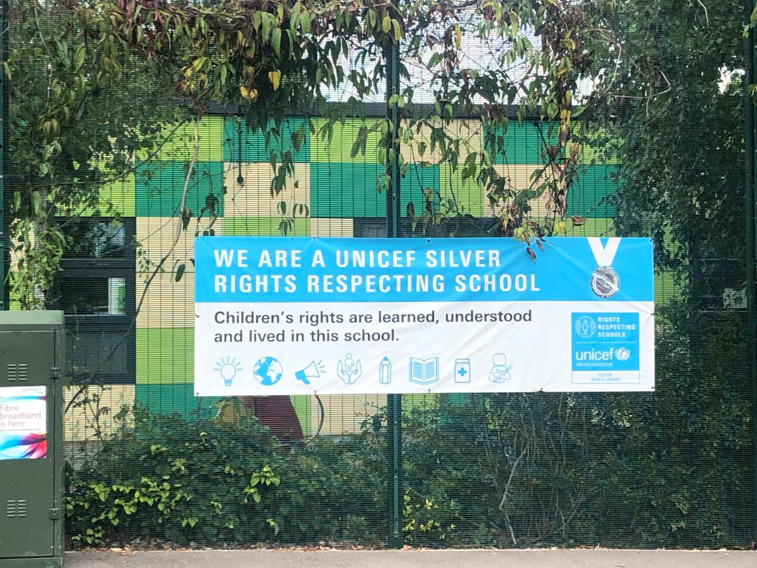

We are committed to placing the UN Convention on the Rights of the Child at the heart of our core values and ethos; believing children’s participation is integral to all aspects of school life. This results in empowered and self-confident children who can advocate for the rights of children everywhere.

This ethos further fosters a sense of community, respect and responsibility. It encourages the children to be active and informed citizens, who look to develop a positive future for all; campaigning and raising awareness.

The children’s experiences at Gwyn Jones Primary ensure the children know that they have the Rights of the Child and that these rights are inalienable. They also understand responsibilities they have as members of our local and global society.

**How to Apply**

Should you wish to apply for the post, please complete an application form and include a personal statement, which clearly demonstrates your suitability for this role. Please send your completed applications to [HR@gwynjones.waltham.sch.uk](mailto:HR@gwynjones.waltham.sch.uk)

**Closing Date**

Please ensure your application arrives by 4.00pm on the closing date of Friday 30th December 22 (at 4pm)

**Shortlisting**

Shortlisting will take place on Tuesday 3rd January 23 if you have not heard from us by Thursday 5th January 2023 please assume that unfortunately, on this occasion, your application has not been successful.

**Interview**

Interviews will take place on Monday 9th January 2023.

**Safeguarding**

Applicants called for interview are kindly requested to contact their referees so that references are received ahead of the interview dates.

Gwyn Jones Primary School is committed to safeguarding and promoting the welfare of children and young people and expects all staff and volunteers to share this commitment. The school follows safer recruitment practices and the successful applicants will be required to apply for an Enhanced Disclosure and Barring Service check. A copy of our Safeguarding Policy is available to view on our website

**Location**

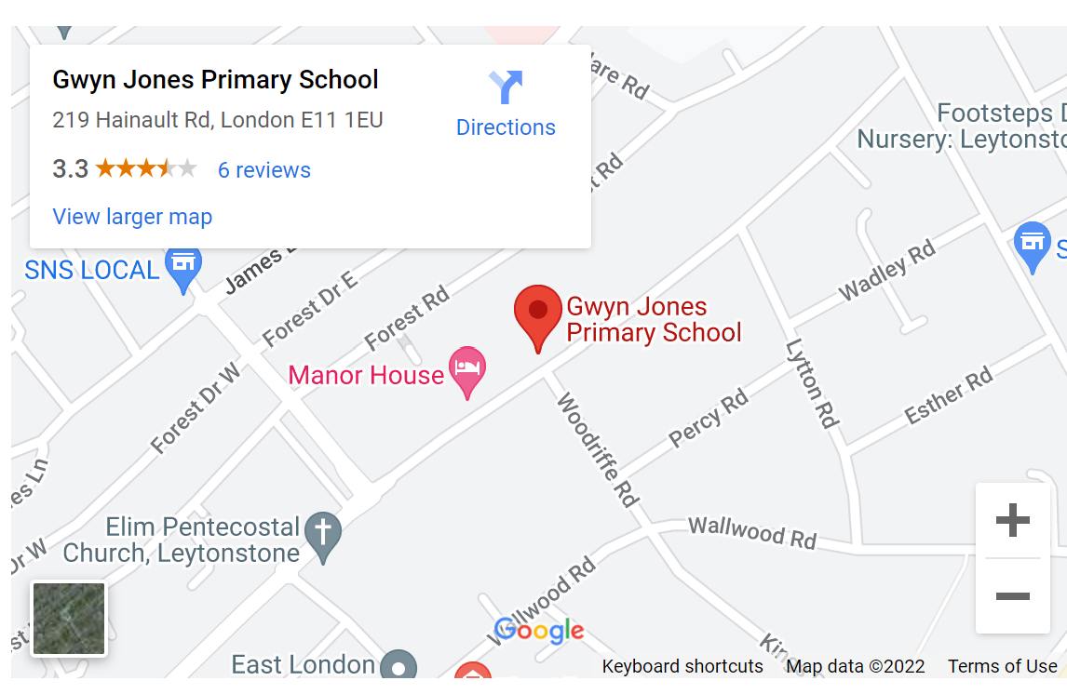

JOB DESCRIPTION

**Job Title: Site Services Officer (Level 3)**

**Department: CYPS**

**Division: Schools**

**Range: 18-20** (£30,699- £31,731)

**Responsible to: Head Teacher or nominee**

**Responsible for**

**(where relevant): Small team of Cleaners**

# Job Purpose

# **To provide an efficient, healthy and safe range of site support services including: key holding, security, letting and janitorial duties and supervise the general maintenance and cleaning of the school. Be responsible for the maintenance of a clean and hygienic school interior.**

**Key External Contacts**

* Contractors and suppliers
* Facilities providers
* Parents
* General Public

**Key Internal Contacts**

* Head Teacher/Nominated Representative
* Cleaners
* Staff
* Pupils

**Major Tasks**, **Duties and Responsibilities**

***1 Key Activities - Operational***

***Security***

* Lock/unlock school buildings and areas
* Undertake regular security checks and identify security risks
* Monitor fire safety equipment and carry out fire drills
* Operate and respond to alarm systems where appropriate
* Monitor CCTV or surveillance equipment where appropriate
* Liaise with police, security and surveillance contractors
* Provide emergency access to the school site
* Make arrangements for effective response to emergency call out (out of school hours)

**Maintenance**

* Undertake appropriate building repairs e.g. redecorating and fixing broken fittings
* To organise and carry out various maintenance duties to ensure that the general upkeep and maintenance of the premises is satisfactory, as per specific schedule for your school.
* To organise and carry out minor decoration and improvement work e.g. erecting shelves, notice boards, bookshelves, fixing doors, painting and fixing hinges etc. as agreed with the head teacher
* To be responsible for routine inspections of the buildings and planned preventative maintenance programmes for, fixtures, fittings, furniture, premises and grounds; to assess for minor work or repairs required to be carried out to maintain safe and satisfactory conditions
* Undertake regular site inspections within an agreed programme
* Operation and maintenance of heating plant and lighting systems
* To oversee and monitor the electrical testing of portable electrical appliances and to maintain the appropriate records
* Collect and assemble waste for collection
* Undertake cleaning duties such as graffiti removal, litter-picking
* Coordinate deliveries to the school site
* Liaise with contractors as directed
* Supervision of other cleaners
* Provide training for cleaning staff

***2 Key Activities - Resources***

* To advise on matters relating to energy control and conservation
* Be responsible for maintaining Health and Safety records, information and data, producing reports as required on school systems eg Concerto and I am Compliant

##### Create and maintain a orderly and productive working environment

# To assist with relevant risk assessments as required

* Promote and ensure the health and safety of pupils, staff & visitors (in accordance with appropriate health & safety legislation) at all times

***3 Key Activities – Organisation & Supervisory***

##### Demonstrate and assist in the safe and effective use of specialist equipment/materials where relevant

* Portering duties e.g. delivering mail, moving furniture and equipment
* Assist the headteacher in the management and operation of lettings system
* Monitor and manage stock within an agreed budget
* Direct/supervise cleaning and/or site staff and ensure cleaning is in accordance with specification
* To arrange cover for cleaner in cases of holidays and short term absence
* To carry out cleaning duties if no cover available.
* Where appropriate to organise and administer the use and maintenance of all school vehicles and to carry out driving duties when required by the headteacher
* Liaison with the school meals service contractors in relation to their use of the site, where appropriate.

***4 Responsibilities***

* Be aware of and comply with policies and procedures relating to child protection, health, safety and security and confidentiality, reporting all concerns to an appropriate person
* Contribute to the overall Rights Respecting ethos/work/aims of the school
* Participate in training and other learning activities as required
* Assist in the supervision, training and development of staff
* Establish constructive relationships with contractors and other professionals
* To be responsible, in conjunction with the SBM, for the administration and control of appropriate areas of the budget
* Attend and participate in regular meetings with line manager
* Treat all users of the school with respect, courtesy and consideration
* Present a positive personal image, contributing to a welcoming school environment which supports equal opportunities for all
* The above mentioned duties are neither exclusive nor exhaustive and the post holder may be required to carry out other relevant and/or reasonable duties as directed by their Head Teacher/Line Manager commensurate with the skills, abilities and grade of the post.

**Other requirements:**

* To have an up-to-date Enhanced DBS Disclosure.

**Site Services Officer – Level 3**

Person Specification

|  |  |  |
| --- | --- | --- |
|  | Essential | Desirable |
| **Experience** | | |
| Experience of carrying out building maintenance work, within the reasonable capacity of a normal handyperson in a school or similar environment | x |  |
| Experience of keeping work records | x |  |
| **Qualifications** | | |
| Good numeracy/literacy skills | x |  |
| NVQ 2 **OR** equivalent qualification desirable |  | x |
| **Knowledge, Skills and Abilities** | | |
| Ability to relate well to children and adults | X |  |
| An understanding of the main Health & Safety Regulations, including COSHH and risk assessment, and how they apply in a school environment | X |  |
| Knowledge of moving and handling procedures | X |  |
| Willingness to develop knowledge of use of ICT and to participate in development and training opportunities | X |  |
| Ability to undertake a range of caretaking and cleaning duties | X |  |
| Ability to identify work priorities and manage own workload, whilst ensuring that lower priority work is kept up to date | x |  |
| Ability to act on own initiative, dealing with any unexpected problems that arise | X |  |
| Ability to demonstrate good inter-personal skills to communicate with a range of people | X |  |
| Ability to provide high quality supervision, training and support to cleaning staff | X |  |
| Ability to inspect and record the work of others | X |  |
| Ability to work effectively and supportively as a member of the school team | X |  |
| Ability to demonstrate commitment to Equal Opportunities | X |  |
| Demonstrate a commitment to own wellbeing and the wellbeing of others | X |  |