**Sanders** *Draper*

**Information Pack**

**Assistant Headteacher**

**(Inclusion and SENDCo)**



**To be the best we can be, by being true to our values.**



**Sanders** *Draper*

Teamwork Hard work Transparency

Dear Candidate,

Thank you for taking the time to consider joining our team of staff at Sanders Draper part of the Success for All Educational Trust (SFAET). We share the Trust vision of ‘Commitment to Success for All’ and work hard as a team to ensure our students develop the skills that will enable them to achieve the very best at every stage of their life.

Sanders Draper has a very unique history and you can read more about this further in this pack. We believe strongly that we will be the best we can be, by being true to our values of Teamwork, Hard work and Transparency.

If you were to ask a parent why they chose Sanders Draper for their child, they would tell you how the focus here is on the development of the whole child. Sanders strives for academic success as well as offer a range of opportunities beyond the classroom and throughout providing excellent pastoral care. We are most certainly a school which is in demand with waiting lists for students in all year groups. The school has been on a journey of improvement and we are looking for ambitious, passionate staff to join our excellent staff body.

We understand the importance and role that a school plays within the local community. Our students play an increasing role in looking to give back positively to Hornchurch and Havering. Our students are amazing and have a real thirst to grow, develop and be challenged. We provide many opportunities for them to use their voice and also represent Sanders; for example, classroom ambassadors, Student prefects and Senior Leadership team, our PE leaders who help organise and run local primary schools sports day or in the many opportunities to play music.

We are committed to improving outcomes for all students and focus on high quality teaching and learning to ensure the best possible progress for every student. Our Partnership with Redden Court School, The Royal Liberty School and Rise Park has afforded us fantastic opportunities to collaborate and share best practice. Together we are passionate about raising educational standards across Havering

Sanders Draper has been and continues to be a journey to becoming an outstanding educational establishment, we are relentless in our pursuit of this. We are driven by our belief that every student is capable of achieving great things and that through our belief in them. We also understand the importance of working with home in partnership illustrating

We have a balanced CPD Programme which offers a mixture of department time, staff designed training matrix covering a range of aspects of note for staff/departments and whole school CPD. Additionally we offer support to staff at all levels to develop and experience opportunities to progress their careers within Sanders and the Trust.

Staff well-being is vitally important and we invest in School Advisory Service. This is a package of Health and Well-Being Services with a range of services for all staff in the school to access. Further information can be found about this towards the end of the information pack.

We seek an Assistant Headteacher to join us from January 2023. Sanders Draper is a hardworking school which is driven to support all of our students and ensure that the whole child is developed through our approach. I have proudly been Head at Sanders Draper since September 2018 during which time we have made considerable progress on many fronts. I consider the appointment of a new SENCo very important in our continual push for excellence in all matters at Sanders Draper.

This exceptional opportunity provides an opportunity to join our leadership team. It will offer the successful applicant opportunities to shape a successful, growing school.

At Sanders Draper, we have a passionately holistic approach to providing the children we serve the best possible education to give them what they need for successful and happy futures. We are committed to providing an excellent education that develops ambition, raises expectations and delivers excellent results. Our students are helped to become the best versions of themselves as people who know they must work hard and who have responsibilities. At Sanders Draper we value academic success however believe that it must be matched by the development of character and conscience through our wider curriculum drive. We also believe that a happy child is a child who is better equipped to study and fulfil their potential.

We have very strong relationships with parents and carers, who play an active role in the school's vision and values. We genuinely believe in the importance of working in partnership with our staff, parents/carers, students and all stakeholders as we know this approach is vital as we all work together to support the progress of every child.

We are looking for someone who can work effectively within a strong Senior Leadership Team and lead our Inclusion Faculty. This would include someone who has the experience of leading whole school initiatives. The candidate must possess a genuine commitment to making a positive contribution to the school. We are looking to appoint an ambitious and inspirational senior leader to take on this exciting Inclusion role. This is a vital role in a school with an outstanding reputation for its work with SEND and vulnerable students and will require an exceptional individual.

The successful candidate should be inspiring, extremely motivated, hardworking leader with a fine track record of developing others as well as themselves and who is still an excellent teacher themselves. We want someone who is caring, forward thinking and able to work with everyone in a community that is hardworking, totally committed and loyal.

The successful candidate will be committed to our vision, our values and ethos, and have the interpersonal skills and ability to lead staff and students to achieve all they can. The successful person will join an experienced and hardworking team of professionals who will continue to do all they can to drive the school forward.

Visitors to our school are always impressed by the atmosphere at Sander Draper and the real passion and pride students have for the school. I would welcome you to visit us to see this for yourself, meet some of our amazing students and staff and get a true taste of Sanders Draper. To arrange a visit please telephone Mrs Vicky Murphy on 01708 443068

We are committed to safeguarding and promoting the welfare of children and young people and we expect all staff to share this commitment. We require the successful candidate to undertake an enhanced criminal records check via the Disclosure and Barring Service. We welcome enquiries from everyone and value diversity in our workforce. Applications are welcome from all sections of the community regardless of gender, gender identity, ethnic origin, disability, age or sexual orientation.

References from 3 previous employers will be sought prior to interview.

*For details on how to apply, please visit our website:*[https://www.sandersschool.org.uk/about-us/vacancies](https://www.reddencourtcloud.co.uk/about-us/vacancies)

*Closing date: Tuesday 4th October at noon*

*Interviews will take place on: Tuesday 18th October.*

Stuart Brooks, Headteacher

***To be the best we can be, by being true to our values***



**Job Description and Specification**

**Job Title: Assistant Headteacher – Inclusion and SENCO**

**Pay Scale: Leadership Range – Point 12-16**

**Reports to: Deputy Headteacher**

**Role and Purpose**

The role of the Assistant Headteacher/SENCO is important both to the strategic development of the school as well as the effective management of the school’s operational functions.  The Assistant Headteacher/SENCO is expected to operate within the agreed management system of the school, subject to the direction of the Head Teacher.

Candidates should either have the SENDCO qualification or be prepared to work rapidly towards it.

The Assistant Headteacher/SENCO is expected to make a significant contribution to the core purpose of our school which is to ensure that all our students achieve their best academic potential.  The Assistant Headteacher/SENCO, as part of the Senior Leadership Team (SLT), is expected to take a leading role in promoting high standards for all students and a positive ethos within the school.

**Principal Responsibilities:**

* The strategic leadership within the school of Inclusion and SENCO provision as directed by the Headteacher.
* To be aware of and assume the appropriate level of responsibility for safeguarding and promoting the welfare of children and to report any concerns in accordance with the school’s safeguarding policies.
* The SENDCO is expected to advise the Headteacher and SLT on all matters which are SEND related.
* Undertaking responsibilities as a member of the Leadership Team of the school.
* The leadership, day-to-day management and high standards of behaviour for learning in the school, along with the implementation of policies, plans, targets, practices and procedures related to the system within the context of the vision, ethos, aims and goals of the Academy.
* Develop and monitor systems of guidance and support designed to assist staff in maximising student participation and attainment.
* Raise awareness and understanding of SEN strategies across the school to enable teachers to be more effective in teaching students on the SEN register.
* Coordinate strategies to achieve identified school improvement.
* Lead whole school work on SEN and Disability equality issues.
* Assess and support SEN admissions and assessments, disseminating information to HOFs and HOYs and monitoring provision.
* Evaluate and report on the effectiveness of additional specialist support, suggesting areas and strategies for improvement.
* Lead professional development through example; support and co-ordinate the provision of SEN professional development for staff in school.
* Use financial and resource management innovatively and wisely.
* Build effective links with relevant groups in order to develop plans to meet output targets.
* Work with HOFs, HOYs, parents, community groups, schools, local and national bodies, teaching and non-teaching staff, LA SEN support team.
* Ensure effective and timely communication/consultation, as appropriate, with Governors, SLT, teaching staff, support agencies and the parents of students.
* Represent the school’s views and interests as relevant meetings.
* Ensure that SEN commitments are effectively and efficiently time-tabled and roomed.
* Promote and support teachers in raising students skills and attainment across the curriculum.
* Encourage motivation and enthusiasm in acquiring higher level skills developing positive responses to challenges and high expectations.
* Actively monitor and follow up progress.  Monitor and evaluate data to identify trends in performance and issues for development as part of the SEF and SDP.
* Identify, update and take appropriate action, on issues arising from data, systems, policies and reports.
* Produce and analyse reports on SEN student performance, including the use of P8 and A8 data, behaviour, attendance and achievement.
* Ensure that SEN quality procedures meet the requirements of the SDP.

**Other Responsibilities**

* Line Management of the SEND Faculty.
* To liaise with social care and the early help team as appropriate.
* Contribute to faculty reviews, school development plan and formal reports to Governors.
* Reporting to governors and SLT on SEND provision and vulnerable groups.
* To be responsible for identifying the students that are at risk of being ‘not in employment, education or training (NEET) who are from the SEND cohort.
* Updating any appropriate policies within SEND.
* To target interventions towards students who are regularly late to school and struggle with punctuality from the SEND cohort.
* Being a role model for both students and staff and being a presence around the school.
* To take an active role in the school performance management system to review own progress and set targets for future development.

**Professional Attributes**

* The ability to consistently model the values and ethos of the school.
* The ability to work effectively within SLT and take collective professional responsibility.
* Effective communication with parents, students, staff and governors.
* An ability to analyse complex situations and to plan appropriate course of action.
* The ability to think creatively and strategically.
* Inspire challenge and develop individuals and teams of people.
* Ability to plan, organise and prioritise so that time is used effectively.
* Encourage ideas from other people
* Ability to plan ahead, identify problems and offer solutions.
* Deal with risk and uncertainty.
* An ability to listen, reflect and have the capacity to be flexible.
* An awareness of recent trends and developments in education.
* A commitment to continuing own professional development.

**Personal Attributes**

* A passion for teaching and learning.
* A commitment to achieving the best for young people regardless of their social background or ability.
* Resilience and optimism in the face of challenges.
* Integrity.
* Attention to detail.
* Decisiveness, consistency and an ability to focus on solutions.
* Courage and conviction.
* Ability to deliver a consistent approach with regards to discipline.
* Stamina to cope with the role.
* A good sense of humour.

*Sanders Draper is committed to safeguarding and promoting the welfare of children and young people.*

*All adults who work at the school must share this commitment to young people.*

| **SKILLS and ABILITIES** | **ESSENTIAL** | **DESIRABLE** | **ASSESSED BY** |
| --- | --- | --- | --- |
| The ability to lead and manage the SEND team effectively and efficiently and work with other professionals and agencies. | ✓ |  | Interview |
| Communication skills, oral, written to a variety of audiences. | ✓ |  | Application & Interview |
| The ability to deliver well planned, organised and innovative lessons/interventions | ✓ |  | Interview |
| Proficiency in the use of ICT and the software programmes used in school. | ✓ |  | Application |
| The ability to lead, model and manage positive behaviour and assertive discipline in the school. | ✓ |  | Application & Interview |
| The ability to manage school information and data for recording, monitoring, evaluation and reporting. | ✓ |  | Application & Interview |
| **OTHER ATTRIBUTES** |  | | |
| Ambitious and committed to own professional development. | ✓ |  | Interview |
| The ability to deal effectively with students, parents and all stakeholders. | ✓ |  | Interview |
| To be flexible when working within Inclusion and be able to prioritise workload efficiently. | ✓ |  | Application & Interview |
| Understanding of Child Protection procedures | ✓ |  | Interview |
| Team player and highly motivated. | ✓ |  | Interview |
| An understanding of the needs of SEND children | ✓ |  | Interview |
| **QUALIFICATIONS and EXPERIENCE** |  | | |
| Qualified Teacher Status | ✓ |  | Evidence of qualification |
| Nationally recognised SEND qualification |  | ✓ | Evidence of qualification |
| Demonstrate a significant impact at whole school level. | ✓ |  | Interview |
| Evidence of further professional development which demonstrates an understanding of the current issues impacting on SEND provision | ✓ |  | Application & Interview |
| Proven track record of raising achievement through outstanding classroom practice. | ✓ |  | Application |
| Experience of senior or middle leadership with a secondary school. | ✓ |  | Application & Interview |
| Evidence of relevant continuing professional development, including for example NPQH. |  | ✓ | Application |

**Staff Benefits**

Career Development:

* Apprenticeships
* Support towards achieving further qualifications
* Leadership programmes
* Progression opportunities
* Teacher Training Programme

Family Friendly:

* Childcare vouchers – if you are using registered or approved childcare, you can choose to take part of your salary in childcare vouchers to pay for it which are Tax and National Insurance free. This means you get extra value from your pay packet each month.

Financial:

* Pension – teaching staff access Teacher Pension Scheme and Associate Staff access Local Government Pension Scheme
* All teaching staff are allocated a Chromebook

Health and Wellbeing:

* Schools Advisory Service offering:
  + Access 24 hours a day to a GP Helpline where you can have a telephone consultation for you and close relatives.
  + Access to Physiotherapy
  + Access to a counselling service
  + Free 12 week Weight Management Programme
  + Support for stress management
  + Lifestyle Screening
  + Relationship Counselling
  + Long Term Condition support - Support for you and family members where you or a member of your family is suffering from a long term condition such as cancer, Multiple Sclerosis or Motor Neurones Disease. This list is not exhaustive.
  + Private Medical Service
  + Stress Counselling

**Staff wellbeing approach**

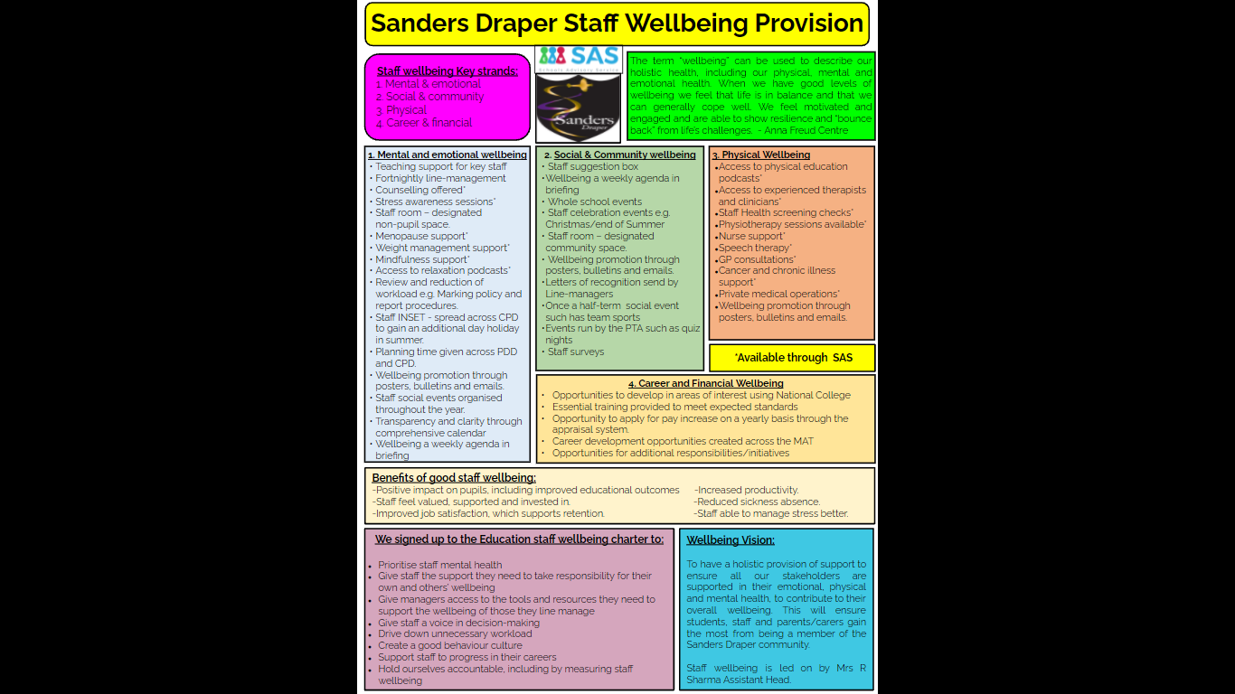

Schools Advisory Service philosophy is to work with Sanders to prevent and reduce staff absence. All the Well-Being and Medical support offer to Sanders staff is designed and implemented by the SAS team of experienced in-house Nurses. Our joint aim is to keep staff in the classroom thus ensuring the children at Sanders get the best possible opportunity to succeed!

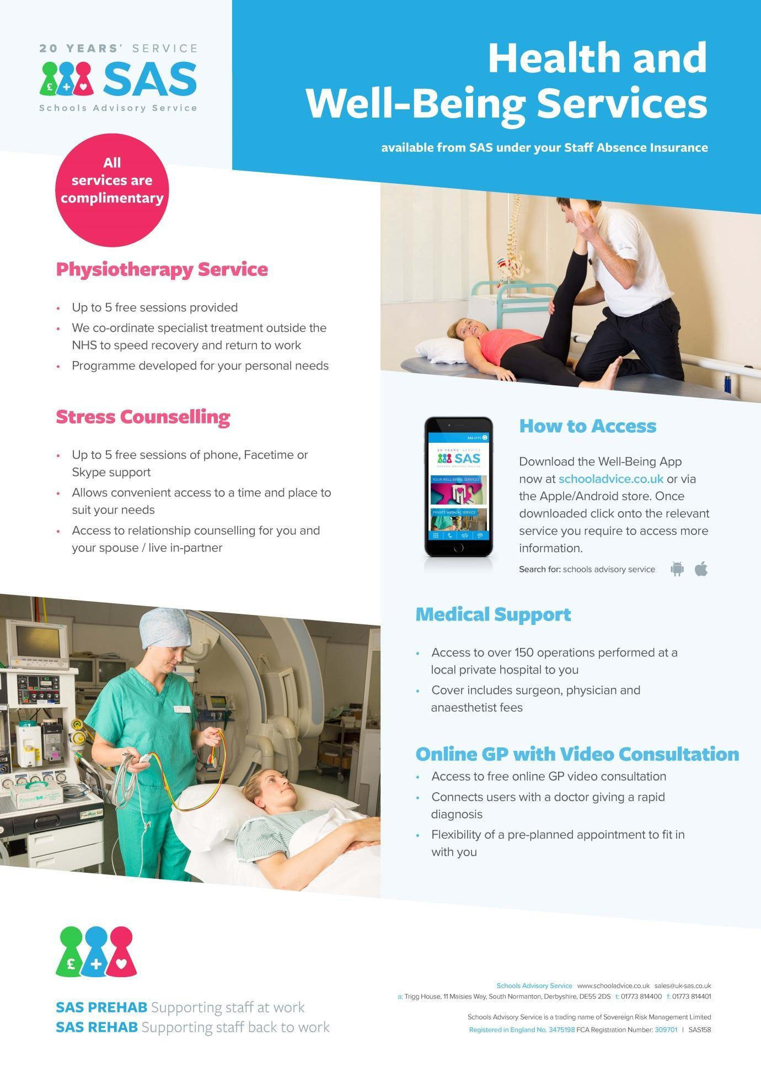

**Vision and Values**

To secure success at Sanders Draper, the traditional values of teamwork, hard work and transparency are underpinned by our relentless drive and determination to improve all aspects of the school. Like you, we know that a good education has never been so important: students only get one chance at it so we ensure that every aspect of the school is given due care and attention.

Teamwork 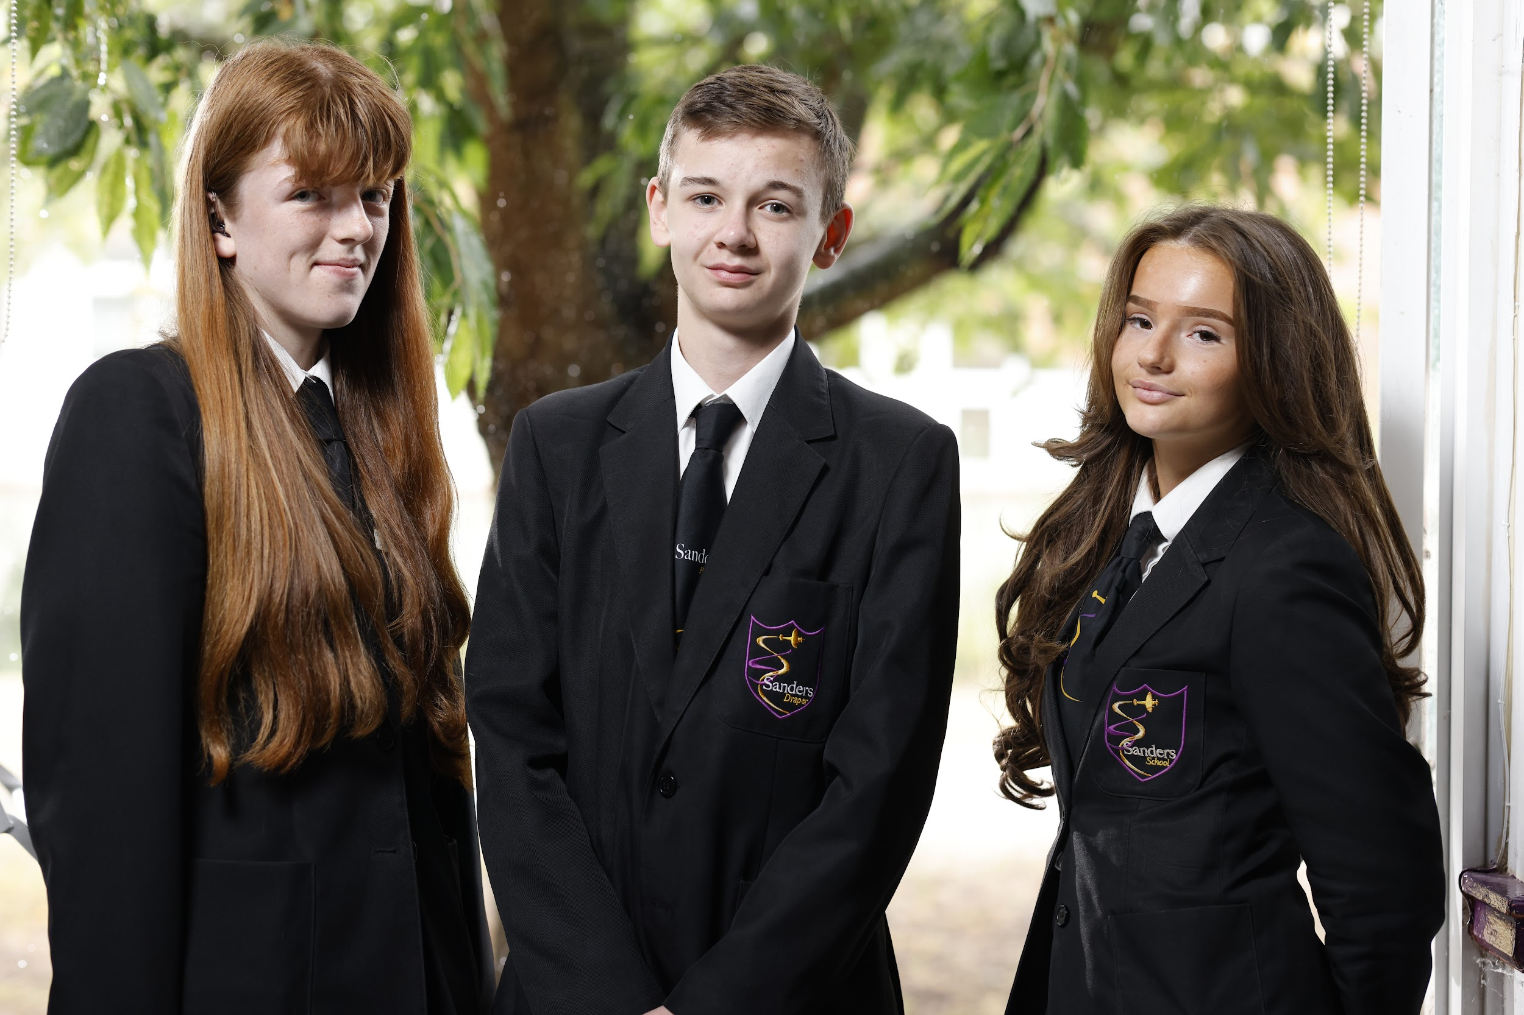

This is a key value and the concept of teamwork is optimised by the approach of Team Sanders. Importantly everyone - a member of staff, a parent or a student - has the same goal of ensuring that every student feels safe, enjoys school, and makes exceptional progress. The approach of working in and as a team effectively with each other is continually reinforced throughout all aspects of the school.

Hard Work

Hard work is required by all, to bring about the success we desire and especially to overcome the many barriers we will all face. Students now face more obstacles than ever before and so must ensure that they are resilient in their studies, always giving their all.

Transparency

We believe strongly in being clear as to the approach and expectation that Sanders Draper has, and to make explicit the roles everyone has to play. The parent forum illustrates our belief in the importance of the role home plays and how there is a need to strengthen the effective communication between the school and home. We value the student’s voice and opinion and always take decisions with their best interests at heart. All staff, students and stakeholders adhere to these values as we look to create a culture of support, challenge

and openness at Sanders Draper.

| Our Vision  To be the best we can be, by being true to our values. |
| --- |

“Leaders have set clear non-negotiables around lesson organisation and classroom protocols. They have worked at a strategic level working with the school community to develop a vision and values system. Leaders are keen to reconnect with the positive history of the school.” Havering School Improvement Review - S. Sutton March 2020

“I am proud to be a member of Sanders and understand we are all working together as one team to be successful” Year 9 student

“ All classes visited were calm and purposeful. Students demonstrated good behaviour and almost all students were engaged and working well. Students enjoy their learning and teachers choose tasks and ways of learning that interest them. Expectations are high.” Havering School Improvement Review - S. Sutton March 2020

*“I would just like to say a massive thank you to all of the staff at Sanders, both the senior leaders and the teachers. The communication from the school is outstanding and we always feel like we know what is going on in the school. We are so happy that we picked Sanders School and would recommend the school to family and friends. Thank you for all that you do” - Parent of a Year 8 student*

What people say about us

“What a great atmosphere. Happy student and staff” (A visiting parent Open Evening 2019)

School leaders work closely with external agencies, parents and carers to provide support to pupils when it is needed. Leaders with specific safeguarding responsibility in the school have a thorough understanding of the safeguarding policy and procedures. They have detailed knowledge of the needs of pupils and work well to promote pupils’ well-being and safety. (Ofsted 2017)

“I am proud to be a member of Sanders and understand we are all working together as one team to be successful” (Year 9 student 2019)

“Pupils enjoy a range of extra-curricular activities that support learning and enrich their experiences” (Ofsted

2017)

“I am excited at the journey Sanders is on and the drive and passion by the leaders to improve the outcomes for the students” (Staff member 2019)

“Sanders is better than primary school because there’s more after school clubs, I go to rugby on a Monday. The Atmosphere is great, the teachers help us and are really nice” (Year 9 student 2019)

“Sanders offers incredible support to its students #Proud2BTeamSanders” (Parent 2019)

“At school I feel safe and know that the staff really care about me. They are always there. ” (Yr8 student 2019)

“The Parental Communication Group allows parents to provide constructive feedback directly to the school. The group look at the processes and systems in place and how it could be improved from a parental view and not just that of the school. It is about being part of the school community, being involved and helping to make a difference.” (A parent who is a member of the Parental Forum Group 2019)

They provide pastoral and practical support for children who are worried about anxiety, depression and other concerns. The team are aware of the social and cultural pressures on the children, they recognise the lack of parental understanding and confusing role models for some children. The clear aim is de-escalation, keeping children focused on day to day life and the positives they experience. (External 175 Audit - Havering Borough 2019)

“I am so proud to be a staff member at Sanders and know that I am making a real difference to the future lives of our students” (Staff member 2019)

“My daughter has had lots of opportunity to develop as a leader which is so important” (Parent 2019)

* *

**Curriculum Provision**

Sanders Draper is proud to offer a broad and balanced curriculum through which our students are exposed to a range of creative and practical subjects from Year 7.

In line with national expectations, students are encouraged to follow the English Baccalaureate (The EBACC subjects are English, maths, science, history or geography, and a foreign language). All students will complete the Combined Science GCSE (some students are offered the chance to take the three single sciences). At the end of Year 9, students select from history or geography for their humanities subject.

At Key Stage 3 (Years 7, 8 and 9), all students study the following subjects: art, drama, design technology, English, ethics and values, French, food, geography, history, ICT, maths, music, physical education, and science.

To support students in making informed decisions as to their GCSE choices, a range of aspects run in KS3 and in Year 9, so that students and families are aware of the expectations of subjects and can make a fully informed choice.

Additional support is provided for students who struggle to complete their homework in the form of Homework Club which takes place in the library each day from 8.00am to 8.30am and from 3.15pm to 4.00pm.

You can find further information regarding our curriculum provision within the curriculum section on the school website.

**GCSE subjects on offer at Sanders Draper**

| **Compulsory** | **Optional (2 subjects selected from the list below)** |
| --- | --- |
| English (Language and Literature)  Maths  Science (Combined or Triple)  History or Geography  Ethics and Values  Physical Education (Core no-exam)  French* (compulsory for most students) | Art  Business Studies  Childcare  Drama  Food  Design and Technology  Information Technology  Music  Physical Education - GCSE  Textiles  (those not studying French study 3 subjects) |



“I was supported in making good choices for my GCSEs and was able to have a good mixture of the core and optional expressive subjects. It means I have lots of choices open to me in the future.” – Year 9 student

“The school provides pupils with a broad and balanced curriculum” Ofsted 2017

“The new curriculum model has moved to a traditional broad and balanced curriculum for all” Havering School Improvement Review - S. Sutton March 2020

**Wider Curriculum**

At Sanders Draper, we encourage pupils to take advantage of the many opportunities offered to them. Pupils can benefit significantly from taking part in extracurricular activities, not only to support their academic progress but also to encourage their all-round development. We strongly believe that pupils taking part in extracurricular activities benefit in many ways, including lower stress levels, increased confidence and improved attendance.



There is an extensive offer of PE clubs (including football, basketball, rugby, fitness, trampolining and netball) and Sanders Draper are active participants in borough wide sport competitions. The creative arts faculty offers clubs in music, dance, drama and art, and many students perform at events throughout the year. The English, science, French and maths departments also run extracurricular clubs. We have a Reading, Film and Digital Effects club, and will be introducing new clubs, including a debating club and ‘Club 7’ specifically for Year 7 students to help them settle in September. There will certainly be something for your child to take part in to develop their skills further and improve their teamwork, communication and confidence. Our clubs run before school, at lunch and after school.

We have secured funding from the European Union to take part in a multi-cultural project with 4 schools across Europe. Our project “Hand in Hand - To Promote Social Responsibility” aims to develop our students into more responsible, tolerant and culturally aware citizens. It involves students travelling across Europe, experiencing different cultures. and understanding how young people live in different societies: an amazing opportunity!!

The enrichment opportunities that we offer at Sanders Draper encourage students to think about their subject area outside of the classroom and to develop cultural capital. Trips to universities allow students to envisage where they could be in terms of their education if they work hard in their studies. Students are encouraged to take part in whole school events, to represent the school, and to carry out roles in the community. The careers programme at Sanders Draper also allows for enrichment outside of the classroom, with opportunities to experience careers related talks, workshops and visits, to help students understand the world of work and have hands-on experience in their chosen career. This year students have been able to have interactions with employers via online webinars, introducing them to the world of work and informing them of the broad range of new careers that are available to them.

We actively encourage students to take part in enrichment and strongly believe in the impact of such experiences and how they develop students’ well-being, confidence, teamwork and leadership skills. We also believe in ensuring that our young students are safe, so we have regular workshops on areas that are important to make young people more aware, such as internet safety and staying safe when in the community.

“Sanders is better than primary school because there’s more after school clubs. I go to rugby on a Monday. The atmosphere is great, the teachers help us and are really nice” – Year 9 student

“Pupils enjoy a range of extracurricular activities that support learning & enrich their experiences” Ofsted 2017

**Raising Standards**

At Sanders Draper, we work hard to implement change in order to raise standards for all our pupils. Working as a body of staff and led by the Raising Standards Team, we look to continually improve the level of education and care your child receives at our school.

The theory behind our work is taken from national educational research from organisations such as The Sutton Trust, PIXL Schools, Fischer Family Trust, TES, and the Department for Education. All of these help us to improve your child’s educational experience and outcomes.



Our aims include:

* To improve the quality of education for all of our students
* To improve outcomes for all of our students
* To ensure the well-being of our students
* To communicate effectively with all stakeholders
* To bring our community together
* To celebrate our community successes

It is important for us to ensure that all students have the chance to achieve their full potential. We can only achieve this if we understand how to help, support and stretch our students. In order to do this, we have introduced new initiatives and systems that allow us to be transparent with all stakeholders.

These include:

* Using robust data
* Tracking and monitoring students and staff
* Improving our SEND provision for all students
* Offering support (academic and pastoral)
* Ensuring staff have access to continual professional development
* Improving teaching and learning
* Maintaining our highly successful pastoral care system

Whilst intervention is key with students in Year 11 for GCSE success, our aim is to have early intervention strategies for pupils throughout their school career. This will help to remove the barriers they have to learning and allow them to achieve. This includes ‘behaviour for learning’ taking place inside all classrooms and a team approach so that all students feel that they can actively participate in class.

We look to close the gaps for students in all subject areas and work to achieve this by testing students, implementing appropriate intervention strategies, and then testing our impact. Students and families support us and we work together to raise outcomes for the students.

“Intervention classes allowed me to prepare for my exams by teaching me how to revise the areas I didn't understand, rather than just trying to do it on my own”. Year 11 Student

“Leaders are ambitious to improve the outcomes for the students” Havering School Improvement Review S. Sutton March 2020

**Pastoral Care**

At Sanders Draper, we pride ourselves on our outstanding pastoral care. Student well-being is at the heart of everything we do. We work tirelessly to ensure that students feel supported and that whilst they are part of the Sanders Draper community, students are happy, healthy and safe. We believe that this is fundamental in enabling all students to progress.

At Sanders Draper, we are a community, a family built on teamwork to ensure that we continue to grow and thrive together. We believe that each member of our team plays an important part and that each has a key role in our success.

We are a proud school with a proud history. Our close links with the local community, RAF and World War 2 are reflected in our house system. This house system has been launched at Sanders Draper in order to further develop our students and ensure that they have appropriate and deserving role models. Each student belongs to a ‘house’ and each ‘house’ has a ‘house hero’. Several ‘house heroes’ either lived or worked in Havering during World War 2 and contributed to our local communities' war efforts. They epitomise our school values and we celebrate this with our students and through the work we do within the house system.

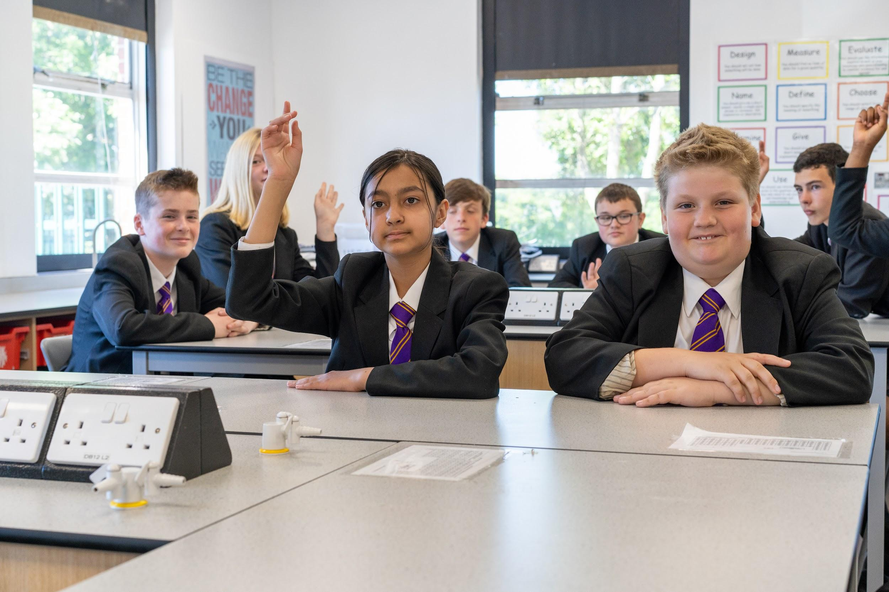

Form tutors are the first point of contact for students. Each morning students attend form-time. This provides an opportunity for staff to develop relationships with students based on trust and mutual respect. It allows for the reinforcement of expectations and the monitoring of standards. Form tutors deliver a form-time curriculum which is developed to meet the needs of students at different stages of their school career. It also provides an opportunity for reflection: we encourage our students to learn from their mistakes and we encourage discussion and debate. Students take responsibility for their own progress. They monitor and record their attendance, and track their achievement points and set targets for themselves related to their progress and attitude to learning.

Once a week students receive key messages through assemblies. Assemblies are led by staff from across the school. They are an opportunity for us to share experiences and key messages, and to celebrate the achievements of those within our community. Year groups are led by a dedicated Head of Year. They oversee the pastoral provision and care of young people within their year group. Our pastoral team extends to our safeguarding officers. These key members of staff provide exceptional care for our young people.

We have robust clear systems for managing conduct and behaviour and have high expectations of every student in terms of their attitude and approach to school life. Each lesson is an opportunity for learning and we do not tolerate poor conduct or low-level disruption in lessons. We believe that all students can achieve, and we ensure that they understand the need for respect and attention to their learning.

We get to know young people as individuals. We excel in providing quality care and guidance. We aspire for our students to be well-informed, well-rounded individuals. We are committed to every member of our team.

“At school I feel safe and know that the staff really care and are always there. ” - Yr9 Sanders student

“They provide pastoral and practical support for children who are worried about anxiety, depression and other concerns. The team are well aware of the social and cultural pressures on the children, they recognise the lack of parental understanding and confusing role models for some children. The clear aim is de-escalation, keeping children focused on day to day life and the positives they experience.” Havering Borough 175 Safeguarding Audit September 2019.

**Teaching and Learning**

At Sanders Draper, we aim to provide a challenging and engaging experience in every lesson and inspire our students to become the best, well-rounded individuals that they can be. Our Teaching and Learning Policy ensures that we:

* provide opportunities for all learners to make outstanding progress in their learning
* engender a positive approach to learning
* train, develop and support teachers to unlock skills, knowledge and potential
* promote the use of resources which encourage and motivate learners
* develop a love of life-long learning
* monitor the quality of teaching within the school
* maintain consistently high standards of teaching

Our philosophy of teaching and learning begins with ensuring all our students are exposed to a consistent, broad, balanced and challenging curriculum which helps develop every student as a successful learner, deeply embedding our core values of teamwork, hard work and transparency *‘to be the best we can be, by being true to our values’.* At Sanders Draper, you will expect every lesson to include individual, group and peer work; a focus on literacy and reading; a deep-rooted understanding of why we learn what we do, and a myriad of opportunities to develop personal, oral and subject-specific skills.

Because of our commitment and belief in developing the whole child, we ensure that all teachers are provided with regular, structured and bespoke training to guarantee that they can share and use the best possible practice with our students in the classroom. We place a strong emphasis on collaboration and our heads of faculties, classroom specialists, pastoral team and senior leadership team all work closely together to place all the students at our school at the centre of everything we do.

In every subject, we monitor and track our students' progress every half term through assessments; provide bespoke intervention when needed; and track and monitor teaching and learning through regular learning walks, work scrutiny, lesson observations, and analysis of key data. Students can expect to find the highest quality of teaching with a thoroughly planned curriculum, all directly linked to GCSE outcomes so that every child in every subject is able to develop the core skills needed in Year 11 and beyond.

We are exceptionally proud of our diverse and focused curriculum which allows all of our students to learn, be challenged and excel academically, morally and socially, equipping them with the key skills for success beyond Sanders.

“Since starting at Sanders, all of the older students have made me feel really welcomed” Sanders student

“I think the fact that as a school you go to the lengths you go to get the kids the best results and grades I can’t praise you and thank you enough” Year 11 parent

“A raft of CPD has been put in place to rapidly up-skill staff and ensure Trust expectations are met and to ensure teachers can deliver the new curriculum. Leaders have set clear non-negotiables around lesson organisational and classroom protocol” Havering School Improvement Review - S. Sutton March 2020

**Sanders Draper House System**

We are keen to ensure that our students are aware of the rich history of the school and the local area. As a school, we honour Raimund Sanders Draper by the changing of the school name to Sanders Draper in September 2021.

We have introduced a new house system which celebrates the rich history of the local area and the unique heritage of the school. We have 5 'Houses’: each student at Sanders Draper will be a member of a 'house'; a team and community within Sanders Draper. We would like to thank all that have been involved in the work on this project and the students, staff, parents and community who have been casting their votes for the house heroes. All of the heroes have shown our values of ‘Teamwork’ and ‘Hard work’ in their lives and will be great role models for our students, staff and families at Sanders Draper.

| Caldwell | Fisher | Lock | King | Eke |
| --- | --- | --- | --- | --- |
|  |  |  |  |  |
| The Ops room support worker at RAF Hornchurch during WW2. The Ops room was the nerve centre for RAF Hornchurch. It provided strategic guidance and was key to both the protection of Dunkirk and the Battle of Britain.  Operating the printer, teleprinter and contributing to plotting, she worked in terrifying times but was known to have shown unfaltering bravery and courage. | The true professional and former Sanders student who epitomises the values of Teamwork and Hard Work who died in action in Helmand Province, Afghanistan, on 5th November 2013.  He had extensive experience in overseas ops and tours. During his second tour of Afghanistan, he sadly died.  Regarded as a true professional by his peers and those whom he led. | The flying ace of WW2. A pilot whose courage and determination helped win the Battle of Britain  A distinguished pilot, he had extraordinary skill in chasing down the enemy and was known for his utter determination in protecting London’s airspace and the citizens who lived there. He was described as a ‘cool’ character, always calm, even in the face of adversity. | Volunteering for the RAF in WW2 having migrated from Jamaica, he helped to organise the first Caribbean-style carnival in London, later becoming the first Notting Hill Carnival. Elected Mayor for the London Borough of Southwark in 1983.  Known for his work with the Windrush Foundation, to preserve the memories of the West Indian pioneers who left their homes to migrate and help rebuild a post-war Britain | A young boy, a hero, who made a selfless choice  Ronald Eke was a 13-year-old when his family home was hit by 2 bombs in mid-November 1940. Despite horrendous injuries (both of his legs being severely crushed) he pretended that his injuries were mild in order to allow for his family members to be found first.  He gave invaluable information so his family and others were saved. |

You can find out more about the Havering Heroes and our House system through our website

<https://www.sandersschool.org.uk/about-sanders/sanders-house-heroes>

<https://www.sandersschool.org.uk/about-sanders/sanders-house-heroes/overview-of-our-house-system>

**Sanders Draper History**

When Suttons School was officially opened by Lady Simon on 2nd June 1938, it was unique in being situated only 530 yards from the perimeter of Hornchurch Aerodrome, soon to gain fame as a vital Sector Station in R.A.F. Fighter Command's elite No. 11 Group.

Built to accommodate 960 boys and girls in two entirely separate establishments, locating the Boys' School at the southern end of the building was a major error since it overlooked the aerodrome, and teachers whose windows had panoramic views across the airfield swiftly discovered that ensuring the average schoolboy's mind was upon his work instead of watching aircraft taking off and landing was no easy task!

On Wednesday 24th March 1943 at 10.40am, a Spitfire of No. 64 Squadron piloted by an American volunteer serving with the R.A.F., Flying Officer Raimund Sanders Draper, developed engine trouble shortly after take-off. What actually happened will never be known for sure but those present believe that he intended to pass to the left of the school in an attempt to land on the open ground beyond.

Realising that with reduced power he could possibly hit the school, he deliberately put the nose of the Spitfire down in the playing field, whereupon it bounced up onto the gravel drive and came to rest against the wall and windows of the two end classrooms. The noise was tremendous but mercifully the high octane fuel did not ignite and only one boy, Dick Barton aged 13, was injured.

​An R.A.F. crash tender smashed its way clean through the wooden boundary fence but Sanders Draper was dead in his cockpit. The boys were assembled in the School Hall by Mr Ward, the Deputy Headmaster, where he told them the sad news. After the dinner break, schooling resumed as normal.

We are forever grateful to Raimund Sanders Draper for the ultimate sacrifice he made, which allows our students to study today. The Sanders community celebrates annually on the 24th March, coming together as we pay our respects to Sanders Draper.



**Staff Stories**

**Ms Nicholson, Deputy Head (Behaviour, Attitude and Culture)**

Since joining Sanders as a trainee teacher, I have been able to grow and develop my skills and expertise through the opportunities and experiences made available to me. I have filled the role of geography teacher, Head of Year, leader for KS4 and progressed to the Senior Leadership Team as Assistant Headteacher and am now a Deputy Head. I lead across the school on all matters pastoral as well being the school’s Designated Safeguarding Lead. Sanders Draper shares my view that it is vital that we develop the whole child. The school believes passionately in every young person. I have huge admiration for our students. They are the heartbeat of our school. Our staff are passionate and dedicated in ensuring that they support our students. As part of the SFAET, I am able to further develop as a leader and utilise expertise across the trust.

**Mr M Yeates, Head of Faculty - Performing Arts / Pupil Premium Lead**

I joined Sanders as a newly qualified teacher; it was the perfect school to develop my practice and knowledge of teaching, planning and assessment. With support I was given the freedom to develop music within the school, raising its profile, and I became a part of the Sanders community. Professionally the school has supported and developed my skills so that I could make an impact in more whole school responsibilities. I am Head of Performing Arts and part of the Raising Standards Team, helping to improve outcomes for all our students. The school has given me the time and resources to be able to start a two-year NPQML course in Middle Leadership which will benefit both my own practice and the whole school. The Sanders Draper community is a special community, made up of unique and curious young minds. I not only love teaching the pupils but also running the various extracurricular clubs, which are enthusiastically and well attended.

**Mrs Allen, Second in Science**

Sanders Draper has supported me from when I was training 5 years ago, through my NQT, and then I progressed into the KS3 Lead in Science role 3 years ago. I have been encouraged to challenge stereotypes within the science industry to help more girls think about a career in science by a number of interesting projects I have been working on. The staff and students are a pleasure to work with and I enjoy coming to work every day. I can see that the multi-academy-trust is a good support network and I look forward to the progress that we are planning on making as a school to become the best that we can be.

**Mrs S King, Deputy Head (Curriculum, Outcome & Raising Standards Lead)**

Sanders Draper recognises the need to raise standards across the school for all students. My appointment was based upon this, coming from a school that made significant progress, and I am keen to add to and drive forward changes at Sanders Draper. I have had the privilege of working in Dagenham, Dubai and Basildon and feel my experiences can help drive Sanders Draper to be the best school it can be, whilst remaining a community school with a great history. The staff and students are a pleasure to work with and our team ethic is impacting positively on our results and pupil achievement. Our drive and inclusion in the trust can help us to meet our goals for all of our students.

**Mr J Watson, Head of History**

Since joining Sanders in January 2020, I have felt really valued as a teacher and have found SLT really supportive of my professional development. For example, when I was a member of the Raising Standards Team, I had the chance to attend informative webinars and then work alongside members of SLT to develop strategies to both support low attainers and stretch and challenge high attainers. These strategies have begun to have a positive impact on our pupils' learning, particularly in terms of student engagement. This demonstrates the value of teamwork that lies at the heart of our community: teachers and pupils work together to succeed.

**Mrs M Shread, Assistant Head (Wider curriculum and Personal Development)**

I began my teaching career as a trainee teacher at Sanders School in September 2003...and I have never left!! The school has been a part of my life now for 18 years and my career has progressed massively during that time. I began as a science teacher, moved into a Head of Year role, became Head of the Science Department and then Head of the Science and PE faculty, and finally became an Assistant Head. I have never wanted to leave Sanders as both the staff and students are amazing and it is like having an extended family. The opportunities that we provide, and the support, encouragement and development of the whole child at Sanders Draper is something I am particularly proud to be a part of and we really work hard here to grow students into being the best people that they can be!!

**Mr C Britton, Head of Year and PE Teacher**

Since joining the Sanders community as a trainee, I have embraced every opportunity to develop as an educational and pastoral practitioner. I began my journey as an aspiring physical education teacher, and soon assumed the additional role of Head of Year. These roles have allowed me to truly express and implement my passion for helping and inspiring young people into reaching their full potential. The Sanders ethos, core values, and staff members are integral in facilitating our ever-evolving approach to developing our young people. My mission is to ensure every young person realises and utilises their best attributes, in order to secure a positive future

**Ms E Mustali, Maths Teacher**

Since joining Sanders School in October 2019, I have felt valued as a teacher and felt myself becoming a part of a strong community of educators and making a noticeable difference to students. My experience at Sanders has enabled me to feel immensely involved in children’s learning and I feel that I have truly possessed a thorough understanding of the local, close-knit community and the school’s cohesive culture. The school’s ethos resonates with some of my own values of embracing diversity and inclusivity, and I am really relishing promoting this throughout everyday practices in school. Not only have I been able to explore my subject in a lot of depth but have secured good relationships with staff across the school, something that has been a prominent part of my journey. I have also had the opportunity to closely work alongside a range of fellow professionals and solidify my understanding in certain areas, ranging from SEN, pastoral care and development planning. The school have been encouraging in every aspect and you find yourself consistently aspiring to achieve your best.

**Student Stories**

**Kyla, Ex-Student President (2019/20)**

From the very first moment I stepped into Sanders, I already felt as though I was part of a whole new family. The sense of community overwhelmed me in the most positive way possible. There were greetings and smiles everywhere I turned, which gave me the reassurance and confidence to know that I was going to love the school - everyone was extremely welcoming. Every member of Sanders will do their best to ensure you are in a happy and calm environment. I am proud that I was the school's first president. The school provides many opportunities for you to expand your learning and settle in comfortably. There are a wide range of clubs varying from sports to art to reading - these enable you to make more friends and build a good relationship with your teachers. All of the staff members are exceptionally friendly: the bonds that will be built run in and out of lesson time. The staff make you believe that you are capable of anything. I was given amazing encouragement and support throughout my whole time at Sanders. Whenever you may be in need, someone will always be there to listen and help you in any way that they can. There are many exciting things to look forward to at Sanders Draper.

**Ella, Ex-Student President (2021/22)**

Being at Sanders has given me so many opportunities over the years. Our values are Teamwork, Hard Work, and Transparency, which are definitely shown throughout Sanders. New students can always expect a warm welcome from their classmates in their own year, or the older years above. When I first joined Sanders, it was a big change from primary, but I soon found out that this was nothing to worry about. At Sanders Draper, we have a great support system from teachers and students, and this has always really helped me. There was always someone to help me find my way around the school or answer any questions I had. Settling into the school was made really easy - everyone greeted me and made sure that it was a happy environment for us. I was able to make new friends and good relationships with teachers in class, and also by taking part in the wide range of clubs that Sanders has to offer such as sports, arts, science, and more which allow the bonds between students, their peers, and their teachers to become even stronger and create amazing opportunities for us as students. Along with this, our Student Voice and prefect system let us use our voices to help make positive changes in our school. At Sanders Draper, you are confident that you can achieve anything, which is supported by the constant encouragement from teachers. From just needing someone to listen, to needing a question answered - there is always someone that you can go to at Sanders Draper.

**Jake Student Vice President (2021/22)**

As soon as I left primary school I was apprehensive about joining secondary school. This was going to be a whole new world, right? The sense of being part of this school was nerve-racking but in the best way possible. I felt nervous, if not a little scared on the first day of school because of all the new things: new teachers, new friends and even a new school. Luckily these 'new' worries didn't stick around for long. I made a lot of friends, the teachers were very nice and this new experience was great. Sanders provides many opportunities varying from sports to art to technology, and these enable you to make more friends and build a good relationship with teachers. Every member of Sanders Draper will do their best to ensure that you are in a happy and welcoming environment. Whenever you are struggling and may be in need of support, there are always people to support or listen to you in any way that they can. There are many exciting things to be looking forward to at Sanders and you will have an amazing time.

**Elena (Year 8)**

As I started my very first day here at Sanders, I felt as if I knew everyone, and the friendly smile and the greeting by every staff member made me feel as if I was part of the family. Every single classroom comes with new ideas as the teacher plans what we are going to learn about, with such creative and driven teachers, always ready to help when needed. I always feel they show how much they really care about you. There are a wide range of extracurricular activities for everyone to enjoy. Our staff here make you dream, believe and achieve, as they all believe that every single young person has an opportunity to be something big in life. I am extremely proud of being part of this team as there are a lot of things to look forward to here at Sanders Draper.

**Daniel (Year 8)**

The transition from primary to secondary is quite drastic: new people, new buildings and new lessons. Luckily, Sanders makes this process easy. The staff here are very welcoming and you will quickly make new friends. With sports, science, journalism, chess, music and art clubs to choose from, the opportunities are countless! The community here at Sanders is great and I am sure you will love your experience. Why wouldn't you join?

**Paige (Year 8)**

I joined Sanders because the teachers and everyone here is very nice. Don’t be shy to put your hand up if there is anything you do not know, the teacher will help you straight away, they are really helpful. The older students are just like you, only taller! My advice would be to introduce yourself and get to know others at Sanders

**Macey (Year 9)**

Sanders is a kind and welcoming environment. The staff do whatever they can to ensure you have the most educational and memorable time here at Sanders and the sense of family is overwhelming. The teachers do everything they can to guarantee you reach your full potential. You will create strong bonds with people to last your entire school life and probably beyond that and because of all of those things, I love Sanders. It is part of me and always will be.

**Rui (Year 10)**

Changing from primary to secondary school could be a tough challenge for many students; each year, however, I see the Sanders family welcome in the new Year 7s with open arms getting them ready for a great 5 year journey. When I joined Sanders School I was immediately welcomed by all the incredible staff; staff who will always have the best intentions for you, who will offer 110% without fail. A feeling of comradery is shared through those halls, a feeling of lifelong friendship unites us in the most positive way. To me, Sanders School has helped massively educationally but even better as becoming a young adult - various clubs and assemblies have moulded me and others into young, pioneering adults willing to take on any challenge. Honestly, I cannot express how positive my experience of this school has been and through every aspect of school life.