


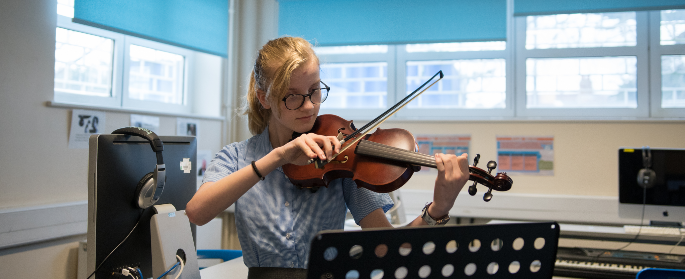






RECRUITMENT PACK

Dear Colleague,

Post: Teacher of SEN (Secondary)

Thank you for your interest in this post. To help you decide if the job would suit you please read through this recruitment pack, which we hope will give you a flavour of what the school is about and of what we expect from the successful candidate.

Redden Court is a high achieving, successful, well-ordered and caring mixed comprehensive school for students aged eleven to sixteen. We are very proud of our school, our students and the Harold Wood Community in which we serve.

Our vision is focused on ‘Commitment to Success for All’ with aspiration for all members of our community. Redden Court is the founding member of the Success for All Educational Trust.

If you would like to become a member of our thriving and successful community, please complete an application form here and return to jobapplications@sfaet.co.uk by the deadline of Wednesday, 28th September 2022 at 12pm. Interviews will take place on Wednesday, 5th October 2022.

If you wish to have an informal discussion about the post before applying please feel free to contact our Head of Faculty on 01708 342293 or by emailing ktempleman@reddencourtcloud.co.uk

I look forward to receiving your application.



Yours sincerely,



Mr A Henry
Headteacher

General Information

The Redden Court School motto "Committed to Success for All" embodies what our school believes in and represents our common goal. We aim to incorporate this vision into everyday school life and ensure that all students have the best opportunities made available to them. Success can and will be found in different goals for a vibrant and varied student body and we value all of our students as individuals with unique talents and interests. We support our students to always be the best that they can be.

Notable Achievements
- In 2021, Ofsted recognised there was enough evidence of improved performance to suggest that the school could be judged outstanding if the inspectors were to carry out a section 5 inspection now. The school’s next inspection will be a section 5 inspection
- In 2021 we were awarded the Wellbeing Award for Schools
- In 2020 we were awarded the SSAT award for exceptional outcomes for our SEND Students
- We have recently been re-accredited as a Thinking School by the CEDU at the University of Exeter
- In 2019 we were awarded the ‘Quality in Careers’ standard for our work in this area

Building and Resources
The school is situated in Greater London, Romford, close to the M25, A12 and A127 and just 10 minutes walk from Harold Wood Railway Station. The school has on site parking for staff and visitors.

The school was built in 1931. Over the years we have expanded the site to accommodate our growing number of students, including two brand new buildings. We have new state of the art facilities in Science, technology and PE. Furthermore, there has been lots of renovation to the existing buildings which makes the school a pleasant learning environment for students and those to come. Our students enjoy well presented classrooms, clean and well kept facilities as well as pleasant dining and social time areas.

SLT
- Mr A Henry, Headteacher
- Mrs S Thompson, Deputy Head of Student Achievement
- Mr S Carrington, Deputy Head of Teaching and Learning
- Mr K Ward, Deputy Head of Pastoral
- Miss T Greaves, Assistant Head of CPD, ITT and Timetabling
- Ms J Tyldesley, Assistant Head of Inclusion
- Mr M Hoque, Director of Pastoral
- Mr D Pendred, Director of Technology
- Mr T Hughes, Director of Sports

Staff
We have 72 teachers, who are supported by 60 professional and competent Student Development Assistants and support staff. We work as a unified team to support and enhance the learning experiences of our students.

Wellbeing
Redden Court values its staff's wellbeing. We endeavour to offer a holistic approach to ensure all our stakeholders are supported in their emotional, physical and mental health.

We offer the following staff benefits:
- Career Development (apprenticeships, support towards achieving further qualifications, leadership programmes, progression opportunities, teacher training, shadow opportunities and a vast CPD programme of relevant courses)
- Pension
- All teaching staff are allocated a Chromebook
- Multi Gym available for staff use
- Staff supervision sessions with a trained professional
- Cycle-to-work scheme
- The school is signed up to the Schools Advisory Service which offers:
- a 24 hour GP helpline,
- access to physiotherapy sessions,
- access to a counselling service,
- free 12 week weight management programme,
- support for stress management,
- lifestyle screening,
- menopause support,
- long term condition support,
- private medical operations.
- Regular staff social and get-together events
- A regular staff survey consults staff and takes actions based on the results.

Edtech
Redden Court School has been recognised as a specialist of computing technology for over a decade, and has always invested in modern technology to enhance the curriculum.

The Department for Education selected Redden Court School in 2020 as one of its Edtech Demonstrator schools to support 100s of other schools in the country with their use of technology in education. This was initially to help schools to respond to the pandemic but the project has continued to expand. In 2017 Google selected us to become one of the only Google Reference Schools in the UK as a result of our success over the years, giving us early, exclusive access to upcoming tools and the opportunity to attend and showcase at events. We have also gained international recognition welcoming many visitors from abroad to support them with their own development.

Google Workspace for Education is an exciting and innovative way of learning, introducing easy tools to engage students whenever, wherever on any device. In 2012, we adopted this free web-based communication and collaboration suite available to education establishments. With products including Gmail, Google Classroom, Calendar, Drive, Docs, Meet, Slides and Sites, we recognise the influence that these tools have on classroom and distance learning, our collaboration inside and outside of school, improvements in administrative efficiency and providing remote access for all. This enables all our students and staff to have access to the most up-to–date technology.

We have also rolled out a 1:1 Chromebook scheme with our students, with many of them buying the device through us, as an affordable browser-based device that provides quick, simple access to our online platforms. We also provide teaching staff with a Chromebook to support our edtech focus. Staff are offered a wide range of CPD to develop their skills in this area.

Recent Results

Results 2021 | Redden Court School
Attainment 8 | 56.73%
Basic English & Maths (strong) | 63.70%
Basic English & Maths (standard) | 78.77%
Ebacc entered | 92.49%
Ebacc APS | 5.32

Pastoral Care
We currently have 973 students at Redden Court and will continue to expand to 1050 over the next couple of years. The pastoral team is particularly well staffed and this allows us to form a wide and comprehensive net of care around our student body.

The team is made of:
- Deputy Head - Pastoral Care
- Pastoral Director
- 5 non-teaching Heads of Year
- Home School Support Worker
- Education Welfare Officer
- 2 Learning Mentors
- 3 Student Service Officers
- Pastoral Support Officer
- Pastoral Administration

We also buy in counselling and mentoring services which, taken as a whole, provides a support base to our students which is second to none.

SEND
We are proud of our reputation for achieving exceptional outcomes for our children with special educational needs and disabilities. We support our students with SEND in mainstream with a combination of in-class support systems and withdrawn interventions. Children who need a higher level of support are educated in our Nurture Group and move on to study GCSEs on the Blue Pathway where they benefit from small classes and a high ratio of adults to children.

Redden Court also supports some children with EHCPs using our Additional Resourced Provision (ARP) funding. We are pleased to be able to offer bespoke packages of support for our children with the most complex needs.

Our dedicated SEND team consists of 5 SEND Teachers and 22 Student Development Assistants (SDAs) led by the Assistant Headteacher for Inclusion and the ARP Lead. Leaders on the SEND team are highly invested in developing staff. Many former SDAs have found their experience on the SEND team to be a vital step as they move towards new careers in teaching, mentoring, counselling or other pastoral work with children.

CPD and Training
We invest heavily in our own staff training and development at all levels, from Initial Teacher Training, Associate and support Staff, through to Senior Leadership level. We run an in-house comprehensive programme each year which includes whole school CPD, faculty training, ECT and RQT professional studies, ASPIRE Teaching and Learning workshops and additional voluntary training sessions. We also offer a wide range of opportunities for staff to gain leadership experience such as termly or yearly secondments onto the pastoral team or senior leadership team. In addition we subscribe to the National College and actively encourage staff to take responsibility for their own professional development by completing courses and certificates online.

Values and Ethos
At Redden Court School our staff values are closely aligned to our student values, ASPIRE. Every individual is valued for what they contribute to our community.

- Ambitious - To be passionate in our desire and determination to achieve success and exceed our potential.
- Supportive - To provide encouragement, physical and emotional support to others where it is needed.
- Professional - To recognise ourselves as role models and demonstrate positive examples to students and each other at all times.
- Innovative - To be creative and open to change and new ideas.
- Respectful - To treat others with dignity and respect; to celebrate and welcome diversity.
- Equality - To promote and ensure that every individual has an equal opportunity to make the most of their lives and talents.

Collectively these values help to raise standards, develop positive behaviours and develop individuals. We recognise that through these values our staff work towards a common goal that supports the vision for our school.

Ofsted
Our last Ofsted report can be found here.

“There is a strong sense of team and belonging among staff, students and parents who feel valued and listened to. Members of the school community genuinely
care for and look out for each other.”
Wellbeing Award for Schools, 2021

