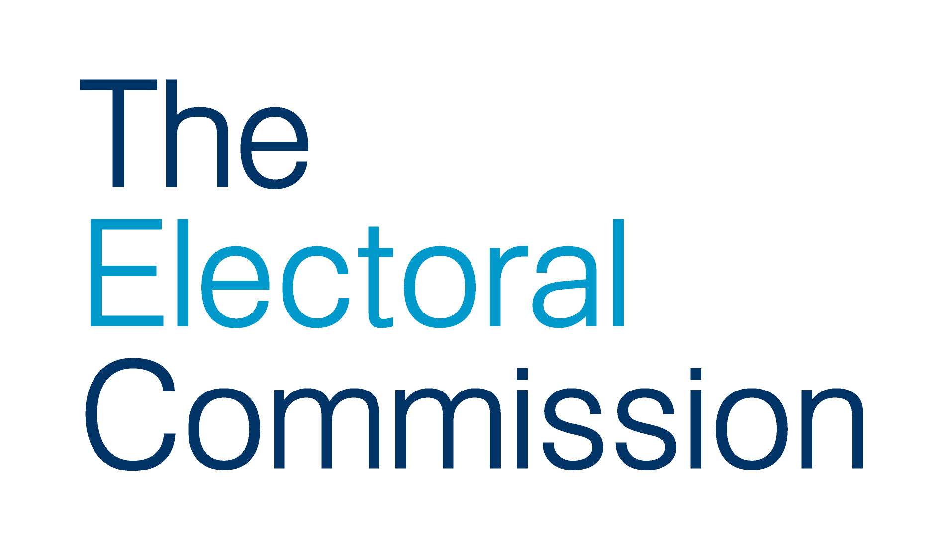
Job description

Job Title: Legislation (Policy) Senior Adviser

Directorate: Regulation

Responsible to: Head of Legislation Strategy and Coordination

Responsible for: -

Overall purpose

Election-related legislation is currently before the UK Parliament – including the Elections Bill – and the Welsh Senedd. Over the coming months this is likely to be supplemented by a significant volume of new secondary legislation covering a wide range of electoral policy areas.

With the aim of supporting and overseeing well-run elections and securing compliance and integrity about political finance and in line with the Commission’s vision, strategic objectives and plans, the post holder will be responsible for ensuring that the Commission’s work to respond to secondary legislation is planned, coordinated and monitored.

Main responsibilities

- Planning, coordinating and monitoring the Commission’s work to respond to the secondary legislation needed to implement key provisions in the UK Government’s Elections Bill and other legislative reforms.

- Working closely with the Commission’s policy, guidance, legal and Scotland, Wales and Northern Ireland teams in helping to coordinate the Commission’s responses to statutory consultations on draft secondary legislation.

- Ensuring interdependencies, assumptions and risks about secondary legislation and the Commission’s implementation plans are captured and clearly communicated across the Commission.

- Liaising with Government officials to ensure that the Commission’s plans, assumptions and expectations about secondary legislation are communicated, and that information used to inform the Commission’s plans is accurate and up-to-date.

- Providing advice and regular updates to the Head of Legislation Strategy and Coordination and Head of Policy on the progress of the Commission’s work on secondary legislation and on any changes to planning assumptions.

- Attending relevant internal and external meetings to represent the Commission; providing briefings on progress and issues with secondary legislation for senior staff in respect of such meetings.

Additional details

This role requires the post holder to work both autonomously and as part of a key cross-Commission programme team to coordinate the Commission’s essential work on secondary legislation.

The post holder is expected to use their planning and communication skills to ensure that this work is managed effectively and delivered in accordance with internal and external expectations, and to use their judgement to challenge and influence as appropriate.

The post-holder will be expected to use the Commission’s project and programme management methods as required.

Key working relationships

The post-holder will be based in the Commission’s Legislation Strategy and Coordination team. They will be expected to develop good working relationships with colleagues across the Commission to ensure the effective management of the responsibilities of the post. In particular, this will require the development of a strong and integrated working relationship with the policy, legal and devolved office teams, as well as operational teams specialising in the regulation of political parties, elections and referendums and electoral administration.

The post-holder will also need to develop strong working relationships with UK, Scottish and Welsh Government officials to inform the effective planning and coordination of the Commission’s work on secondary legislation.

Person Specification

Competency | Requirement | Essential or  Desirable
Qualifications | Degree level education or equivalent relevant experience | E
Experience | Substantial experience of planning and coordinating activities involving complex work streams  Detailed knowledge and relevant experience of working with central Government policy and legislative processes  Experience of problem solving with the ability to interpret complex legislation and to translate it for others  Experience of analysing information, identifying trends and presenting findings.  Experience of leading policy development and proven experience of influencing decision-makers, ideally in a diverse and fast-moving policy environment | E  E  E  D  D
Knowledge and skills | Excellent written and oral communication skills, with ability to use plain English to communicate content in a clear style  Well–developed interpersonal and communication skills  Ability and experience of working in an environment where close attention to detail and accuracy are critical  Familiarity with UK political systems and structures  Good level of IT skills including MS Excel, Word, Project, databases and Outlook  A strong commitment to delivering results and continuous improvement  Ability and experience of effective planning and organising and managing own time  Diplomacy, tact and discretion | E  E  E  E  E  E  E  E
Personal Qualities | The ability to work independently and flexibly, including under limited supervision and as part of a team  The ability to use initiative to solve problems, including meeting the needs of diverse stakeholders  A flexible approach to work and ability to manage changing requirements and business priorities as necessary  Possess an understanding of, and interest in, democracy and the electoral processes in the UK | E  E  E  D

Bold type indicates minimum criteria

October 2021

