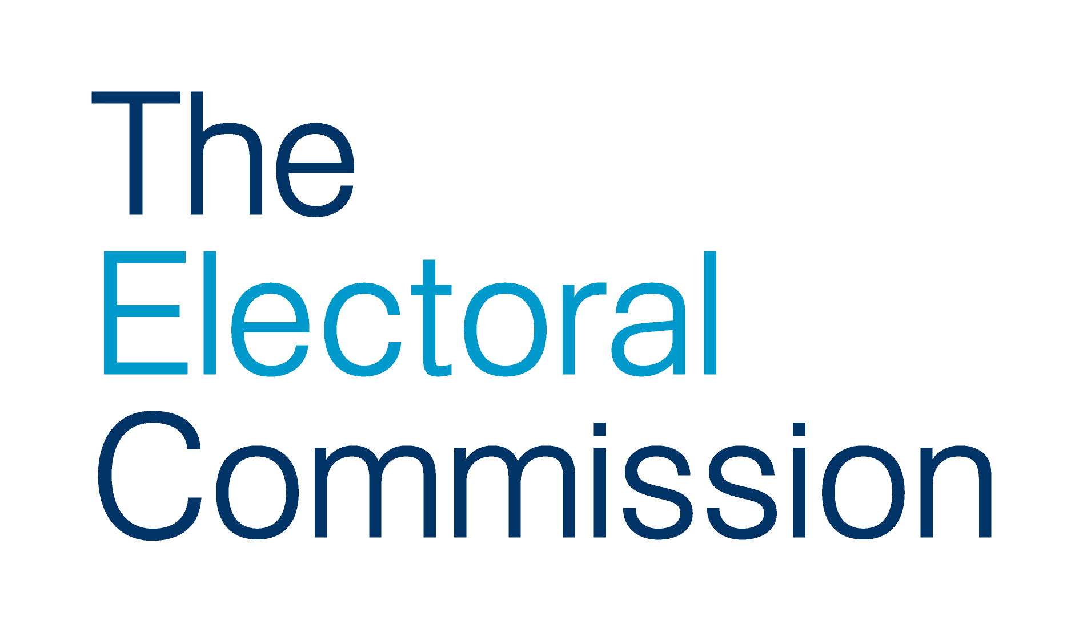

Job Description

Job Title: Senior Adviser – Risks and Benefits

Directorate: Finance and Corporate Services

Responsible to: Planning and Performance Manager

Responsible for: N/A

Overall purpose of the post
To provide expert advice to the Commission and its staff on risk management and benefits management.

To lead the embedding of the Commission’s risk management strategy and benefits management strategy, and ensure that processes the Commission has in place to support risk management and benefits realisation are developed, understood and undertaken.

Main responsibilities
- Maintain and review the risk management strategy, including our risk management policy; and the benefits management strategy, including the benefits realisation plan.
- Ensure the risk management policy and benefits realisation plan are implemented, prepare analyses and develop plans to improve the management of risks and benefits, escalating risks and issues as necessary.
- Provide ongoing, comprehensive and expert advice and guidance to all staff and Commissioners on risk management and benefits realisation, including the identification of dependencies, lessons learnt and dissemination of learning.
- Analyse, advise, report and provide assurance to the Executive Team, Senior Leadership Group and Audit Committee of the Commission Board on a quarterly basis on the management of risk implementation and realisation of benefits.
- Participate (as appropriate) and coordinate risk identification, assessment, planning, management and validation of threats and opportunities, including mitigating actions, to manage risks and maximise opportunities.

- Participate (as appropriate) and coordinate benefits identification, creation and maintenance of profiles, maps and forecasts, to define, quantify and leverage benefits and minimise dis-benefits.
- Design and facilitate risks and benefits discovery workshops.
- Develop and deliver guidance and on-going training for staff and Commissioners, appropriate to their role, to embed risk management and benefits realisation.
- Contribute to the PMO, including the completion of benefits reviews and assessment of change requests for their impact on the management of risk and the realisation of benefits.
- Carry out ongoing risk and benefits management maturity assessments and contribute to other quality management activities as be appropriate.
- Support Directors, Heads of Service and other audit report lead officers to implement internal audit activities and maintain the log of internal audit recommendations and actions for the Audit Committee of the Commission Board.

General
- Understand, and actively promote, the aims and objectives of the corporate plan, business and service plans; the performance management framework, including monthly and quarterly management reports; and use corporate systems.
- Understand and actively promote our project and programme management framework, including supporting project sponsors, managers and teams.
- Ensure equality of opportunity is maintained and respected at all times in accordance with the appropriate policies and procedures.
- Comply with the statutory provisions of the Health and Safety at Work Act 1974.
- Actively participate in opportunities to communicate within the organisation including attending team and directorate meetings.
- Make full use technology for all appropriate tasks.
- Demonstrate a willingness to work flexibly with others to respond to needs of an evolving organisation.
- Perform any other duty as directed by the Head of Strategic Planning and Performance.

Additional details

The post-holder will have significant opportunity to shape the Commission’s approach to risk management and benefits management.

The risk management strategy, policy and guidance is due for a refresh and update. A greater focus on risk appetite and risk tolerance, as well as tracking mitigation actions, has been requested by the Executive Team. In addition, a new system being implemented this year will integrate the ways risks and benefits are linked with actions, both projects and business as usual activities, and business plans.

The post holder will play an important role in the development of our benefits management strategy. Our practice around the profiling, mapping and tracking benefits (or impact) is currently undergoing substantial refresh.

Further information about benefits management can be found online, by searching the Association of Project Managers website, or following this link. A benefit is a measurable improvement from change, which is perceived as positive by one or more stakeholders, and which contributes to organisational objectives. Benefits management is the identification, quantification, analysis, planning, tracking, realisation and optimisation of benefits.

The post holder is a member of the Performance, Planning and Governance Team, within the Finance and Corporate Services Directorate. The role is also a member of the corporate programme management officer (PMO) which supports the delivery of change initiatives across the Commission. As a member of the PMO, the post holder is expected to assist and contribute to project management both generally, and specifically in terms of risk management and benefits realisation.

Demonstrating value for money, and impact (or benefits realisation) is important in this role.

There may be occasional travel to the Commission’s offices in Edinburgh, Cardiff and Belfast, although the Commission also makes extensive use of video and telephone conferencing technologies.

Key working relationships

Directorate wide: A key day-to-day working relationship is with the Head of Strategic Planning and Performance. Key colleagues include those within the Planning and Performance Team and the corporate PMO, including the Head of Projects, Head of IT and Facilities, Head of HR and the Financial Controller.

Organisation wide: The post holder will need to establish and maintain strong working relationships with colleagues across the Commission as necessary in order to ensure the effective delivery of the responsibilities of the post. This may include regular contact with Commissioners, the Chief Executive, Directors, other members of the Senior Leadership Group, members of the corporate PMO, the independent advisor to the Audit Committee, the internal auditors, and project teams, providing advice on risks and benefits where necessary.

The key success factor for this role is the ability to work across both strategic and operational levels, ranging from an attention to detail and an ability to work methodically and logically, to the ability to feed into strategy development and influence senior stakeholders. Therefore the post holder will need to demonstrate strong interpersonal skills and be able to develop and maintain effective relationships with key colleagues, particularly risk owners and benefits owners. The Commission’s continually updates its business plans and contingency plans, so the post holder will also need an ability work constructively with ambiguity and uncertainty.

Specialised knowledge

It is essential that the post holder can bring sound professional knowledge, expertise and experience to their functional areas – risks and benefits – including an excellent grasp of key concepts and issues.

Candidates that are able to demonstrate that they bring equivalent experience in risk management and benefits management are welcome, as qualification training will be available. Aptitude for the role is considered the critical quality for the post holder as we expect to provide training on the Commission’s approach to risk management and benefits management.

People Management

The post holder does not have any direct reports, although as this role is at senior advisor level this possibility may arise in the future.

Risk Management and Benefits Management

As the senior advisor on risk management and benefits management, the post holder needs to work effectively with the Senior Leadership Team and corporate PMO – for example to design risk profiles or benefits maps.

This job description reflects the present requirements of the post and should not be seen as an exhaustive list of responsibilities. Duties and responsibilities may develop and change in consultation with line management.

Person Specification

Competency | Requirement | Essential or  Desirable
Specialist knowledge and experience | Educated to degree level or equivalent experience  Managing Benefits (Practitioner) certificate, Management of Risk (Practitioner) certificate, project management qualification or equivalent experience and knowledge  Experience of policy development and review within the field of risk management and benefits management  Good IT skills, including most Microsoft Office packages, Word, PowerPoint, etc. | Essential  Essential  Essential  Essential
Delivering results | Able to use own initiative to proactively seek out problem areas, or areas where activities, policies or functions could be improved  Experience of evaluating activities and policies and making formal risk and benefit interventions, that have possibly led to changes in activities or direction | Essential  Essential
Problem solving | Strong analytical and problem-solving ability, including the ability to negotiate with managers on reasonable changes and solutions to problems identified | Essential
Planning | Able to prioritise, manage time pressures and meet tight deadlines  Experience of project management, planning and performance | Essential  Essential
Communication | Strong written communication skills  Strong oral and interpersonal communication skills and confidence in dealing with senior managers and external stakeholders  Experience of giving formal presentations and developing and running training sessions | Essential  Essential  Essential
Team working / managing relationships | Ability to form positive, proactive working relationships with senior stakeholders (Commissioners, directors), managers and others within the organisation  Team player  Leadership skills in relation to risks and benefits, being a key individual in the organisation driving the realisation of benefits | Essential  Essential  Essential
Personal effectiveness | Confidence and knowledge to advise senior managers on their duties in relation to risk management and benefits realisation | Essential
Business management | Familiarity with UK political systems and structures, including central and local government | Desirable

Bold type indicates minimum criteria

Definition adapted from Managing Benefits, APMG, 2014, p.15.

