|  |
| --- |
| JOB ROLE PROFILE AND PERSON SPECIFICATION |

Post Title and Number: **Commercial Manager**

Present Grade: **MM2**

Department: **Place**

Service/Section/Team: **Meridian Water Team**

Reports to (title): **Delivery Director**

|  |
| --- |
| Overall purpose of the Role: |

Meridian Water is Enfield Council’s flagship programme to create a new neighbourhood and deliver 10,000 new homes and 6,000 jobs over the next 25 years.

The commercial manager will be a key part of the delivery team focusing on a broad and interesting range of development and construction related projects. These will range from meanwhile use to high rise residential developments. Projects values start from £000’s to in excess of £200m.

The commercial manager will ensure best value in the procurement and delivery of building contracts, consultant appointments and development agreements. It is expected this person will have held previous commercial roles, perhaps as a quantity surveyor, cost manger or commercial manager. They will likely be professionally qualified RICS or similar. They will bring market knowledge and a desire to apply this within a client-side organisation on a fantastic regeneration project.

To take specific management responsibility for all construction projects, with regard to quantity surveying services and cost related matters, whether provided internally or externally, including provision of estimates, cost plans, bills of quantity, tender documentation, procurement processes, contract management and cost control. This will include preparing and entering contracts and appointments. Monitor expenditure and ensure relevant systems are updated, including the Council’s Quarterly Monitor, prepare any necessary reports for authorisation, in liaison with the relevant Project Manager.

|  |
| --- |
| Dimensions including Structure Chart: |

1. **Annual budgetary amounts with which the role is either directly or indirectly concerned**:

The post holder is responsible for the monitoring and management of substantial capital budgets in excess of £100 million.

**Structure Chart**

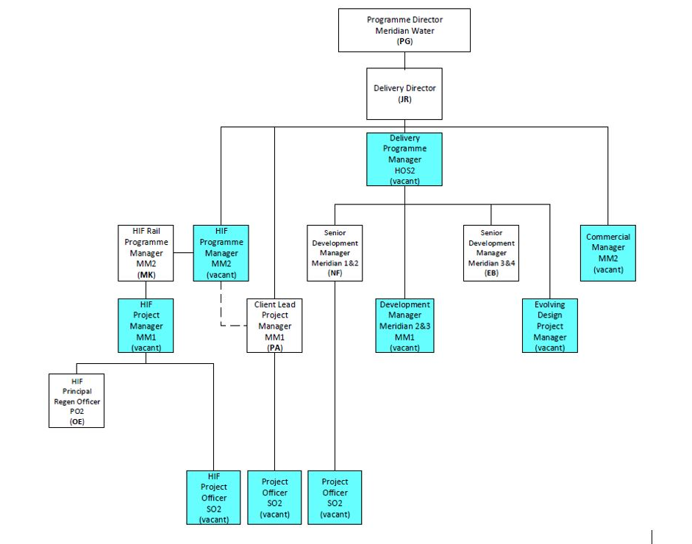

1. **Number of direct reports**

The postholder will have no more than 2 direct reports. They will work with colleagues across the team and in wider teams at all levels. This will involve influencing, advising and developing staff as appropriate.

There will be oversight of external consultants and contractors and developers, where this role will be a seen as the client lead for commercial matters.

Involvement in the supervision of a large number of consultants undertaking a variety of complex planning and regeneration activities, including scheme design and development, planning, legal, procurement and development appraisal and viability.

To advise and train the wider team to ensure they are kept up to date with current techniques and practices for which the postholder is responsible through day to day contact and regular team meetings.

The role is required to deputise for the Delivery Director when required.

1. **Nature of reporting relationship between post holder and line manager and wider team**

The postholder will have regular one to one meetings with the Delivery Director. Also attendance at regular team meetings, as well as relevant project meetings and boards.

**Any other relevant statistics**

Management of external consultants commissioned to deliver housing, infrastructure and environmental regeneration projects. The post holder is expected to supervise the input into regeneration projects of other members of staff from across the council through cross departmental matrix working groups. Close working with local community groups, community leaders and other council stakeholders and to develop effective partnerships and build relationships with key internal and external stakeholders.

The post holder is expected to use relevant Project Management Systems (e.g. Verto, Covalent, MS Project) and principles in the preparation, reporting, delivery and monitoring of regeneration projects.

|  |
| --- |
| Key Accountabilities: |

|  |  |
| --- | --- |
| **Accountabilities** | **Percentage of Time (%)** |
| 1. **Contract administration.** Ensure excellent contract administration processes are in place for all contracts and appointments including project and programme level reports. Specifically cost control, certification / payments to contractors, and adherence to agreed programmes. Oversee all aspects of contract management ranging from the preparation of contract documents to approval of final accounts. | 20% |
| 1. **Lead the commercial service on projects.** Set the brief and deliverables for provision of cost management services. Challenge proposals and costs estimates for completeness and appropriateness, look for alternative approaches that deliver better value. Negotiate directly on behalf of LBE where required, pre and post contract. | 15% |
| 1. **Monitor and control budget expenditure** relating to scheme development and delivery, in line with corporate financial regulations. Carry this out at project and programme level. Manage team wide budgets of revenue and capital. Manage and administer funding agreements and necessary associated submissions. | 15% |
| 1. **Project Management.** Undertake the role of Project Manager for projects outsourced to consultants, or contribute to the Project Management function, ensuring that sound project management principles are followed with clear briefing and commissioning procedures, gateway controls, risk management, and reporting. | 15% |
| 1. **Commissioning and Management of Contractors and Consultants.** Identify the requirement consultants and contractors. Determine and specify services to be provided, undertake any necessary fee tendering processes valuation of fee bids and recommending appointments. Chair briefing meetings monitor progress and provide direction to achieve desired outcomes and ensure the service provided meets expectations. Prepare contracts and appointments. | 10% |
| 1. **Market knowledge and data management.** Hold an up to date understanding of cost drivers and council requirements, benchmarking this against the market. Keep updated and circulate this in MW and wider council teams. Be responsible for maintaining specification and cost data. Familiarity with main contact forms (JCT, NEC). Establish and maintain standard terms and contract amendments. Develop policies, procedures and core standards to achieve best value in the design, procurement and maintenance of buildings. | 10% |
| 1. **Performance reviews**. Undertake regular reviews of services by consultants, providing feedback to Consultants and those managing frameworks or approved lists. Where necessary take intervention to give specific direction, serve notices of concern or make recommendations to the Delivery Director | 5% |
| 1. **Cost advice**. Provide professional advice on feasibility to model options. Feed into financial models and appraisals. Advise on claims and disputes procuring any necessary resource. | 5% |
| 1. **Sustainability.** Ensure that projects take due consideration of the local and national sustainability agenda. Ensure opportunities for innovation and incorporation of energy / carbon saving measures are taken, as appropriate to each project. | 5% |
| 1. **Support Council Processes and Government Processes.** Uphold all Council corporate policies, procedures, initiatives. Follow due process for obtaining authority, preparing, or contributing to / consulting on Committee Reports, Forward Plans, Key Decisions. Undertake / contribute to any devolved actions, including representing the Service on cross-departmental working parties, Project Boards etc. Deputise for the Construction Programme Manager or Maintenance Programme Manager when required. | Incl. |
| 1. **Undertake promotional activities** to raise the profile of project delivery in Meridian Water at a local, regional and national level. | Incl. |
| 1. Any other duties reasonably requested by management | Incl. |

|  |
| --- |
| Key Relationships (Internal and External): |

* Regular key relationships on a one to one basis include other senior and professional officers within the council, council members, partnership organisations, the GLA and other government and public sector organisations, statutory undertakers, developers and landowners within the borough, senior officers in adjoining boroughs
* The Chief Executive, Directors, Heads of Service and other officers as appropriate
* Enfield’s MPs
* MHCLG and GLA and other partners / funders
* Developers
* Lead consultants for specialist services
* Landowners, Leaseholders and Agents
* Residents and businesses directly affected by regeneration proposals
* Representatives of public, private and voluntary sectors agencies with whom the Council may work in partnership

|  |
| --- |
| Equality and Diversity: |

The Council has a strong commitment to achieving equality in its service to the community and the employment of people and expects all employees to understand, comply with and promote its policies in their own work.

|  |
| --- |
| Health and Safety: |

The post holder shall ensure that the duties of the post are undertaken with due regard to the Council’s Health and Safety Policy and to their personal responsibilities under the provisions of the Health and Safety at work Act 1974 and all other relevant subordinate legislation.

For a more detailed definition of these responsibilities, refer to the current versions of the Corporate Health& Safety Policy, Group Safety Policy and employee information leaflet entitled "Health & Safety Policy; Guidance on Staff Health & Safety Responsibilities".

|  |
| --- |
| Corporate Health and Safety Responsibilities: |

All employees have personal responsibilities to take reasonable care for the health and safety of themselves and others. This means:

1. Understanding the hazards in the work they undertake;

2. Following safety rules and procedures;

3. Using work equipment, personal protective equipment, substances, and safety devices correctly; and

4. Working in accordance with the training provided and only undertaking tasks where appropriate training has been received.

Employees shall co-operate with the Council by allowing it to comply with its duties towards them. This requires employees to:

* take part in safety training and risk assessments and suggest ways of reducing risks; and
* take part in emergency evacuation exercises.

Employees shall report all accidents, ‘near miss’ incidents and work-related ill health conditions to their manager/supervisor/team leader.

Employees shall read the Corporate Health & Safety – Organisation Part B Policy to ascertain and understand their responsibilities as an employee, line manager, Assistant Director or Director of the Council.

|  |
| --- |
| Information Security: |

In order to protect the confidentiality, integrity and availability of Council information, including information provided by customers, partner organisations, and other third parties, where applicable, employees will comply with the Council’s Information Security Policy.

|  |
| --- |
| Statement of Commitment to Safeguarding of Children and Vulnerable Adults through safer employment practice: |

Enfield Council is committed to safeguarding and promoting the welfare of children and vulnerable adults. Safe recruitment of staff is central to this commitment, and the Council will ensure that its recruitment policies and practices are robust, and that selection procedures prevent unsuitable people from gaining access to children, young people and vulnerable adults. All staff employed to work with or on behalf of children and young people in the Council must be competent.

All staff working with Children & Vulnerable Adults should be aware of and share the commitment to safeguarding and promoting the welfare of children, young people and vulnerable adults when applying for posts at Enfield Council.

|  |
| --- |
| PERSON SPECIFICATION |

**Job Title:** Commercial Manager **Grade:** MM2

**Department:** Place  **Team:** Meridian Water

|  |  |
| --- | --- |
| **KNOWLEDGE, SKILLS & ABILITIES** (You are not restricted to 2 criteria for each category) | **HOW TESTED**  Application – A  Test – T  Interview – I |
| **Job Specifics – Skills, Experience**  **Essential:**   1. Knowledge and proven experience of leading the commercial aspects of regeneration projects in the public sector, with a sound knowledge of the technical, legal, commercial and socio-economic factors that affect and influence major projects. 2. Procurement experience, including leading and implementing large scale procurements with a sound knowledge of OJEU tendering procedures and managing multi-disciplinary consultant teams. 3. Working knowledge of JCT and NEC contracts 4. Significant regeneration project management experience, using agreed Project Management protocols and gateway procedures to deliver physical and/or socio-economic projects. Ability to produce performance and monitoring reports in line with project reporting requirements. 5. Experience of interrogating and analysing a range of relevant commercial and technical data and concisely convey a clear message to decision makers 6. Stakeholder management and communication skills, including the ability to develop and maintain relationships with a diverse group of stakeholders, including landowners, developers, strategic partners, businesses and residents, senior Officers and Members. This will also include the ability to present information both orally and in writing, through appropriate decision-making reports. 7. Ability to manage capital and revenue budgets and interrogate financial information for accuracy and to ensure best value for the Council.   **Desirable:**   1. Significant knowledge and understanding of regeneration and economic growth issues in London. 2. Prince 2 Project Management qualification. | **A/I**  **A/I**  **A/I**  **A/I**  **A/I**  **A/I/T**  **A/I** |

|  |  |
| --- | --- |
| **Behaviours**  Appropriate behaviours are key to the delivery of our vision for Enfield.  We want staff who will work collaboratively, flexibly and constructively, and exhibit this ethos in all their dealings with residents, colleagues and partners. Our leaders will be exemplars of the following behaviours and encourage them in staff at all levels;  **Takes Responsibility**  We want staff who are willing to make decisions and be accountable for them. Staff should have a positive can-do attitude where they see problems as challenges which can be overcome. They should accept responsibility for service delivery, be clear about their service offer and deliver what they promise.  **Is Open, Honest and Respectful**  We want staff who are comfortable and confident to acknowledge the difficulties and the barriers they face. They should also be able to constructively challenge the way things are done where there is evidence that it impedes service delivery. Challenge should be conducted in a professional, courteous manner with the aim of reaching a mutually agreeable resolution.  **Actively Listening and Learning**  We want staff who are prepared to actively listen and reflect on customer concerns with a view to understanding the customer’s point of view. Staff should be able to receive constructive criticism and be prepared to adapt the way they operate and deliver services where appropriate.  **Working Together to find solutions**  We want staff who can work collaboratively with other departments and partners, freely sharing their knowledge and skills to identify solutions to address customer concerns.  **Candidates: Please ensure you address these behaviours in your responses to the essential and desirable (if applicable) criteria above.** | **A/I** |
| **Competencies:**  **Candidates: Please ensure you address these competencies in your responses to the essential and desirable (if applicable criteria above).**  1. Taking Initiative- seizing opportunities 4. Planning and managing resources  2. Communication & Influence 5. Working in partnership  3. Self-confidence 6. Intellectual adaptability |  |
| **Qualifications & Professional registration criteria**  **Candidates: Please ensure you address these qualifications in your responses to the essential criteria, you will be expected to meet these requirements of the role and they will be explored with you at interview.**   1. Membership of appropriate professional body e.g. RICS/ CIMA 2. Degree qualification in a relevant subject e.g. Surveying, Engineering, Accountancy, Regeneration | **I** |
| **Special requirements**  **Candidates: Please note you will be expected to meet these requirements of the role and they will be explored with you at interview.**  **1.**  Ability to travel within and outside of the Borough to meetings and site visits. These meetings may take place at evenings and weekends | **I** |