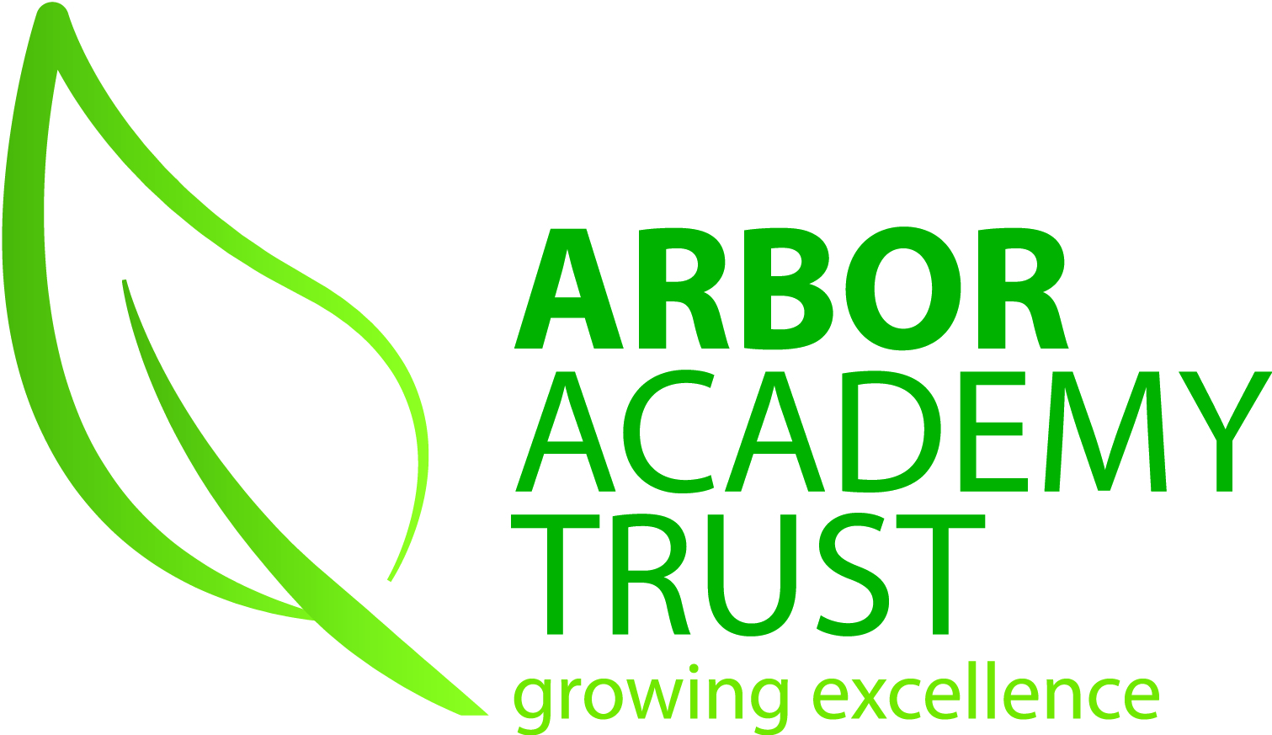

JOB DESCRIPTION

Job Title: Graduate Trainee

Grade: Scale 5

Scale point : 12

Responsible to: CEO & Executive principal

Responsible for: None

Job Purpose

The aim of this role is to give graduates an insight into how the challenging environment of a Trust and its schools operate, and to develop the appropriate skills necessary for a leadership career within Education and Schools.
Whilst working within our Trust, the role holder will have the responsibility for the successful delivery of set projects that have clear objectives with achievable and recognisable outcomes.
These will incorporate day-to-day operational work allowing the graduate to contribute to the on-going work of the Executive team in which they will be based, working directly with the CEO and Executive principal.
The successful graduate will have the opportunity to work within all schools within the Trust and will develop their skills, knowledge and experience within the Education Sector.
The graduate will gain experience in Schools administration and management, and develop knowledge and skills necessary for a leadership career in schools. This will cover training in key methods and processes as well as undertaking project based and operational work which will contribute to the work of Executive team at Arbor Academy Trust.

Key External Contacts

- Contractors
- Local Authorities
- Education Authorities

Key Internal Contacts

- Executive team
- Senior leadership
- Staff
- Governors/Trustees

Major Tasks, Duties and Responsibilities

Main duties and responsibilities:
1. Contribute to projects and initiatives:
• Take on operational responsibility for completing projects and developmental work within our schools, ensuring successful delivery in line with agreed timescales and to the required quality standard.
• Provide overall day-to-day coordination of the project, act as the main point of contact for the project.
• Organise project events and carry out duties related to projects as directed by the CEO and Executive principal.
2. Administration:
• Produce detailed project outlines and plans, collate project documentation, create and update documents as required.
• Develop an understanding of School administration and policies
• Support administrative tasks and processes within a number of schools as directed by the CEO and Executive principal.
• Complete operational work that contributes to the ongoing work of the team.
3. Contribute to policy and strategy:
• Write assigned sections of reports and provide/ distribute and update reports for the Trust Board and committees within the Trust.
• Contribute to policy redrafts and updates in all areas and publication of the policies.
• Support communications with the Executive team within the Trust.
• Coordinate the delivery of project communications
• Establish and maintain effective and productive working relationships with the Executive team within the Trust
• Liaise with staff at all levels across the Trust to identify and share best practice
4 Professional development
• Take personal responsibility for continuous personal and professional development and actively participate in the day to day functions of Trust life

Other requirements:

- To have an up-to-date Enhanced DBS Disclosure.

This role profile outlines the duties required at the current time to indicate the level of responsibility. It is not intended to be a comprehensive or exhaustive list and may be varied to include other reasonable requests which are up to the same skill level, and of the same type, already undertaken and which do not change the general character of the job or the overall level of responsibility

