**MUSIC TEACHER APPLICATION PACK**

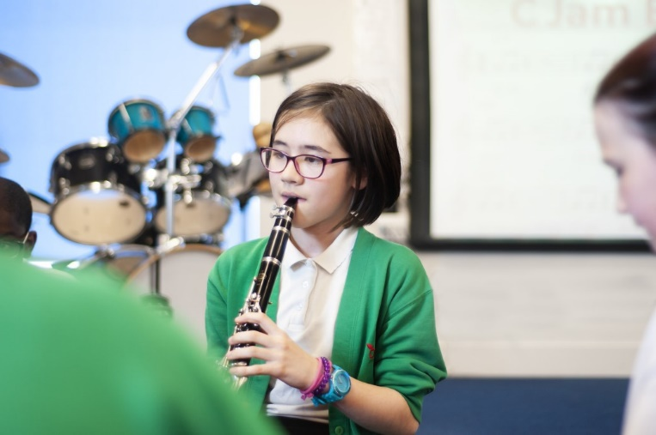

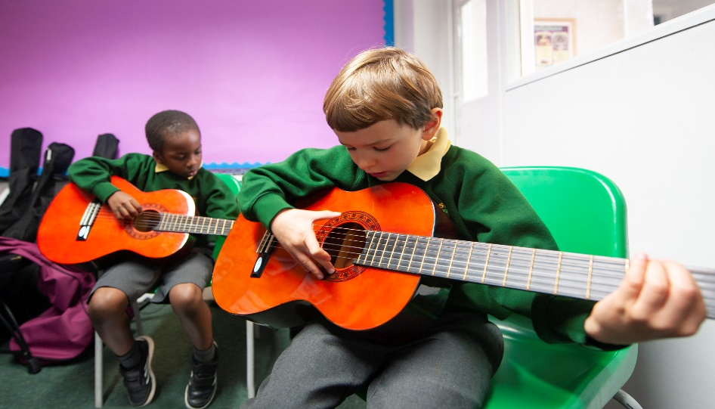

### Dear Applicant,

Thank you for your interest in the position of a music teacher at our schools. I hope that you will find this information pack helpful. If you would like to learn more about this post we would be delighted to answer any questions you may have and can offer tours of all three sites to meet children and staff.

We are seeking a dynamic music teacher to join our two existing music teachers and work at Orchard School full time to cover maternity on a six month fixed contract. Orchard Primary works in partnership with two other Hackney Schools, Southwold and Hoxton Garden. All three schools are in Hackney. With a joint pupil roll of over 1300 pupils we are a dynamic organisation with a passion for making a difference and not accepting excuses for low standards. Each school has its own music teacher who work in partnership and we aim to give children a full and rich curriculum with music as an essential ingredient to their education experience.

Teaching children from Nursery to Year 6, the successful candidate will lead the music provision at Orchard School. This will include including delivering instrumental clubs, singing assemblies and, with the support of our administrative team, maintain the high profile of our peripatetic lessons to encourage as many children as possible to learn the skill of playing a musical instrument. First and foremost we are looking for dynamic and confident teacher who has the energy and skill to make a difference as well as the flexibility to work in a large organisation. This post requires collaborative working with colleagues from each school and offers the opportunity to experience working on different school sites.



**Contents**

•

•

•

•

•

Welcome!

What are we looking for? What do we offer?

How to apply

Job description & person specification

**Holcroft Road London E9 7BB**

**Tel: 0208 985 7785**

**Ivy Street**

**London N1 5JD Tel: 0207 739 8591**

**Detmold Road London E5 9NL**

[**recruitment@vs.hackney.sch.uk**](mailto:recruitment@vs.hackney.sch.uk)

We take our role in raising the aspirations of our children and meeting the ambitions of our staff very seriously. We can offer excellent music facilities including reliable administrative support, a spacious dedicated classroom for music lessons, a generous budget for instruments and opportunities to work jointly with other music teachers in our organisation including developing our Federation choir. If you are hardworking, reflective, put children first, have an expertise and passion for music and are looking to further develop your skills as a teacher then we would love to hear from you.

Kind Regards,

Rachel Davie

Executive Headteacher

**Music Teacher**

We are looking to appoint a skilled and ambitious practitioner who wants to make a difference.



**In particular we are looking for someone who is:**

* A great teacher with very high expectations of themselves and the children they teach
* Passionate about creating quality learning opportunities for children, never giving up on them
* Organised and committed to raising the profile of music across the school so that it impacts on all children regardless of ability or background
* Organised and able to communicate successfully to a range of stakeholders
* Flexible with a good sense of humour and an understanding of the ‘bigger picture’
* Hard working, creative and keen to develop their own teaching to make it the best it can be

**We can offer you:**

* A genuine opportunity to make a difference
* A happy and motivated team of friendly teachers to work with.
* A large, well-resourced classroom, great facilities and a generous instrument budget
* An exciting, well organised and vibrant environment in which to work
* A supportive and experienced administrative and
* management team
* A fantastic community of parents and children who deserve the best
* Opportunities to work with two partner schools
* Children who love music!

*Our schools are committed to safeguarding and promoting the welfare of children and young people and expects all staff and volunteers to share this*

*commitment. We welcome applications from all sections of the community, regardless of gender, race, religion, disability, sexual orientation or age.*



**HOW TO APPLY**

1. Read the job description and person specification carefully.
2. Compete the application form either electronically or print it off and hand write it.
3. Ensure your supporting statement relates to the competencies outlined in the person specification.
4. Email your competed application to Ms Beverley Shore at

[**recruitment@vs.hackney.sch.uk**](mailto:recruitment@vs.hackney.sch.uk)

1. Please make sure that your application form indicates the name & address of the school where you have most recently taught and the age group that you currently working (if applicable).

Closing date for applications :

**30th September 2020**

References will be sought for short listed candidates prior to the interview dates. Our Schools are committed to safeguarding and promoting the welfare of children and expects all staff to share this commitment. Successful candidates will be required to completed an enhanced DBS disclosure.

Should you have any queries or would like to arrange to visit our schools please contact Ms Beverley Shore our schools manager on: **0208 806 5201** or email: [**recruitment@vs.hackney.sch.uk**](mailto:recruitment@vs.hackney.sch.uk)

**We look forward to receiving your application!**



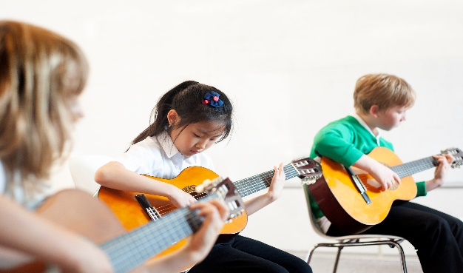

**MUSIC TEACHER JOB DESCRIPTION Grade: MPS/UPS/LP**

## Job Description

The responsibilities of the post are to be performed in accordance with the provisions of the most up to date edition of the School Teachers’ Pay and Conditions document and within the range of teachers’ duties set out in that document.

## Job Purpose

* To carry out professional duties and to have responsibility for an assigned classes
* Teaching music lessons across the Primary age range and leading whole school music provision including peripatetic lessons
* To be responsible for the day-to-day work and management of classes and the safety and welfare of the pupils, during on-site and off-site activities
* To promote the aims and objectives of the school and maintain its philosophy of education
* To promote and develop the place of music in our daily curriculum, developing enrichment activities, schemes of work and means of assessment as appropriate

Person Specification

#### KNOWLEDGE, SKILLS AND ABILITY

* A thorough up to date knowledge of the range of teaching, learning and behaviour management strategies and how to implement them effectively
* A thorough understanding of the national curriculum and a range of assessment requirements and arrangements
* Know how to use local, national and statistics to evaluate the effectiveness of teaching
* Knowledge and understanding of the implications of equal opportunities, multicultural education and inclusion
* Knowledge of computer software relevant to the curriculum
* Knowledge and understanding of the potential of computer technology to enhance the curriculum
* Know the legal requirements, national policy and guidance on the safeguarding of children
* Ability to prepare and plan effectively
* Good organisational and people management skills
* Ability to prioritise and management time effectively
* Ability to work as part of a team

#### TEACHING AND LEARNING

* Evidence of a good understanding of a range of teaching styles and approaches appropriate for inclusive education
* Evidence of the ability to raise achievement ensuring that the needs of individual /groups of pupils are met

#### EQUAL OPPORTUNITIES

* Demonstrate a clear understanding of and a commitment to equal opportunities and give evidence of effective implementation
* Ability to form and maintain appropriate relationships and personal boundaries with children and young people

#### You must demonstrate on your application form that you meet the following

#### Essential criteria:

**QUALIFICATIONS**

Qualified Teacher Status, and evident of appropriate subsequent in-service training and professional development

#### EXPERIENCE

Proven experience of high standards of classroom practice

Evident of use of assessment strategies, including Assessment of Learning.

#### PERSONAL QUALITIES

* Ability to solve problems and strategically plan for improvement
* Respect the views of parents, carers and children, and a commitment to the involvement of these groups in the learning process
* Ability to communicate orally and in writing effectively with colleagues, governors outside agencies and parents/ carers
* Commitment and willingness to meet the needs of the ethos and flexible working arrangements of a diverse inner-city school

**Main duties and responsibilities**

* To create and manage a caring, supportive, purposeful and stimulating environment which is conducive to children’s learning
* To plan and prepare lessons in order to deliver the National Curriculum ensuring breadth and balancing all subjects
* To identify clear teaching objectives and learning outcomes, with appropriate challenge and high expectations. To maintain good order and discipline among the pupils, safeguarding their health and safety
* To organise and manage groups or individual pupils ensuring differentiation of learning needs, reflecting all abilities
* To plan opportunities to develop the social, emotional and cultural aspects of pupils’ learning.
* To maintain a regular system of monitoring, assessment, record-keeping and reporting of children’s progress. To prepare appropriate records for the transfer of pupils
* To ensure effective use of support staff within the classroom, including parent helpers. To participate in staff meetings as required
* To co-ordinate peripatetic instrumental tuition, including marketing of opportunities and ensuring as many children as possible take this opportunity
* Contribute to the development and co-ordination of a particular area of the curriculum
* To be part of a whole school team, actively involved in decision-making on the preparation and development of policies and programmes of study, teaching materials, resources, methods of teaching and pastoral arrangements
* To ensure that school policies are reflected in daily practice
* To communicate and consult with parents over all aspects of their children’s education – academic, social and emotional
* To liaise with outside agencies when appropriate eg. Educational Psychologist.
* To continue professional development, maintaining a portfolio of training undertaken.
* To meet with parents and appropriate agencies, to contribute positively to the education of the children concerned
* To support the Headteacher in promoting the ethos of the school
* To promote the welfare of children and to support the school in safeguarding children though relevant policies and procedures
* To promote equality as an integral part of the role and to treat everyone with fairness and dignity.
* To recognise health and safety is a responsibility of every employee, to take reasonable care of self and others and to comply with the Schools Health and Safety policy and any school-specific procedures / rules that apply to this role
* Other tasks and duties as deemed appropriate to the role and reasonable by the Headteacher