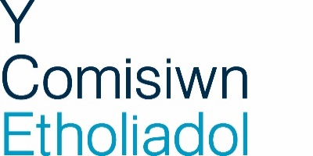 |  | 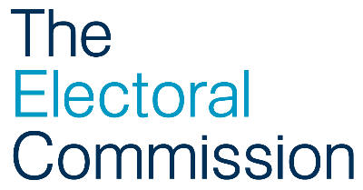

Job title: Welsh Translator

Directorate: Electoral Administration and Guidance Directorate

Responsible to: Head of Electoral Commission, Wales

Responsible for: NA

Location: Cardiff

Overall purpose of the post

This role provides translation services for the Electoral Commission and supports the organisation to meet the commitments set out in its statutory Welsh Language Standards.

The Welsh Translator will undertake translation of official documents, web content, general written translations, translations from Welsh to English and undertake proofreading. To assist in your translation work you will also be expected to become familiar with all the areas of the Commission’s work.

Main responsibilities

- Responsible for translating and proofreading materials in line with the Commission’s Welsh Language Standards and corporate style guidelines, where required, working to agreed timescales.
- Play a part in other aspects of the Commission’s work in Wales, with a focus on Communications.

- Support teams across the Commission in developing Welsh content including the provision of appropriate advice to colleagues across the UK.

- Outsource large pieces of translation work as required and manage the authors and suppliers so that work is delivered on time and is within budget.

  - Quality check any out-sourced translation work in line with the brief to ensure it is in clear and technically-accurate language, as well as being as well-structured and formatted as the English version.

- Assist the Senior Communications Advisor in dealing with internal queries relating to the Welsh language.

- Respond to enquiries regarding our websites from our Welsh stakeholders and other organisations.

- Act as the first point of contact for telephone enquiries made in Welsh, and provide answers with support from other members of the Wales Office team.
General

- Willingness to travel between our office in Cardiff and other Commission offices in the UK, where sometimes an overnight stay may be required.

- Undertake any additional work as necessary as part of the Commission’s Wales Office team.

- Participate in the Commission’s Performance Management process ensuring own personal development and contributing to the overall performance of the Directorate

- Understand, and actively promote, the aims and objectives of the Corporate Plan.

- Ensure equality of opportunity is maintained and respected at all times in accordance with the appropriate policies and procedures.

- Work co-operatively with colleagues across the Commission and show a willingness to work flexibly with others to respond to the needs of the organisation

- Comply with the statutory provisions of the Health and Safety at Work Act 1974.

- Actively participate in opportunities to communicate within the organisation including attending team and directorate meetings.

- Make full use of technology for all appropriate tasks.

- Ensure that confidentiality is respected and maintained at all times.

- Perform any other duty as directed by line management.

Key working relationships

The post-holder has to build and maintain working relationships and influence a range of stakeholders on a regular basis. This includes internal customers and external translation agencies. This role will need to manage expectations of internal customers who are often based remotely.

This job description reflects the present requirements of the post and should not be seen as an exhaustive list of responsibilities. Duties and responsibilities may develop and change in consultation with line management.

Person specification

Values & Behaviours | Essential Criteria | Desirable Criteria
Authoritative  Qualifications and training  Relevant experience  General and specialist knowledge /expertise | Experience of translating corporate materials into the Welsh language  Experience of proofing and editing material in Welsh, to corporate style  Experience of working on developing websites in the Welsh language  High level of IT literacy, to include: MSWord, Outlook, Excel | Professionally qualified Welsh language translator  Experience of using, and understanding principles behind, website content management systems  Knowledge of writing for the web, information architecture, web accessibility and usability issues and the government agenda for public sector websites  Familiar with Content Management Systems, ideally Drupal, or a willingness to learn  Member of the Association of Welsh Translators and Interpreters, or willingness to achieve qualification  Educated to degree level in Welsh or equivalent experience  Good understanding of the position of the Welsh language in Wales and of devolution generally.
Independent | The ability to work flexibly both with limited supervision and as part of a team
Transparent | Excellent organisational skills and the ability to work well under pressure and prioritise multiple projects effectively
Making an impact | Strong problem solving skills
Engaged  Effective relationships  Communication | Strong interpersonal and negotiating skills, confident dealing with internal and external stakeholders at all levels  Excellent attention to detail and accuracy with a high standard of quality checking written Welsh and English  Excellent written communication skills, with ability to use plain language to communicate content in a clear style  Experience of dealing with customers and or/members of the public  Excellent verbal communication skills | Experience of working in a communications within the public sector or a law firm
Leadership and management | N/A | N/A
Special requirements | Impartiality, with a high degree of integrity, sense of probity and a strong commitment to equality | Understanding of the Welsh Language Standards  Possess an understanding of, and interest in, democracy and the electoral processes in the UK

Bold type indicates minimum criteria

